

CAPSTONE PROJECT REPORT
Report 3 – Software Requirements Specification

Automatic Brewing Coffee

– Ho Chi Minh, April 2025 –
Table of Contents
I. Record of Changes 3
II. Software Requirement Specification 4
1. Product Overview 4
2. User Requirements 5
2.1 Actors 5
2.2 Use Cases 5
3. Functional Requirements 7
3.1 System Functional Overview 7
3.2 Dashboard Management Screen 17
3.3 Order Management Screen 19
3.4 Organization Management Screen 24
3.5 Store Management Screen 35
3.6 Account Management Screen 46
3.7 Product Management Screen 51
3.8 Menu Management Screen 66
3.8 Category Management Screen 66
3.8 Location Management Screen 66
3.8 Ingredient Type Management Screen 66
3.9 Sync Event Management Screen 67
3.10 Sync Task Management Screen 67
4. Non-Functional Requirements 67
4.1 External Interfaces 67
4.2 Quality Attributes 67
5. Requirement Appendix 68
5.1 Business Rules 68
5.2 Common Requirements 68
5.3 Application Messages List 68

I. Record of Changes
Date | A*  M, D | In charge | Change Description
22/6/2025 | A | Non-functionals screen flow | Adding a list of non-functionals exist the system
22/6/2025 | M | Project name, date | Adding title and date for the srs
18/7/2025 | M | Use case diagram | Adding new actor(Kiosk System) in UCD
23/7 | A | Screen | Adding new screen
*A - Added M - Modified D - Deleted

II. Software Requirement Specification

1. Product Overview
Automated Coffee Brewing System is a modern software platform designed to centrally manage a network of automated coffee vending machines (kiosks) from participating organizations, including the kiosk‘s system, which connects and communicates with its devices to process orders. The system aims to automate the coffee sales process, minimize human intervention, enhance customer experience, and enable remote supervision across multiple locations.
The system interfaces with end-customers (coffee buyers), payment gateways, inventory management systems, technical support teams, administrators, and external suppliers. Key features include menu and price management, real-time device monitoring, automated promotions, payment integration, inventory tracking, and maintenance alerts.
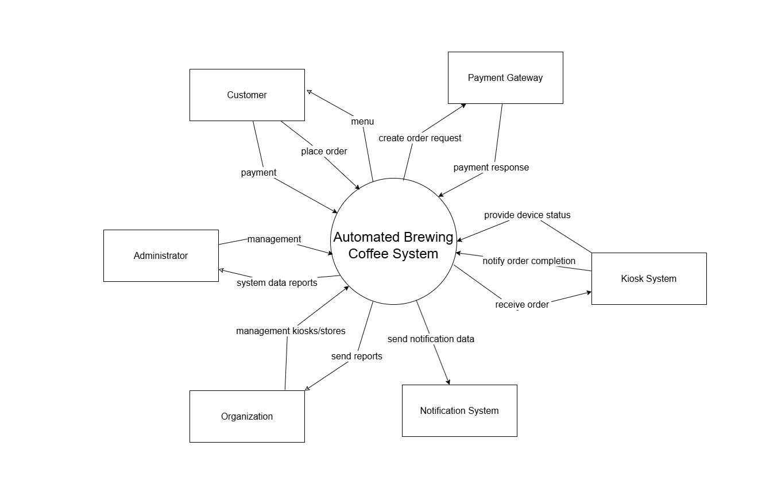
The context diagram below illustrates the system boundary and all external entities that interact with the Automated Brewing Coffee System. It performs the flow of data and control signals between the system and other parties, ensuring clear separation between the internal processes and the outside world.

2. User Requirements

2.1 Actors

# | Actor | Description
1 | System Administrator | - Responsible for managing the entire system, including all kiosks and device settings.  - Monitors device statuses, handles system-wide configurations, and oversees performance across organizations.  - Can receive alerts (e.g., machine errors, low supplies) and forward them to Organization Administrators.
2 | Organization Administrator | - Manages kiosks and devices owned by their organization.  - Monitors kiosk activity, views operational status, and reviews sales reports.  - Handles basic configurations such as menu updates or kiosk availability.
3 | Customer | - Individuals who place coffee orders and interact directly with the kiosk or the mobile app.
4 | Kiosk System | - The system interacts to make drinks.

2.2 Use Cases
2.2.1 Diagram(s)
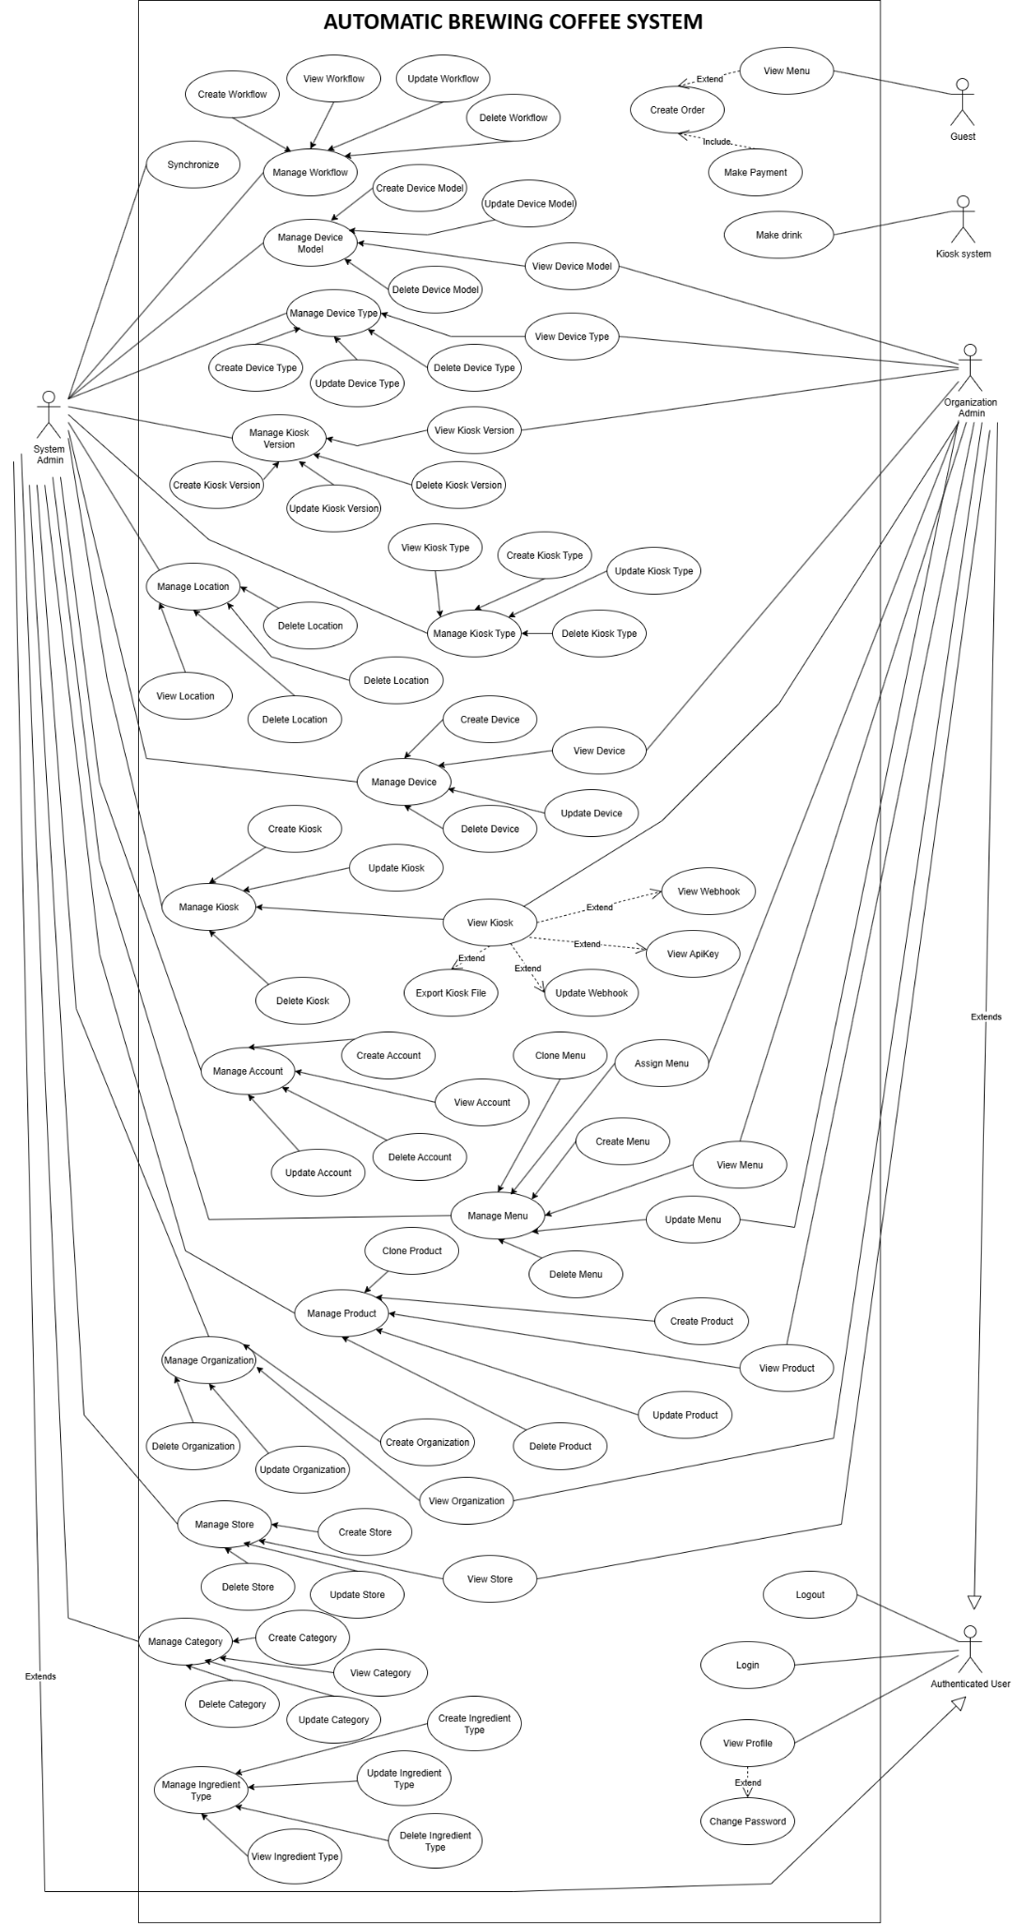

3. Functional Requirements

3.1 System Functional Overview

3.1.1 Screens Flow
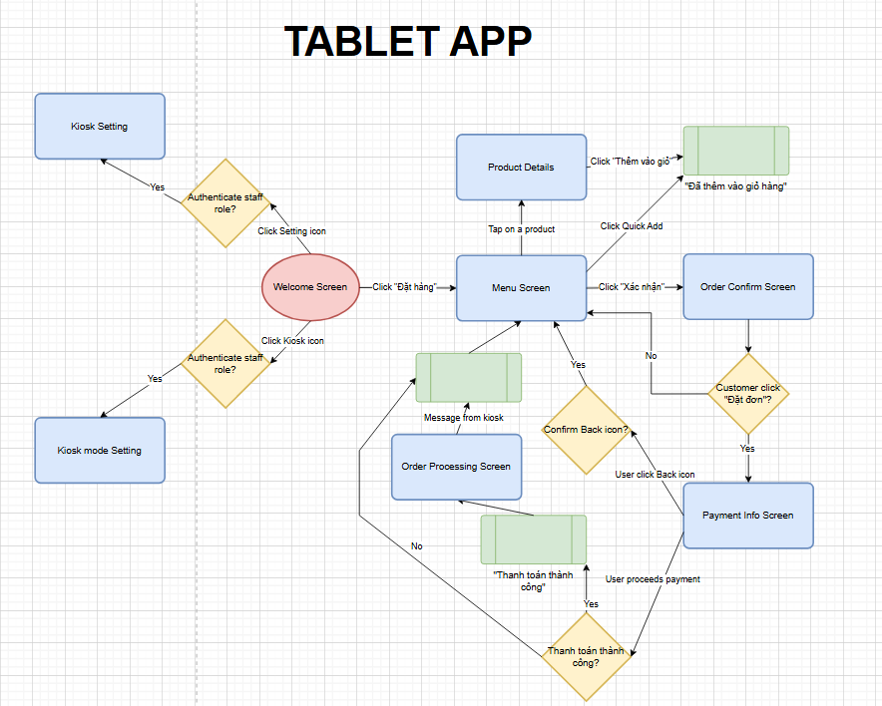
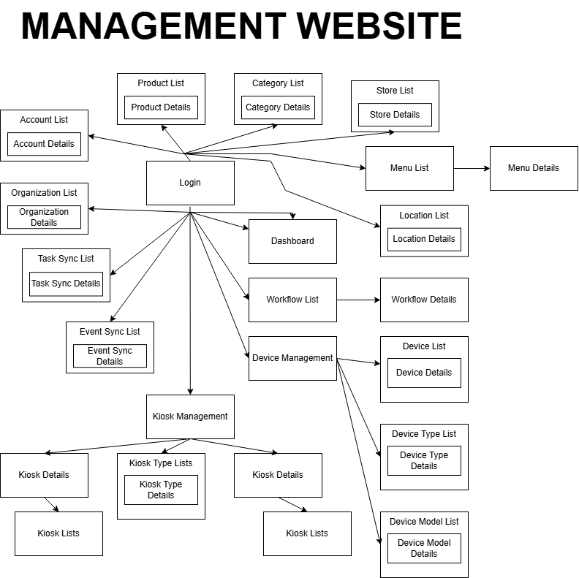

3.1.2 Screen Descriptions
[Provide the descriptions for the screens in the Screens Flow above]

3.1.2.1 Mobile Descriptions
# | Feature | Screen | Description
1 | Order Beverage | Welcome Screen | Entry point of the app with a button to begin ordering.
2 | Order Beverage | Menu Screen | Displays available food/menu items. Users can tap to see details or quick-add.
3 | Order Beverage | Product Details | Detailed view of a menu item with "Add to cart" functionality.
4 | Order Beverage | Order Confirm Screen | Shows items selected and allows users to confirm order.
5 | Order Beverage | Payment Info Screen | Allows users to input or confirm payment methods.
6 | Order Beverage | Payment Success Screen | Confirmation screen shown after successful payment.

3.1.2.2 Web Descriptions
# | Feature | Screen | Description
1 | Authentication | Login | Admin login screen.
2 | Dashboard | Dashboard | Overview of system stats and quick navigation.
3 | Workflow Management | Workflow List | List of workflows.
4 | Workflow Management | Workflow Details | Detail of selected workflow with editable properties.
5 | Device Management | Device Management | Main screen to navigate device-related settings.
6 | Device Management | Device List | List of devices managed.
7 | Device Management | Device Details | View/edit specific device info.
8 | Device Management | Device Type List | List of device types.
9 | Device Management | Device Type Details | Details for a selected device type.
10 | Device Management | Device Model List | List of device models.
11 | Device Management | Device Model Details | Details for a selected device model.
12 | Kiosk Management | Kiosk Management | Detailed view of a kiosk type.
13 | Kiosk Management | Kiosk Type List | List of kiosks registered.
14 | Kiosk Management | Kiosk Type Details | Details of a specific kiosk.
15 | Kiosk Management | Kiosk List | List of kiosks registered.
16 | Kiosk Management | Kiosk Details | Details of a specific kiosk.
17 | Menu Management | Menu List | List of menus created.
18 | Menu Management | Menu Details | Full detail of menu and items.
19 | Product Management | Product List | List of all products.
20 | Product Management | Product Details | Detail view/edit screen for a product.
21 | Category Management | Category List | List of item categories.
22 | Category Management | Category Details | Detailed information of a selected category.
23 | Store Management | Store List | View all store branches.
24 | Store Management | Store Details | View/edit specific store details.
25 | Location Management | Location List | List of location entities (e.g., areas, regions).
26 | Location Management | Location Details | Detailed view and configuration of a location.
27 | Account Management | Account List | List of admin/user accounts.
28 | Account Management | Account Details | Full detail of an individual account.
29 | Organization Management | Organization List | List of organizations or tenants.
30 | Organization Management | Organization Details | Detail view and editable info of an organization.
31 | Sync Management | Sync Management | Overview of task sync logs.
32 | Sync Management | Task Sync Details | Details of specific sync tasks.
33 | Sync Management | Event Sync List | List of synced events.
34 | Sync Management | Event Sync Details | View of event-level synchronization records.

3.1.3 Screen Authorization

Screen | Admin | Organization
Dashboard | X | X
View Stats Summary | X | X
Account Management | X
Query All Data | X
Add New Data | X
Update All Data | X
Delete Data | X
Category Management | X
Query All Data | X
Add New Data | X
Update All Data | X
Delete Data | X
Ingredient Type Management | X
Query All Data | X
Add New Data | X
Update All Data | X
Delete Data | X
Location Type Management | X
Query All Data | X
Add New Data | X
Update All Data | X
Delete Data | X
Device Type Management | X
Query All Data | X
Add New Data | X
Update All Data | X
Delete Data | X
Device Model Management | X
Query All Data | X
Add New Data | X
Update All Data | X
Delete Data | X
Device Management | X
Query All Data | X
Add New Data | X
Update All Data | X
Delete Data | X
Kiosk Type Management | X
Query All Data | X
Add New Data | X
Update All Data | X
Delete Data | X
Kiosk Version Management | X
Query All Data | X
Add New Data | X
Update All Data | X
Delete Data | X
Kiosk Management | X
Query All Data | X | X
Add New Data | X
Update All Data | X
Delete Data | X
Workflow Management | X
Query All Data | X | X
Add New Data | X
Update All Data | X
Delete Data | X
Menu Management | X
Query All Data | X | X
Add New Data | X
Update All Data | X
Delete Data | X
Store Management | X
Query All Data | X | X
Add New Data | X
Update All Data | X
Delete Data | X
Product Management | X
Query All Data | X
Add New Data | X
Update All Data | X
Delete Data | X
Organization Management | X
Query All Data | X
Add New Data | X
Update All Data | X
Delete Data | X
Sync Management | X
Profile Management | X | X
Order Management
Query All Data | X | X

3.1.4 Non-Screen Functions
# | Feature | System Function | Description
1 | Payment Management | Auto Expired Payment | Automatically checks all payments and marks them as Expired if the payment time has exceeded the allowed limit.
2 | Order Management | Auto Cancel Order | Automatically cancels associated orders if the corresponding payment is expired, without requiring user interaction.
3 | Kiosk Data Synchronize | Tracking Audit Entities | Automatically triggers an audit tracking when changes occur in the database.
4 | Kiosk Management | Auto Generate Webhook | Automatically triggers to create all webhooks when a kiosk is created.
5 | Kiosk Management | Auto Register Cloudflare Tunnel | Automatically registers and establishes a Cloudflare Tunnel for each kiosk during initialization, allowing secure remote access to kiosk services without exposing the local network.
6 | Kiosk Management | Auto Register Device to Azure IoT Hub | Automatically registers a kiosk device with Azure IoT Hub upon first setup or activation, enabling secure cloud-to-device communication and remote device management.
7 | Organization Management | Auto Create Admin Account on Organization Creation | When a new organization is created, the system automatically generates a default admin account for that organization to enable initial access and management without manual user registration.
8 | Notification | Send Account Credentials via Email | After the admin account is created, the system sends an email containing login credentials (username and password) to the provided organization contact email.
9 | Order Management | Handle Payment Callback from Third-Party | The system receives and validates payment callback data (e.g., from VNPay or MPOS) to confirm transaction status after a user completes payment.
10 | Order Management | Notify Device and Trigger Beverage Process | After successful payment validation, the system sends a command to the kiosk/tablet device to display order status and activates the drink-making workflow (e.g., robot, ice, coffee machine).
11 | Kiosk Data Synchronize | Push Sync Data to Kiosk Device | The system automatically sends pending task data (e.g., product recipes, workflow steps, configurations) from the cloud or central server to the target kiosk device to ensure it is up to date.
12 | Kiosk Data Synchronize | Receive and Process Sync Data on Kiosk | The kiosk device automatically receives synchronization data (e.g., product info, workflows, steps) from the server, parses the payload, and updates its local storage or runtime configuration accordingly.
13 | Kiosk Management | Export Kiosk Configuration File | Upon kiosk creation or during installation, the system automatically generates a configuration file (e.g., JSON, YAML) containing all necessary information such as device IDs, network settings, tunnel credentials, Azure IoT keys, and assigned workflows.
14 | Notification | Send Ban Notification to Affected Users | The system sends real-time or email notifications to all users in the banned organization to inform them about the ban and reason (if applicable).
15 | Kiosk Data Synchronize | Auto Delete Synced Data | After synchronization is completed and confirmed, the system automatically deletes or archives corresponding SyncTask and SyncEvent records to free up storage and keep the database clean.
16 | System Monitoring | Auto Logging and Tracing | The system automatically captures logs, traces, and exception data across services, enabling centralized monitoring and diagnostics.
17 | System Database Management | Auto Apply Database Migrations | On application startup or deployment, the system automatically applies pending database migrations to ensure the database schema is up-to-date with the current application version.
18 | System Performance Optimization | Auto Cache with Change Tracking | The system automatically caches frequently accessed data in memory (e.g., product lists, workflows). It detects changes in the database and refreshes the cache when data is updated. Similar queries are served from cache for faster response. For different queries, the system queries the database and then updates the cache accordingly.
19 | System Messaging & Reliability | Auto Retry Payment Callback Handling via RabbitMQ | When the system fails to process a payment callback message (e.g., due to DB issue, service downtime), the message queue (RabbitMQ) automatically retries the handling according to configured retry policies (e.g., exponential backoff, dead-letter queue) until it succeeds or is moved to error handling.
20 | System Security & Stability | Apply Rate Limiting on API Requests | The system applies rate limiting on selected APIs (e.g., login, payment callback, sync) to prevent abuse, brute force attacks, or excessive traffic from a single client. Limits can be based on IP address, API key, or user.
21 | System Resilience & Availability | Fallback to Memory Cache & DB if Redis Fails | When Redis is unavailable (e.g., disconnected, crashed), the system automatically switches to in-memory caching (MemoryCache) and direct database queries to ensure continuous operation without crashing or blocking.
22 | System Resilience & Availability | Auto Reconnect on WebSocket Disconnection | When the realtime connection (e.g., SignalR or WebSocket) is lost due to network issues or server restart, the client (e.g., kiosk or admin panel) will automatically attempt to reconnect periodically and resume communication without requiring user intervention.
23 | Kiosk Automation | Execute Workflow Based on Synced Data | After receiving a drink order, the kiosk reads the pre-synced workflow (including steps, device actions) and automatically activates the drink-making process based on the defined workflow.
24 | Workflow Observer | Monitor Workflow Execution | Continuously monitors the execution progress of drink-making workflows. It listens to changing events of workflow ‘s steps, compares them with predefined conditions, and decides next actions.
25 | Step Observer | Monitor step result from devices | Listens for step result updates pushed from individual devices. When a device completes or fails a step, it sends a state message. The observer captures this change and marks the step as “observed”.
26 | Device Status Watcher | Monitor and Update Device Detail Status | Monitors the real-time operational status of connected devices. Devices periodically push status reports every minute.

3.1.5 Entity Relationship Diagram
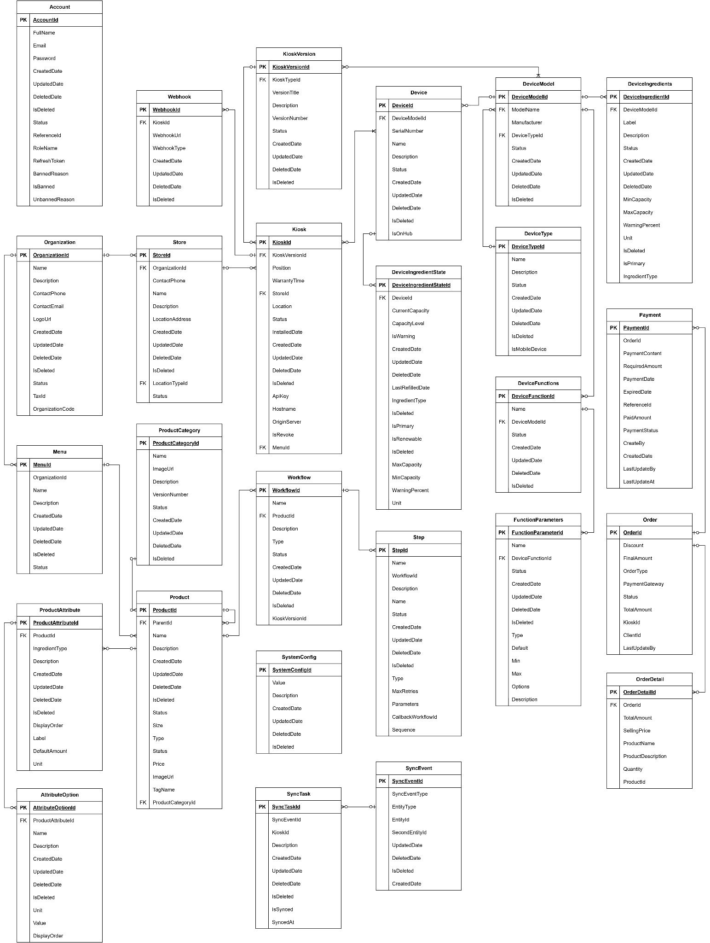

Entities Description
# | Entity | Description
1 | Account | Stores account credentials and identity information for both organization and store users.
2 | Organization | Represents a company or business unit managing one or multiple stores.
3 | Store | Physical or virtual store location under an organization, equipped with kiosks.
4 | Kiosk | A vending or coffee machine unit linked to a store that processes drink workflows.
5 | KioskVersion | Contains versioning information and supported configuration for kiosks.
6 | Menu | Defines the available product selection offered by a store or kiosk.
7 | Product | Represents drink items or recipes available for order.
8 | ProductCategory | Groups products for easier management or display on UI.
9 | Workflow | Defines as recipe or process flow to prepare a specific product.
10 | Step | A step within a workflow to operate devices for specific drink-making actions.
11 | Device | Represents physical components (e.g. pump, cooler) installed in kiosks.
12 | DeviceModel | Template or specification for types of devices (e.g. brand, manufacturer).
13 | DeviceType | Classifies devices by functionality (e.g. mixer, pump, cooler).
14 | DeviceFunctions | Defines callable actions for a device (e.g. HeatWater, Dispense).
15 | FunctionParameters | Parameters accepted by a function (e.g. temperature, volume).
16 | Webhook | Stores webhook endpoints used for triggering actions from external systems.
17 | Order | Stores customer purchase and payment transaction information.
18 | OrderDetail | Line item per product in an order, with quantity and price.
19 | Payment | Stores payment status and transaction information tied to orders.
20 | SyncEvent | Tracks changes in data for synchronization with kiosks.
21 | SyncTask | Job queue for delivering sync events to kiosks.
22 | SystemConfig | Stores key-value configuration parameters applied globally in the system.
23 | DeviceIngredient | The base ingredient of each device model
24 | DeviceIngredientState | The real ingredient of each device working into a kiosk
25 | ProductAttribute | The attributes combine to make the product
26 | AttributeOption | The options of each attribute to make the product

3.2 Dashboard Management Screen

3.2.1 View dashboard
- Function description:
  - Actors/Roles: System Admin, Organization Admin
  - Purpose: The dashboard provides an overview of the system's business performance, customer behaviour, order statuses and kiosk health.
  - Interface:
    - Overview Cards: total revenue, total kiosk, total organization, total store, growth rate, active account of organization.
    - Order summary chart: Pie chart showing order statuses: “Đang chờ”, “Đang chuẩn bị”, “Hoàn tất”, “Đã hủy”, “Thất bại”,
    - Recent Transaction: List of latest completed order,
    - Hourly Sales Chart: Line chart showing peak sales per hour.
  - Data Processing:
    - Server count and calculate all then return for client.
- Function trigger:
  - Navigation path: Admin access the dashboard via the left sidebar by clicking the “Dashboard” menu item.
  - Alternative navigation: This screen is the default landing page after a successful admin login
  - Timing Frequency: Data is auto-refresh every 60 seconds, or manually via browser reload.
- Screen layout:
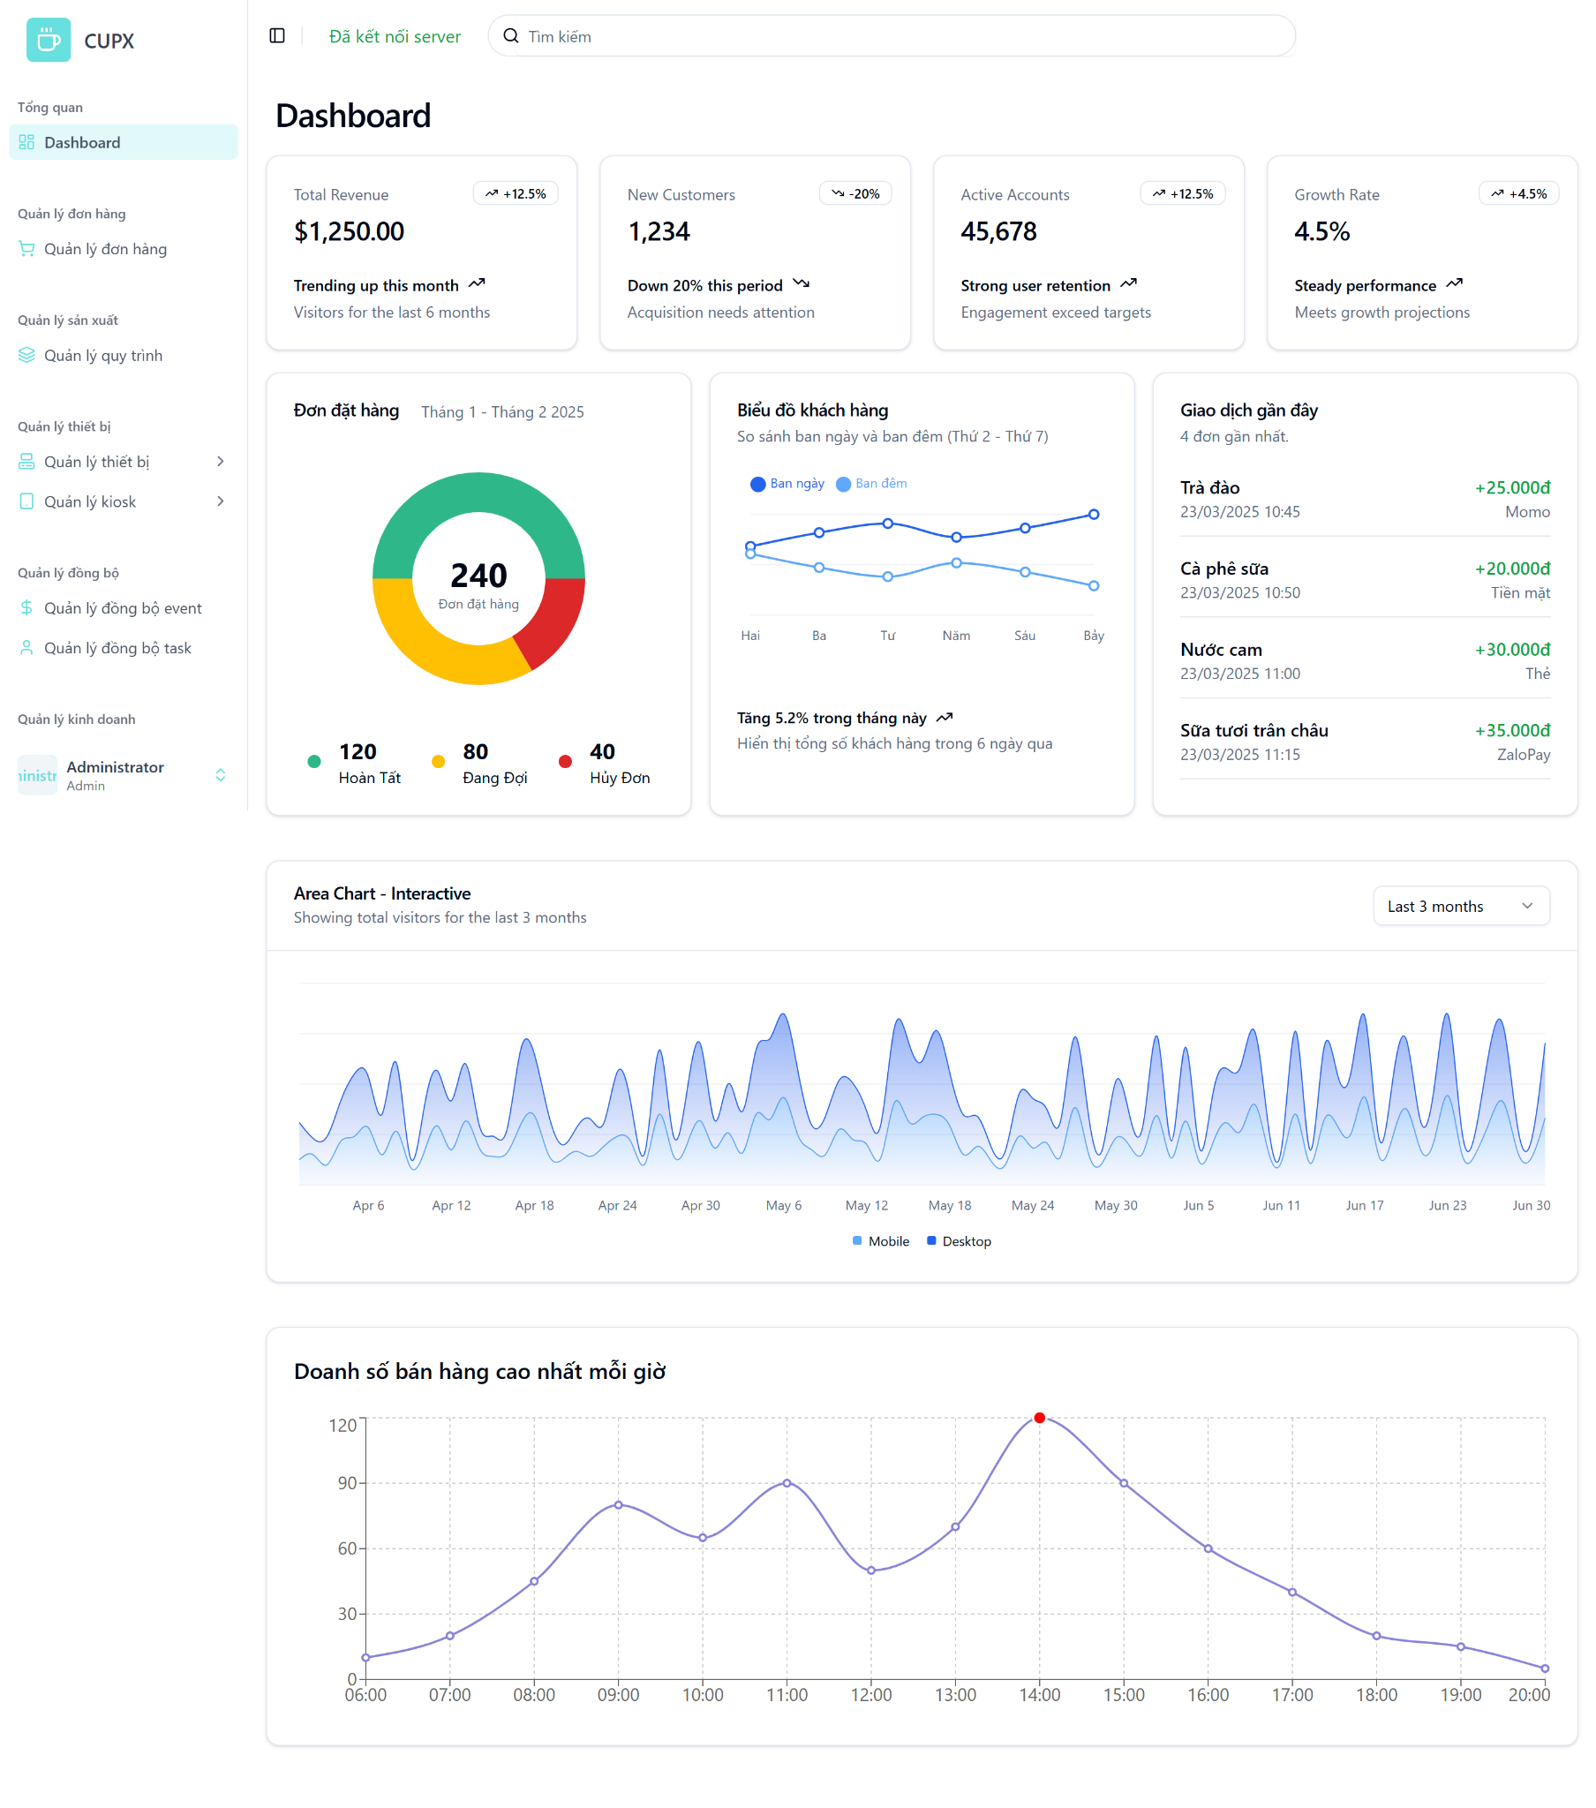
- Function details:
  - Data & Validation:
Data | Validations

  - Functionalities:

Normal Cases | Abnormal Cases

  - Business Rules:

3.3 Order Management Screen

3.3.1 View list of orders
- Function description:
  - Actors/Roles:
    - System Admin: Full access to all order data across the system.
    - Organization Admin: Access limited to orders within their managed organization or kiosks.
  - Purpose: This screen provides administrators with a comprehensive view of all customer orders in the system, including details such as status, payment method, and total amount.
  - Interface:
    - Table: Displays a structured, paginated list of all order with following columns:
      - OrderId
      - OrderType
      - Payment Method
      - Status
      - Final Amount
      - Order Time
      - Action
    - Optional UI Element:
      - Search bar
      - Filter dropdowns
      - Pagination controls
      - Column visibility configuration
      - “Làm mới” (Refresh) button
      - “Xuất dữ liệu” button
  - Data Processing:
    - Server returns for the client a list of orders based on filter, search, sort and paging.
- Function trigger:
  - Navigation path: Admin access the table of list order via the left sidebar by clicking the “Quản lý đơn hàng” menu item.
  - Timing Frequency: Data is auto-refresh every 60 seconds, or manually via browser reload or clicking button “Làm mới”
- Screen layout:
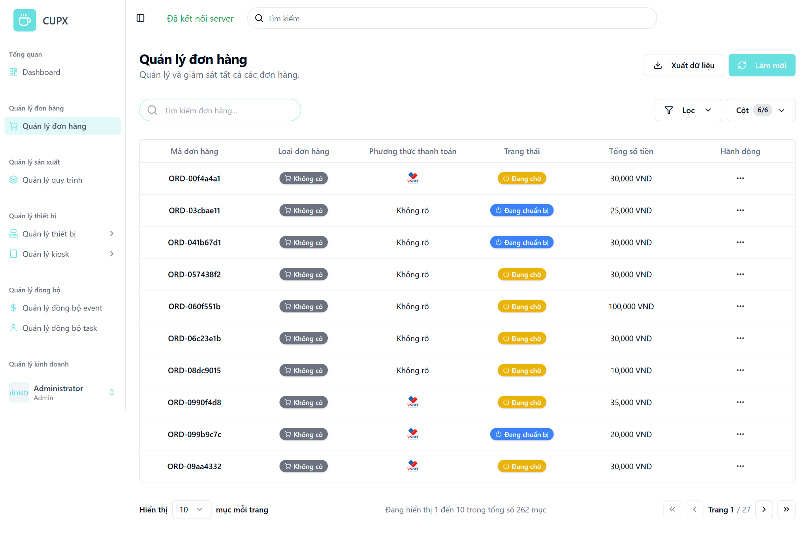
- Function details:
  - Data & Validation:
Data | Validations
OrderId | …
OrderType | …
PaymentMethod | …
OrderStatus | …
FinalAmount | …

  - Functionalities:
Function | Normal Cases | Abnormal Cases
Access order list | Admin accesses the screen and views a paginated table of orders. | If the API fails, an error message is displayed with a retry option.
Search by keyword | Admin searches using order ID or keywords and receives matching results. | If no results match the query, display “No orders found.”
Apply filters | Admin applies one or more filters and the result list updates accordingly. | If invalid filter input is provided or server error occurs, display a warning and keep previous results.
Sort columns | Admin clicks column headers to sort data in ascending or descending order. | If sorting fails (e.g., backend fails), fallback to unsorted data and notify the user.
Pagination navigation | Admin uses pagination controls to navigate between pages (e.g., next, previous). | If the requested page index is invalid or unavailable, reset to page 1 with a warning.
Manual refresh | Admin clicks “Làm mới” and the order list reloads with the latest data. | If refresh fails (e.g., network error), display an error and allow retry.

  - Business Rules:

3.3.1 View detail of an order
- Function description:
  - Actors/Roles:
    - System Admin:Has full access to view the detailed information of any order in the system..
    - Organization Admin: Can view order details only within their own organization or the kiosks they manage.
  - Purpose: This screen allows administrators to view complete and structured details of a specific customer order. It provides critical information such as order ID, status, order type, payment method, financial breakdown (discounts, fees, VAT), and a list of ordered items. This enables transparency, order tracking, and verification for administrative tasks.
  - Interface:
    - Order Metadata Section:
      - Order Id
      - Order Type
      - Payment Method
      - Status
      - Final Amount
      - Order Time
    - Payment Information Section:
      - Payment Method
      - Discount
      - Fee
      - VAT
      - Total Amount
      - Final Amount
    - Order Items Section
      - A list of products in the order showing:
        - Product name
        - Description
        - Quantity
        - Unit price
        - Subtotal
    - Action Button
      - Modal close button “X”
  - Data Processing:
    - Backend returns the client an order with all details.
- Function trigger:
  - Navigation path:Admin opens the order detail by clicking on the “Hành động” button then chooses “Xem chi tiết” in order to record the table.
- Screen layout:
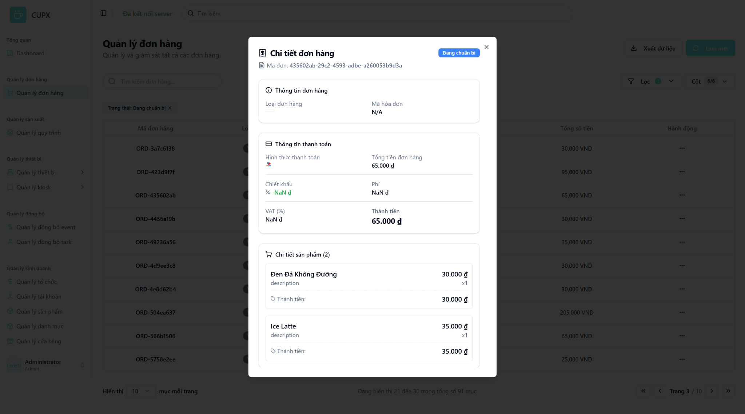
- Function details:
  - Data & Validation:
Data | Validations
OrderId | …
OrderType | …
PaymentMethod | …
OrderStatus | …
FinalAmount | …
DiscountAmount
VAT (%)
Fee
FinalAmount
OrderItems

  - Functionalities:
Function | Normal Cases | Abnormal Cases
Open order detail | Admin clicks on an order in the list and the order detail modal appears with full information. | If the order is deleted or inaccessible, show “Order not found or permission denied.”
View general order information | Displays order ID, type, and status at the top of the modal. | If no results match the query, display “No orders found.”
View payment information | Displays order ID, type, and status at the top of the modal. | If the order type is null or unknown, show “N/A” or placeholder.
View payment information | Displays payment method, total amount, VAT, discount, fees, and final total. | If any field is null, show gracefully with ” 0đ” or “NaN” đ fallback
View order item list | Lists all products in the order, each with quantity, price, and subtotal. | If item data is incomplete (missing name, price), display a placeholder or skip rendering that row.
Display currency formatting | All monetary values are properly formatted in VND. | If formatting fails, fallback to raw numeric value with currency suffix.
Close modal | Admin clicks outside the modal or on the “X” icon to close the view. | If modal fails to close (UI bug), allow escape key or force reload as fallback.

  - Business Rules:

3.4 Organization Management Screen

3.4.1 View list of organizations
- Function description:
  - Actors/Roles:
    - System Admin: Full access to all organization data across the system.
    - Organization Admin: Can not access other organization data.
  - Purpose: This screen provides administrators with a comprehensive view of all customer orders in the system.
  - Interface:
    - Table: Displays a structured, paginated list of all organization with following columns:
      - Organization Id
      - Organization Code
      - Logo
      - Organization Name
      - Contact Information
      - Status
      - Tax Code
      - Action
    - Optional UI Element:
      - Search bar
      - Filter dropdowns
      - Pagination controls
      - Column visibility configuration
      - “Làm mới” (Refresh) button
      - “Xuất dữ liệu” button
  - Data Processing:
    - Server returns for the client a list of organisations based on filter, search, sort and paging.
- Function trigger:
  - Navigation path: Admin access the table of list organization via the left sidebar by clicking the “Quản lý tổ chức” menu item.
  - Timing Frequency: Data is auto-refresh every 60 seconds, or manually via browser reload or clicking button “Làm mới”
- Screen layout:
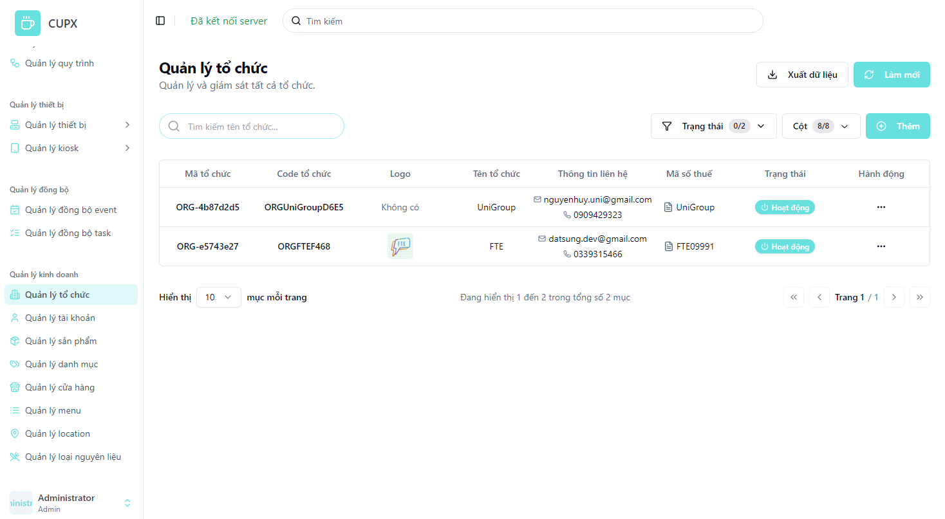
- Function details:
  - Data & Validation:
Data | Validations
OrganizationId | …
Name | …
OrganizationCode | …
Description | …
ContactPhone | …
ContactEmail | …
LogoUrl | …
TaxId | …
Status | …
CreatedDate | …
UpdatedDate | …

  - Functionalities:
Function | Normal Cases | Abnormal Cases
Access organization list | Admin accesses the screen and views a paginated table of organizations. | If the API fails, an error message is displayed with a retry option.
Search by keyword | Admin searches using organization ID or keywords and receives matching results. | If no results match the query, display “No organizations found.”
Apply filters | Admin applies one or more filters and the result list updates accordingly. | If invalid filter input is provided or server error occurs, display a warning and keep previous results.
Sort columns | Admin clicks column headers to sort data in ascending or descending organization. | If sorting fails (e.g., backend fails), fallback to unsorted data and notify the user.
Pagination navigation | Admin uses pagination controls to navigate between pages (e.g., next, previous). | If the requested page index is invalid or unavailable, reset to page 1 with a warning.
Manual refresh | Admin clicks “Làm mới” and the organization list reloads with the latest data. | If refresh fails (e.g., network error), display an error and allow retry.

  - Business Rules:

3.4.2 View detail of an organization
- Function description:
  - Actors/Roles:
    - System Admin: Has full access to view the detailed information of any organization in the system.
    - Organization Admin: Can only view details of their own organization or kiosks under their management.
  - Purpose: This screen allows administrators to view complete and structured details of a specific organization. It provides key information such as organization name, code, tax ID, contact information, status, and description. This feature enhances organizational management, verification, and auditing tasks.
  - Interface:
    - Order Metadata Section:
      - Organization Name
      - Organization ID
      - Organization Code
      - Tax ID
      - Description
      - Status
    - Contact Information Section:
      - Email
      - Phone Number
    - Logo Section:
      - Displays the logo of the organization (if available)
    - Action Button
      - Modal close button “X”
  - Data Processing:
    - The backend returns detailed organization data based on the selected organization ID when the view detail action is triggered.
- Function trigger:
  - Navigation path: Admin opens the organization detail by clicking on the “Hành động” button then chooses “Xem chi tiết” in order to record the table.
- Screen layout:
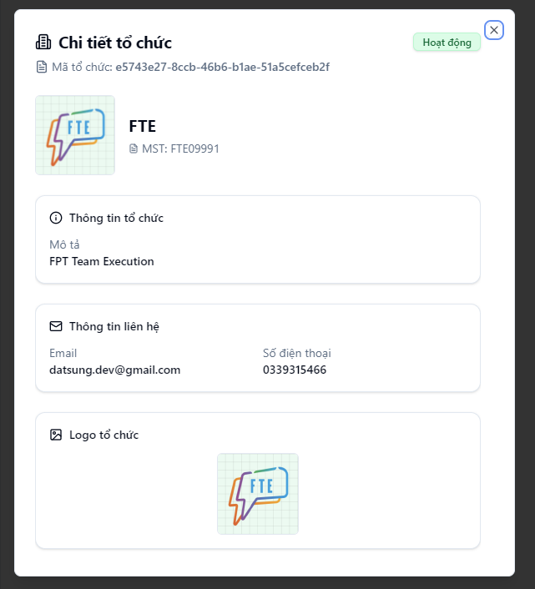
- Function details:
  - Data & Validation:
Data | Validations
OrganizationId | …
Name | …
OrganizationCode | …
Description | …
ContactPhone | …
ContactEmail | …
LogoUrl | …
TaxId | …
Status | …
CreatedDate | …
UpdatedDate | …

  - Functionalities:
Function | Normal Cases | Abnormal Cases
Open organization detail | Admin clicks on an organization in the list and the order detail modal appears with full information. | If the organization is deleted or inaccessible, show “Organization not found or permission denied.”
View general organization info | Displays organization name, code, ID, status, tax ID, and description. | If any field is null or missing, display gracefully with “N/A” or placeholder.
View contact information | Displays email and phone number of the organization. | If contact info is null or invalid, show “N/A” or default placeholder.
View organization logo | Displays the organization’s logo (if available). | If the logo is not uploaded or fails to load, show a default image or icon.
Display status formatting | Status is shown using badges like "Active", "Inactive" with proper styling. | If status is null or unrecognized, display a neutral badge with text “Unknown”.
Display currency fields | All monetary fields (if any) are properly formatted in VND. | If formatting fails, fallback to raw number with currency suffix.
Close modal | Admin clicks outside the modal or on the “×” icon to close the view. | If modal fails to close (UI bug), allow escape key or force reload as fallback.

  - Business Rules:

3.4.3 Create an organization
- Function description:
  - Actors/Roles:
    - System Admin:Has full access to create new organizations in the system.
    - Organization Admin: No access to this feature.
  - Purpose: This screen allows system administrators to add a new organization into the system. It includes fields for organization identity, contact information, operational status, logo, and description. The goal is to onboard new partners or entities into the platform.
  - Interface:
    - Organization Metadata Section:
      - Organization Name: Official name of the organization.
      - Organization ID: System-generated unique identifier.
      - Tax ID: Official business tax identification number.
      - Description: Brief description of the organization (optional).
      - Status: Operational state (e.g., Active, Inactive).
    - Contact Information Section:
      - Email: Contact email address.
      - Phone Number: Organization's phone number.
    - Logo Section:
      - Allows upload of the organization's logo via file or URL.
      - Accepted formats: JPG, PNG, JPEG (max size 2MB).
      - Displays a preview of the uploaded logo.
    - Action Button
      - Modal close button “X”
      - Create Button: Submits the form and sends data to the backend.
      - Cancel Button: Closes the modal without saving.
  - Data Processing:
    - The frontend collects the input values and sends a request to backend
- Function trigger:
  - Navigation path: From the “Quản lí tổ chức” screen, the admin clicks the “Thêm” (Add) button to open the creation modal.
- Screen layout:
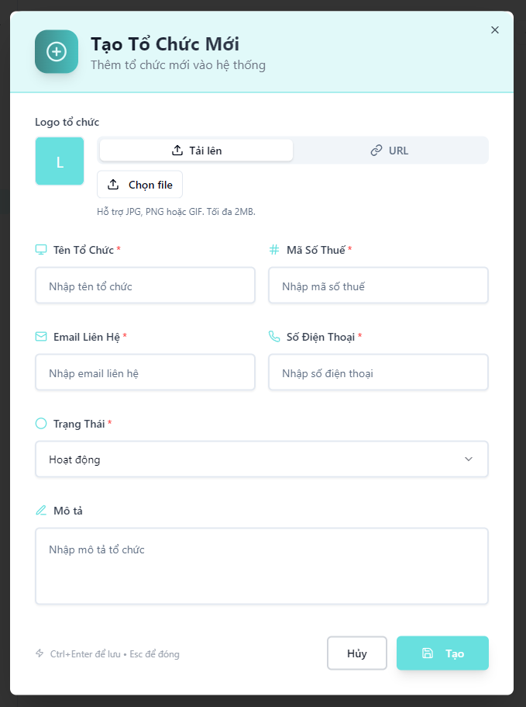
- Function details:
  - Data & Validation:
Data | Validations
OrganizationId | Auto-generated by the backend. Not required from the client.
Name | Required. Maximum length: 100 characters
OrganizationCode | Auto-generated or derived by the system. Not provided by the client.
Description | Optional. Maximum length: 450 characters
ContactPhone | Required. Maximum length: 100 characters
ContactEmail | Required. Maximum length: 100 characters
LogoUrl | Optional. Should be a valid URL format if provided.
LogoBase64 | Optional. Must match base64 format
TaxId | Optional. Maximum length: 200 characters
Status | Required. Maximum length: 10 characters
CreatedDate | Auto-generated by the system upon creation.

  - Functionalities:
Function | Normal Cases | Abnormal Cases
Open creation modal | Admin clicks the “Thêm” (Add) button, and the creation modal appears with all input fields visible. | If the modal fails to load, show an error notification or fallback to the full-page creation screen.
Input organization info | Admin fills in fields such as name, code, tax ID, description, and status. | If any required field is missing or invalid, show inline validation error (e.g., red border + tooltip).
Input contact information | Admin enters a valid phone number and email address. | If an email or phone is incorrectly formatted, prevent form submission and display clear validation messages.
Upload logo | Admin uploads a JPG/PNG/GIF logo file (max 2MB) or pastes a logo URL. | If a file exceeds the size limit or has invalid format, show error and prevent submission.
Status selection | Admin selects organization status (e.g., Active, Inactive) from a dropdown list. | If status is null or outside expected enum, show “Invalid status” error and reject submission.
Submit creation | Admin clicks the “Tạo” (Create) button; frontend validates inputs and sends data to backend. | If submission fails (e.g., server error), display error toast and retain input state for retry.
Close modal | Admin presses ESC, clicks “×”, or clicks Hủy (Cancel) to close the modal. | If the modal fails to close due to UI issues, fallback with ESC key or trigger full-page reload.

  - Business Rules:

3.4.4 Update an organization
- Function description:
  - Actors/Roles:
    - System Admin: Has full access to update any organization’s information in the system.
    - Organization Admin: No access to this feature.
  - Purpose: This screen allows system administrators to modify existing organization data. It supports editing fields such as name, tax ID, email, phone number, status, description, and logo. This feature ensures the system stays up-to-date with accurate organizational information.
  - Interface:
    - Editable Fields Section:
      - Organization Name
      - Tax ID
      - Email
      - Phone Number
      - Status
      - Description
      - Logo (upload or via URL)
    - Action Button
      - Modal close button “X”
      - Create Button: Submits the form and sends data to the backend.
      - Cancel Button: Closes the modal without saving.
  - Data Processing:
    - Frontend collects updated input values and sends a PUT request to the backend API to update organization information.
- Function trigger:
  - Navigation path:From the "Quản lý tổ chức" screen, admin clicks the "Hành động" button and chooses “Chỉnh sửa”.
  - Modal Display: The update modal appears pre-filled with the selected organization’s current data.
- Screen layout:
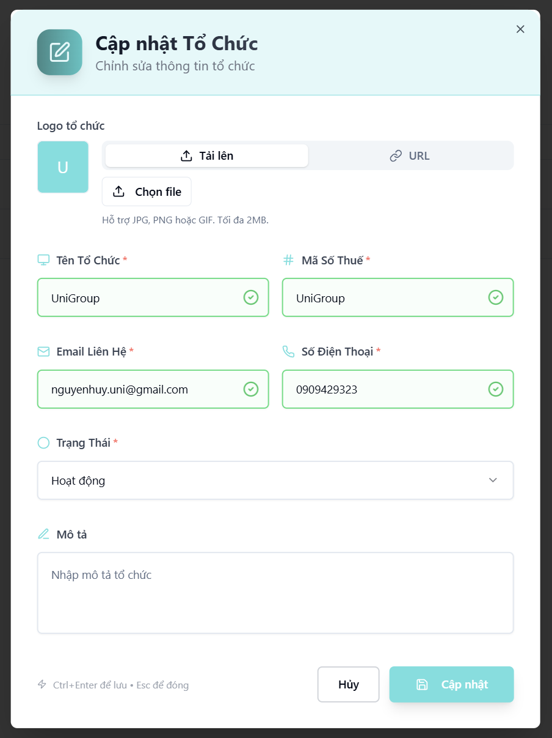
- Function details:
  - Data & Validation:
Data | Validations
Name | Required. Maximum length: 100 characters
Description | Optional. Maximum length: 450 characters
ContactPhone | Required. Maximum length: 100 characters
ContactEmail | Required. Maximum length: 100 characters
LogoUrl | Optional. Should be a valid URL format if provided.
LogoBase64 | Optional. Must match base64 format
TaxId | Optional. Maximum length: 200 characters
Status | Required. Maximum length: 10 characters
UpdatedDate | Auto-generated by the system upon update.

  - Functionalities:
Function | Normal Cases | Abnormal Cases
Open update modal | Admin clicks on the “Chỉnh sửa” (Edit) action, and the modal appears pre-filled with current data. | If organization no longer exists or is inaccessible, show “Organization not found or permission denied.”
Edit organization fields | Admin updates one or more fields and clicks “Cập nhật”. Form is validated, and data is saved. | If required fields are empty or invalid, show inline validation errors and prevent submission.
Upload/update logo | Admin uploads a new logo image, which is previewed immediately. | If the upload fails or the file is too large (>2MB), show an error message and reject the file.
Save changes | Form submits successfully, confirmation message shown, modal closes. | If the backend update fails (e.g., network or server error), show error and retry option.
Cancel update | Admin clicks “Hủy” or closes modal with “×” icon or Esc key. | If modal fails to close due to UI bug, allow force reload or fallback message.
Close modal | Admin presses ESC, clicks “×”, or clicks Hủy (Cancel) to close the modal. | If the modal fails to close due to UI issues, fallback with ESC key or trigger full-page reload.

  - Business Rules:

3.4.5 Delete an organization
- Function description:
  - Actors/Roles:
    - System Admin: Has full permission to delete organizations.
    - Organization Admin: No access to this feature.
  - Purpose: This function allows a system administrator to immediately delete an organization from the system with a single action.
  - Interface:
    - The Delete option is located inside the “Hành động” (Action) dropdown on the View List of Organizations screen.
    - No confirmation modal is shown — clicking “Xóa” (Delete) will immediately trigger the delete operation.
    - After deletion, the organization is removed from the list UI.
  - Data Processing:
    - A DELETE request is sent to the backend with the organization ID.
    - The server performs the deletion (soft/hard based on implementation) and returns success or failure.
    - The frontend updates the list by removing the deleted item.
    - Error toast is displayed in case of API failure (e.g., 403, 500).
- Function trigger:
  - Navigation path: From the left sidebar, admin selects the “Xóa” button from the “Hành động” dropdown.
- Layout:
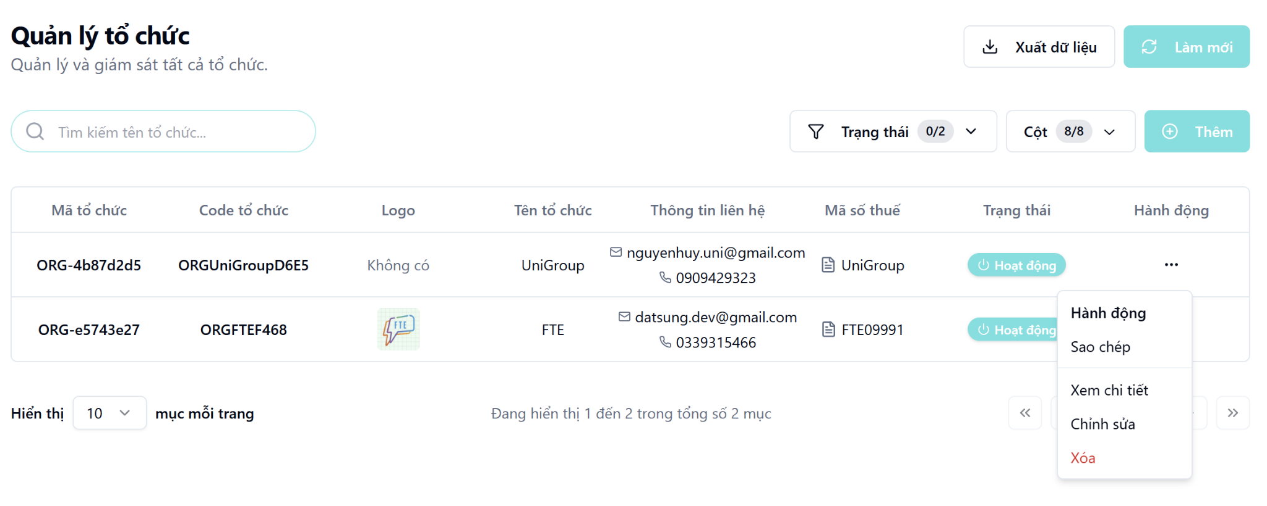

3.5 Store Management Screen

3.5.1 View list of stores
- Function description:
  - Actors/Roles:
    - System Admin: Full access to view and manage all stores under all organizations.
    - Organization Admin: Can only view and manage stores within their own organization.
  - Purpose: This screen provides administrators with a comprehensive view of all stores in the system. It supports pagination, search, filtering, and allows navigation to store details or actions like update/delete.
  - Interface:
    - Table: Displays a structured, paginated list of all organization with following columns:
      - Store Id
      - Store Name
      - Address
      - Status
      - Phone Number
      - Action
    - Optional UI Element:
      - Search bar
      - Filter dropdowns
      - Pagination controls
      - Column visibility configuration
      - “Làm mới” (Refresh) button
      - “Xuất dữ liệu” button
  - Data Processing:
    - Server returns for the client a list of stores based on filter, search, sort and paging and by current account.
- Function trigger:
  - Navigation path: From the left sidebar, admin selects “Quản lý cửa hàng” to open the store management screen.
  - Timing Frequency: Data is auto-refresh every 60 seconds, or manually via browser reload or clicking button “Làm mới”
- Screen layout:
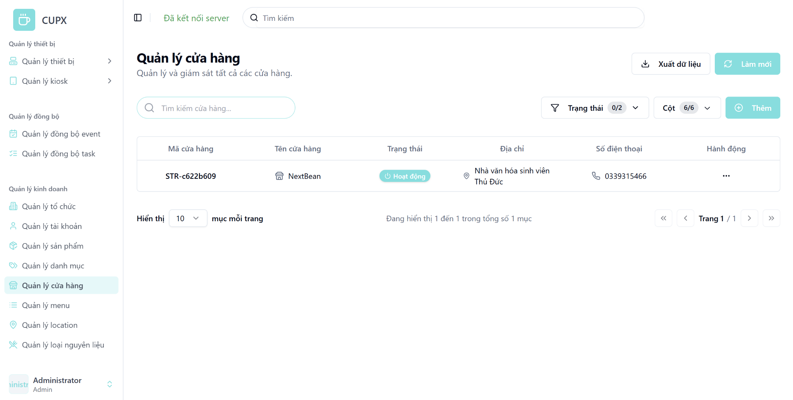
- Function details:
  - Data & Validation:
Data | Validations
StoreId | …
Name | …
ContactPhone | …
Address | …
Status | …
LocationAddress | ..
LocationType | ..
Status | …
CreatedDate | …
UpdatedDate | …

  - Functionalities:
Function | Normal Cases | Abnormal Cases
Access store list | Admin accesses the screen and views a paginated table of stores. | If the API fails, an error message is displayed with a retry option.
Search by keyword | Admin searches using name or store code. | If there is no result, display “No stores found.”
Apply filters | Admin filters by status or organization. | If invalid input or error, show warning and keep previous results.
Sort columns | Admin clicks column headers to sort. | If sort fails, fallback to default order and notify the user.
Pagination navigation | Admin uses pagination controls to navigate between pages (e.g., next, previous). | If the requested page index is invalid or unavailable, reset to page 1 with a warning.
Manual refresh | Admin clicks “Làm mới” to fetch latest data. | If refresh fails, show a retry error message.

  - Business Rules:

3.5.2 View detail of a store
- Function description:
  - Actors/Roles:
    - System Admin: Has full access to view store details across all organizations.
    - Organization Admin: Can only view details of stores that belong to their own organization.
  - Purpose: This screen allows administrators to view comprehensive details about a specific store, including identity, contact information, location, and organization linkage. It helps with verification, tracking, and auditing store-specific data.
  - Interface:
    - Basic Information Section:
      - Store Name
      - Description (if any)
      - Store Id (unique identifier)
    - Contact & Address Section:
      - Phone Number
      - Address
      - Location Type (if any)
    - Organization Information Section:
      - Associated Organization Name
    - Status Badge:
      - Visual display of store's operational status (e.g., “Hoạt động”)
    - Action Button:
      - Modal close button “X”
  - Data Processing:
    - The frontend sends a request with the store ID to the backend.
    - The backend returns full details of the selected store for display.
- Function trigger:
  - Navigation path:From the store list screen (“Quản lý cửa hàng”), admin clicks the "Hành động" button, then selects “Xem chi tiết”.
  - Modal Display:: A modal appears displaying detailed store data.
- Screen layout:
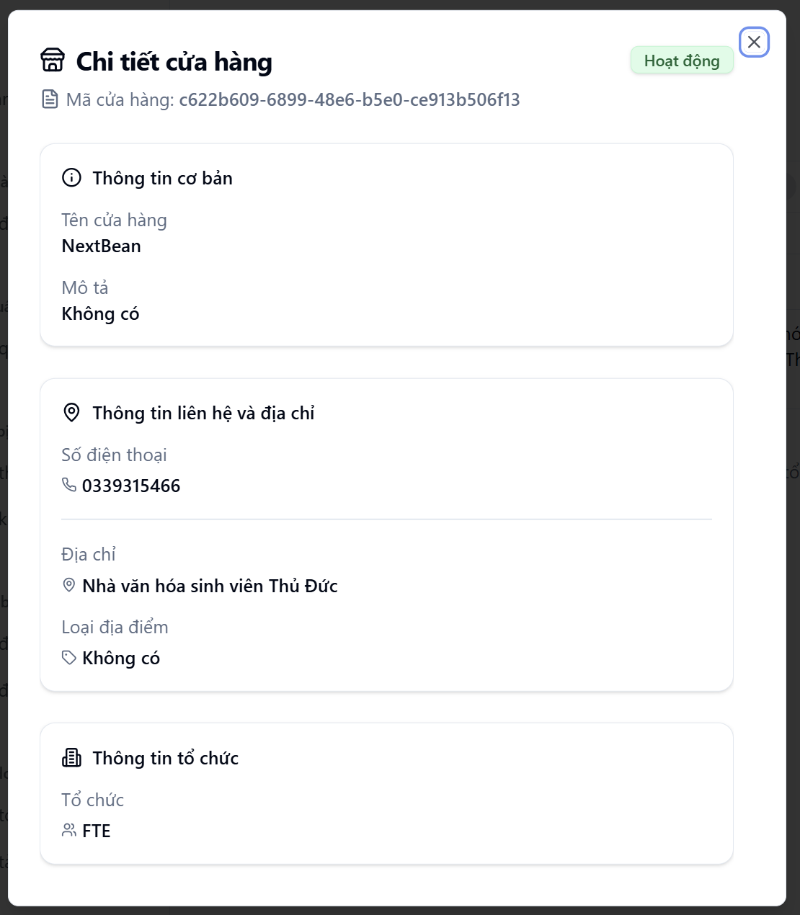
- Function details:
  - Data & Validation:
Data | Validations
StoreId | …
Name | …
ContactPhone | …
Address | …
Status | …
Organization | …
LocationAddress | ..
LocationType | ..
Status | …
Kiosks | ..
CreatedDate | …
UpdatedDate | …

  - Functionalities:
Function | Normal Cases | Abnormal Cases
Open store detail | Admin clicks “Xem chi tiết”, modal shows full information. | If the store is deleted/inaccessible, show “Store not found or permission denied.”
View basic information | Store name, code, description displayed clearly. | If missing/null, show “N/A” or leave blank.
View contact/address | Phone number and address are shown. | If null/invalid, show placeholder or default icons.
View organization link | Displays the associated organization name. | If data is missing, show “Unknown organization.”
Display status badge | Status shown via styled badge (e.g., Active in green). | If status is unrecognized/null, show the “Unknown” badge.
Close modal | Admin clicks “×” or presses ESC to close the modal. | If modal fails, allow escape fallback or reload UI.

  - Business Rules:

3.5.3 Create a store
- Function description:
  - Actors/Roles:
    - System Admin: Has full access to create new stores in any organization.
    - Organization Admin: No access to this feature.
  - Purpose: This screen enables administrators to add a new store to the system. It collects information such as store name, phone number, address, organization affiliation, operational status, location type, and description. The goal is to register and activate store units into the system.
  - Interface:
    - Store Metadata Section:
      - Store Name: Required input for identifying the store.
      - Organization: Dropdown to select the owning organization.
      - Status: Dropdown with values (e.g., Active, Inactive).
      - Location Type: Dropdown to choose the store's physical context.
    - Contact Information Section:
      - Phone Number: Input for contact number.
      - Address: Input for the physical address.
    - Description Section:
      - Free-text field for any store-related notes or comments.
    - Action Button
      - Modal close button “X”
      - “Tạo” (Create): Submits the form to the backend.
      - “Hủy” (Cancel): Closes modal without saving.
  - Data Processing:
    - The frontend collects the input values and sends a request to backend
- Function trigger:
  - Navigation path: Admin navigates to “Quản lý cửa hàng” and clicks the “Thêm” button to open the modal.
  - Modal Display: A modal opens, showing a form with input fields.
- Screen layout:
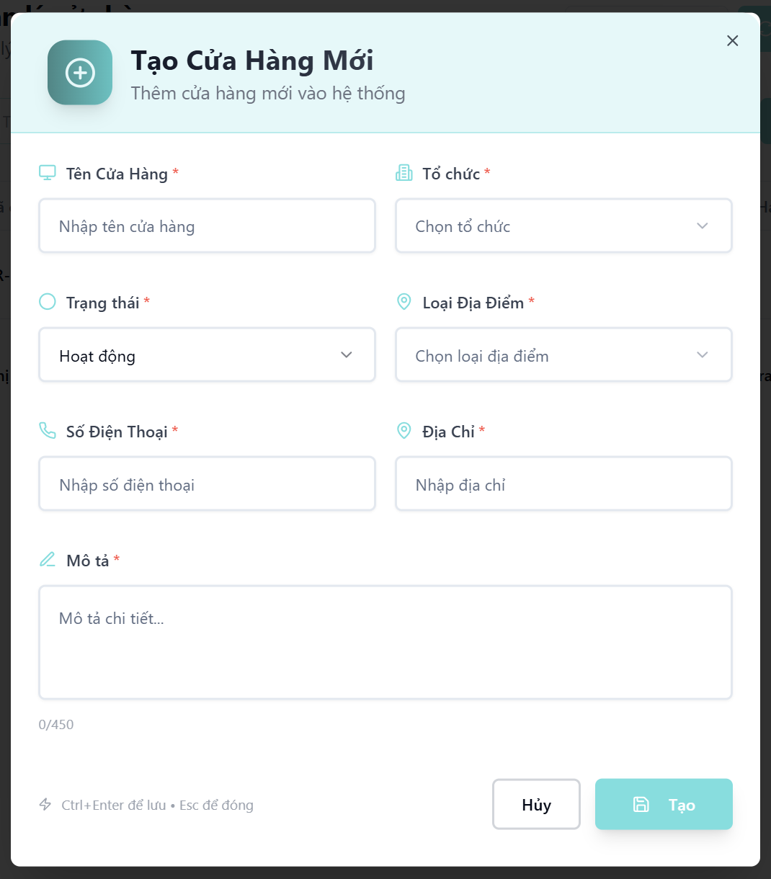
- Function details:
  - Data & Validation:
Data | Validations
Name | Required. Max length: 100 characters
Description | Optional. Max length: 450 characters
ContactPhone | Required. Max length: 100 characters
Address | Required. Max length: 255 characters
Status | Required. Enum: Active/Inactive. Max 10 chars
Organization | Required. Must be valid and accessible
LocationAddress | Required. Max length: 255 characters
LocationType | Required. Must be from predefined enum
CreatedDate | Auto-generated

  - Functionalities:
Function | Normal Cases | Abnormal Cases
Open creation modal | Admin clicks “Thêm”, modal form opens with empty fields. | If modal fails to load, show error or fallback to full-page form.
Input store info | Admin fills in name, status, location type, and description. | If required fields are empty, show inline validation error.
Input contact data | Admin inputs a valid phone number and address. | If the format is incorrect, block submission with clear error messages.
Select organization | Admin selects from a list of available organizations. | If the organization is null or the user lacks access, block and notify.
Submit creation | Admin clicks “Tạo”; form is validated and POST request is sent. | If API fails, show error toast and preserve user inputs for retry.
Cancel/Close modal | Admin presses ESC, clicks “×” or “Hủy”. | If modal can’t close, allow forced escape or fallback reload.

  - Business Rules:

3.5.4 Update a store
- Function description:
  - Actors/Roles:
    - System Admin: Has full access to update any store's information.
    - Organization Admin: No access to this feature.
  - Purpose: This screen allows administrators to update store information such as name, contact info, address, status, organization, location type, and description. This helps keep the store data accurate and current within the system.
  - Interface:
    - Editable Fields Section:
      - Store Name
      - Organization (dropdown)
      - Status (dropdown: Active/Inactive)
      - Location Type (dropdown)
      - Phone Number
      - Description
      - Address
    - Action Button
      - Modal close button “X”
      - “Cập nhật” (Update): Saves the updated store data.
      - “Hủy” (Cancel): Closes the modal without saving.
  - Data Processing:
    - The frontend gathers updated data and sends a PUT request to the backend API to persist the changes.
- Function trigger:
  - Navigation path: From the "Quản lý cửa hàng" screen, admin clicks the “Hành động” menu and selects “Chỉnh sửa” to open the modal.
  - Modal Display:The update modal opens with all fields pre-filled with the store’s current data.
- Screen layout:
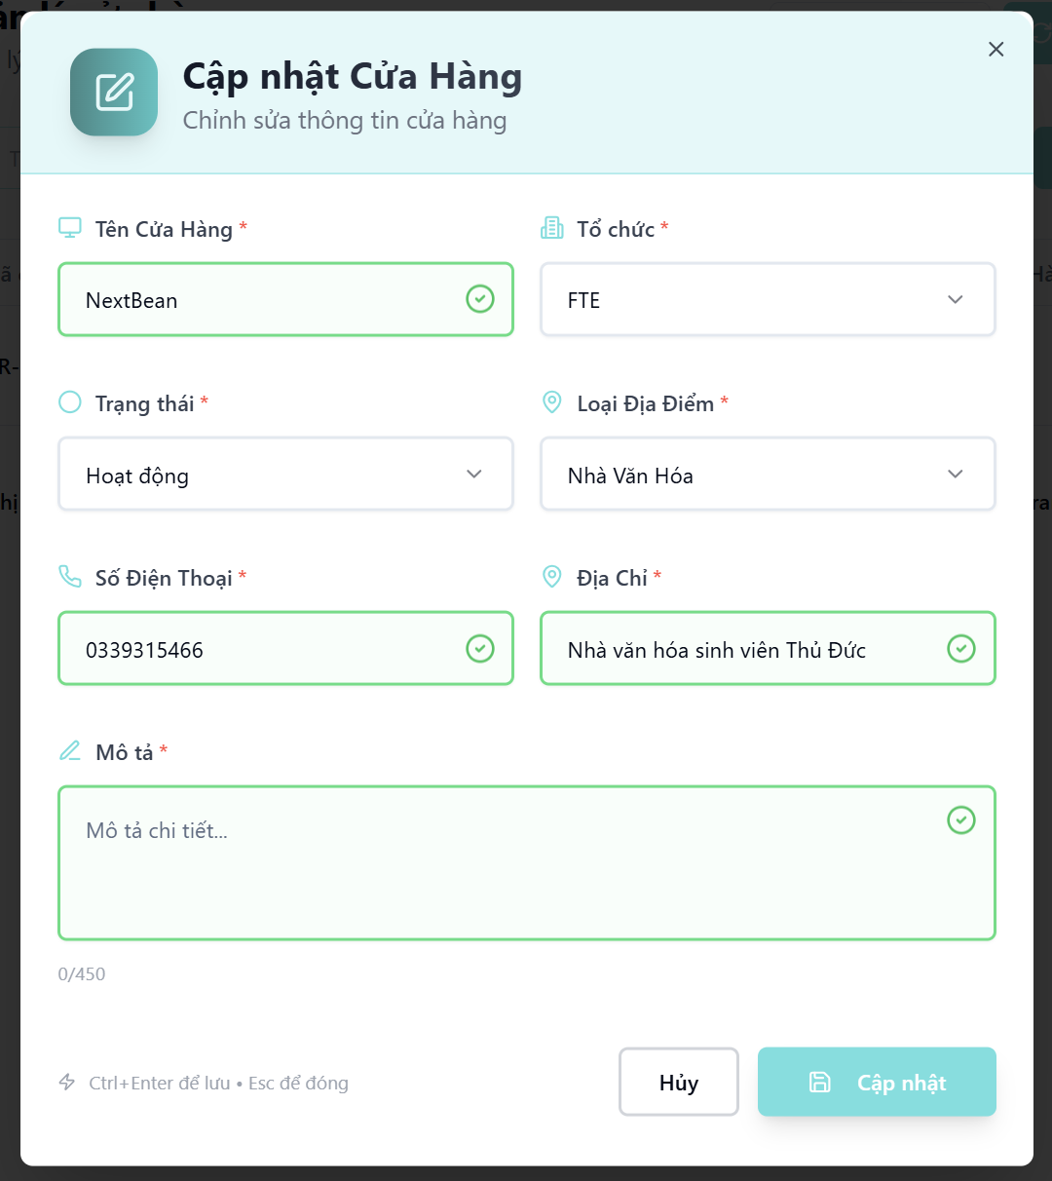
- Function details:
  - Data & Validation:
Data | Validations
Name | Required. Max length: 100 characters
Description | Optional. Max length: 450 characters
ContactPhone | Required. Max length: 100 characters
Address | Required. Max length: 255 characters
Status | Required. Enum: Active/Inactive. Max 10 chars
Organization | Required. Must be valid and accessible
LocationAddress | Required. Max length: 255 characters
LocationType | Required. Must be from predefined enum
CreatedDate | Auto-generated

  - Functionalities:
Function | Normal Cases | Abnormal Cases
Open update modal | Admin clicks “Chỉnh sửa” in action “Hành động”, modal form opens with empty fields. | If modal fails to load, show error or fallback to full-page form.
Input store info | Admin fills in name, status, location type, and description. | If required fields are empty, show inline validation error.
Input contact data | Admin inputs a valid phone number and address. | If the format is incorrect, block submission with clear error messages.
Select organization | Admin selects from a list of available organizations. | If the organization is null or the user lacks access, block and notify.
Submit update | Admin clicks “Cập nhật”; form is validated and a Put request is sent. | If API fails, show error toast and preserve user inputs for retry.
Cancel/Close modal | Admin presses ESC, clicks “×” or “Hủy”. | If modal can’t close, allow forced escape or fallback reload.

  - Business Rules:

3.5.5 Delete a store
- Function description:
  - Actors/Roles:
    - System Admin: Has full permission to delete stores.
    - Organization Admin: No access to this feature.
  - Purpose: This function allows a system administrator to immediately delete an stores from the system with a single action.
  - Interface:
    - The Delete option is located inside the “Hành động” (Action) dropdown on the View List of Stores screen.
    - No confirmation modal is shown — clicking “Xóa” (Delete) will immediately trigger the delete operation.
    - After deletion, the store is removed from the list UI.
  - Data Processing:
    - A DELETE request is sent to the backend with the store ID.
    - The server performs the deletion (soft/hard based on implementation) and returns success or failure.
    - The frontend updates the list by removing the deleted item.
    - Error toast is displayed in case of API failure (e.g., 403, 500).
- Function trigger:
  - Navigation path: From the left sidebar, admin selects the “Xóa” button from the “Hành động” dropdown.
- Layout:
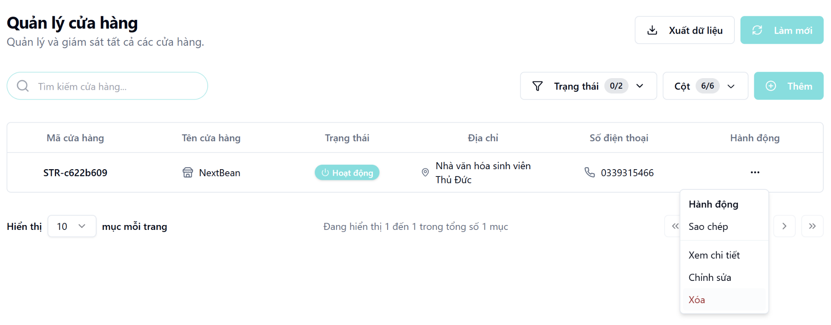

3.6 Account Management Screen

3.6.1 View list of accounts
- Function description:
  - Actors/Roles:
    - System Admin: Has full access to view and manage all accounts in the system.
    - Organization Admin: Can not access this feature
  - Purpose: This screen provides administrators with a comprehensive view of all user accounts registered in the system, including their status, role, and organization affiliation.
  - Interface:
    - Table: Displays a structured, paginated list of all organization with following columns:
      - Account ID
      - Account Name
      - Role
      - Status
      - Is Locked
      - Action
    - Optional UI Element:
      - Search bar
      - Filter dropdowns
      - Pagination controls
      - Column visibility configuration
      - “Làm mới” (Refresh) button
      - “Xuất dữ liệu” button
  - Data Processing:
    - Backend returns a list of accounts based on search, filter, sort, and pagination parameters from the client.
- Function trigger:
  - Navigation path: Admin accesses the account list by clicking the “Quản lý tài khoản” menu item in the sidebar.
  - Timing Frequency: Data is auto-refresh every 60 seconds, or manually via browser reload or clicking button “Làm mới”
- Screen layout:
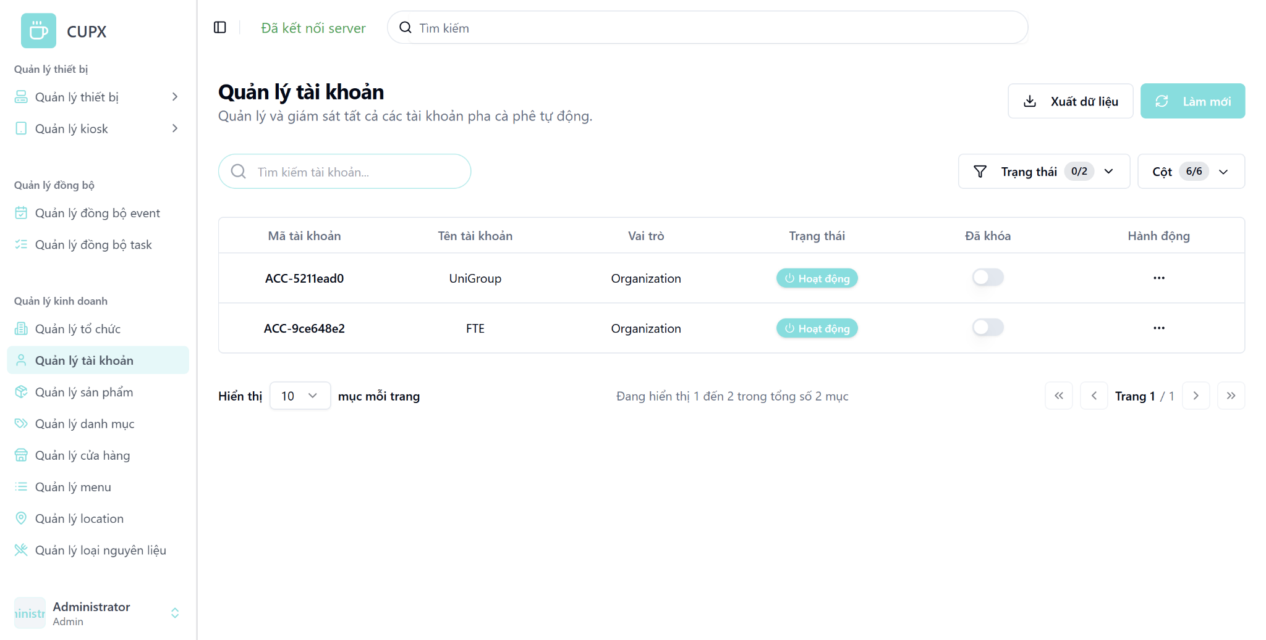
- Function details:
  - Data & Validation:
Data | Validations
AccountId | …
AccountName | …
Role | …
Status | …
IsLocked | …
OrganizationId | ..
CreatedDate | …
UpdatedDate | …

  - Functionalities:
Function | Normal Cases | Abnormal Cases
Access account list | Admin opens the screen and sees the full account list in a table. | If the API fails, show an error message with a retry option.
Search by keyword | Admin uses a search bar to find accounts by name or ID. | If no results are found, show “No accounts found.”
Apply filters | Admin applies filters (e.g., status), and the list updates accordingly. | If the filter causes an error, retain previous results and show a warning.
Sort columns | Admin clicks column headers to sort ascending/descending. | If sorting fails, fallback to default sort and notify the user.
Pagination navigation | Admin clicks to the next/prev page using controls. | If the page index is invalid, reset to the first page and show a warning.
Manual refresh | Admin clicks “Làm mới” to fetch latest data. | If refresh fails, show a retry error message.

  - Business Rules:

3.6.2 View detail of accounts
- Function description:
  - Actors/Roles:
    - System Admin: Has full access to view store details across all organizations.
    - Organization Admin: Can only view details of stores that belong to their own organization.
  - Purpose: This screen allows administrators to view detailed information about a user account, including identity, role, and linked organization, enabling effective account management, auditing, and validation.
  - Interface:
    - Account Information Section:
      - Full Name (Họ tên)
      - Email
      - Role (e.g., “Organization”)
      - Account ID
    - Organization Information Section:
      - Organization Name
      - Organization Code
      - Organization Email
      - Phone Number
      - Tax Code
    - Status Badge:
      - Display account status (e.g., “Hoạt động”).
    - Action Button:
      - Modal close button “X”
  - Data Processing:
    - The frontend sends a request with the store ID to the backend.
    - The backend returns full details of the selected store for display.
- Function trigger:
  - Navigation path:Admin opens the "Account Management" page (“Quản lý tài khoản”), clicks the “...” Action dropdown on an account row, then selects “Xem chi tiết”.
  - Modal Display: A modal window opens with the account's full data.
- Screen layout:
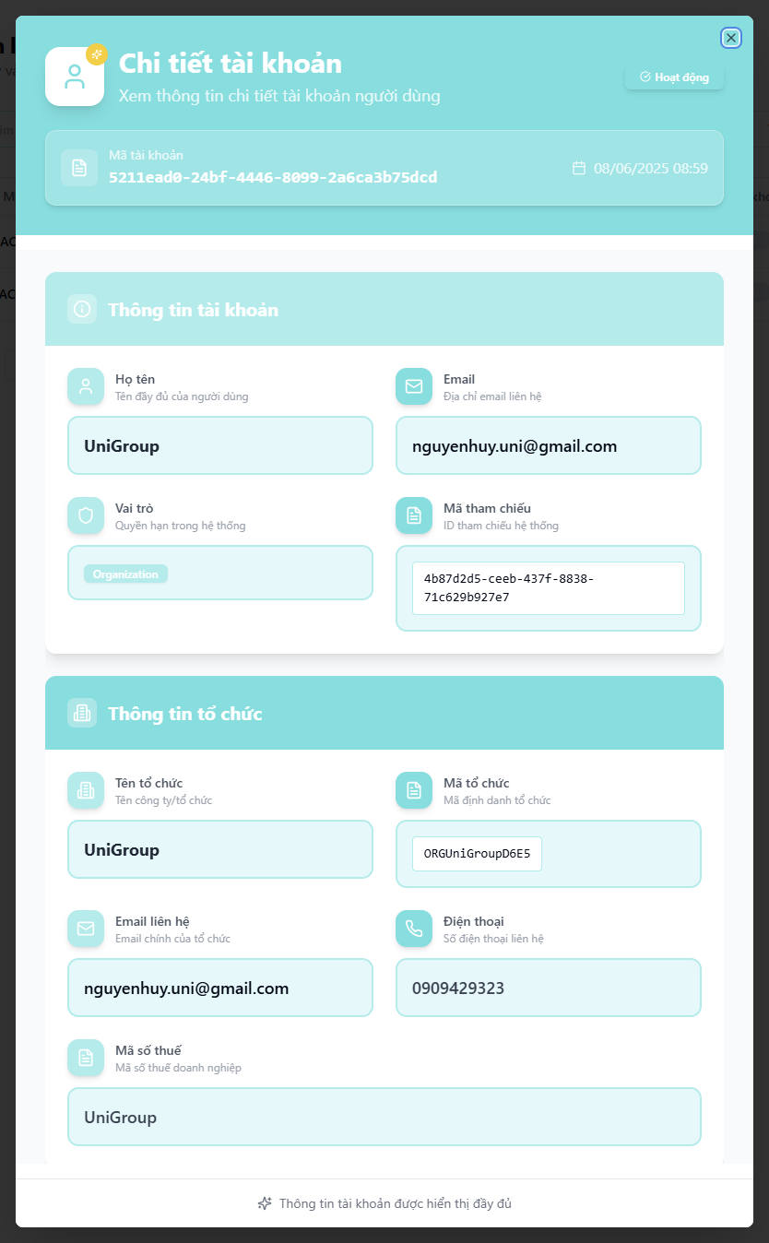
- Function details:
  - Data & Validation:
Data | Validations
AccountId | …
FullName | …
Email | …
Role | …
OrganizationName | …
OrganizationCode | ..
OrganizationEmail | …
OrganizationPhone | …
TaxCode | …
Status | …
CreatedDate | …
UpdatedDate | …

  - Functionalities:
Function | Normal Cases | Abnormal Cases
Open account detail | Admin selects “Xem chi tiết”, modal opens with account data | If the account is deleted/inaccessible, show “Account not found or permission denied.”
View identity info | Full name, role, and ID are shown clearly | If any field is missing/null, fallback to “N/A”
View email | Email shown as contact method | If invalid/missing, show placeholder
View organization | Organization name/code/email/phone/tax are listed | If linked organization not found, show “Unknown organization”
Display status | Status shown as badge (e.g., Active in green) | If status unknown/null, show “Unknown” badge
Close modal | Click "×" or ESC key to close modal | If modal fails, allow escape fallback or reload UI

  - Business Rules:

3.7 Product Management Screen

3.7.1 View list of products
- Function description:
  - Actors/Roles:
    - System Admin: Full access to all product data across the system.
    - Organization Admin: Can only view products assigned in their menu
  - Purpose: This function allows administrators to view and monitor the list of available products in the system with relevant details like type, price, category, and availability status.
  - Interface:
    - Table: Displays a structured, paginated list of all organization with following columns:
      - Product Id
      - Product Name
      - Product Type
      - Price
      - Category
      - Workflow status
      - Status badge
      - Created Date
      - Updated Date
      - Action
    - Optional UI Element:
      - Search bar
      - Filter dropdowns
      - Pagination controls
      - Column visibility configuration
      - “Làm mới” (Refresh) button
      - “Xuất dữ liệu” button
  - Data Processing:
    - Server returns for the client a list of products based on filter, search, sort and paging.
- Function trigger:
  - Navigation path: Admin access the table of list product via the left sidebar by clicking the “Quản lý sản phẩm” menu item.
  - Timing Frequency: Data is auto-refresh every 60 seconds, or manually via browser reload or clicking button “Làm mới”
- Screen layout:
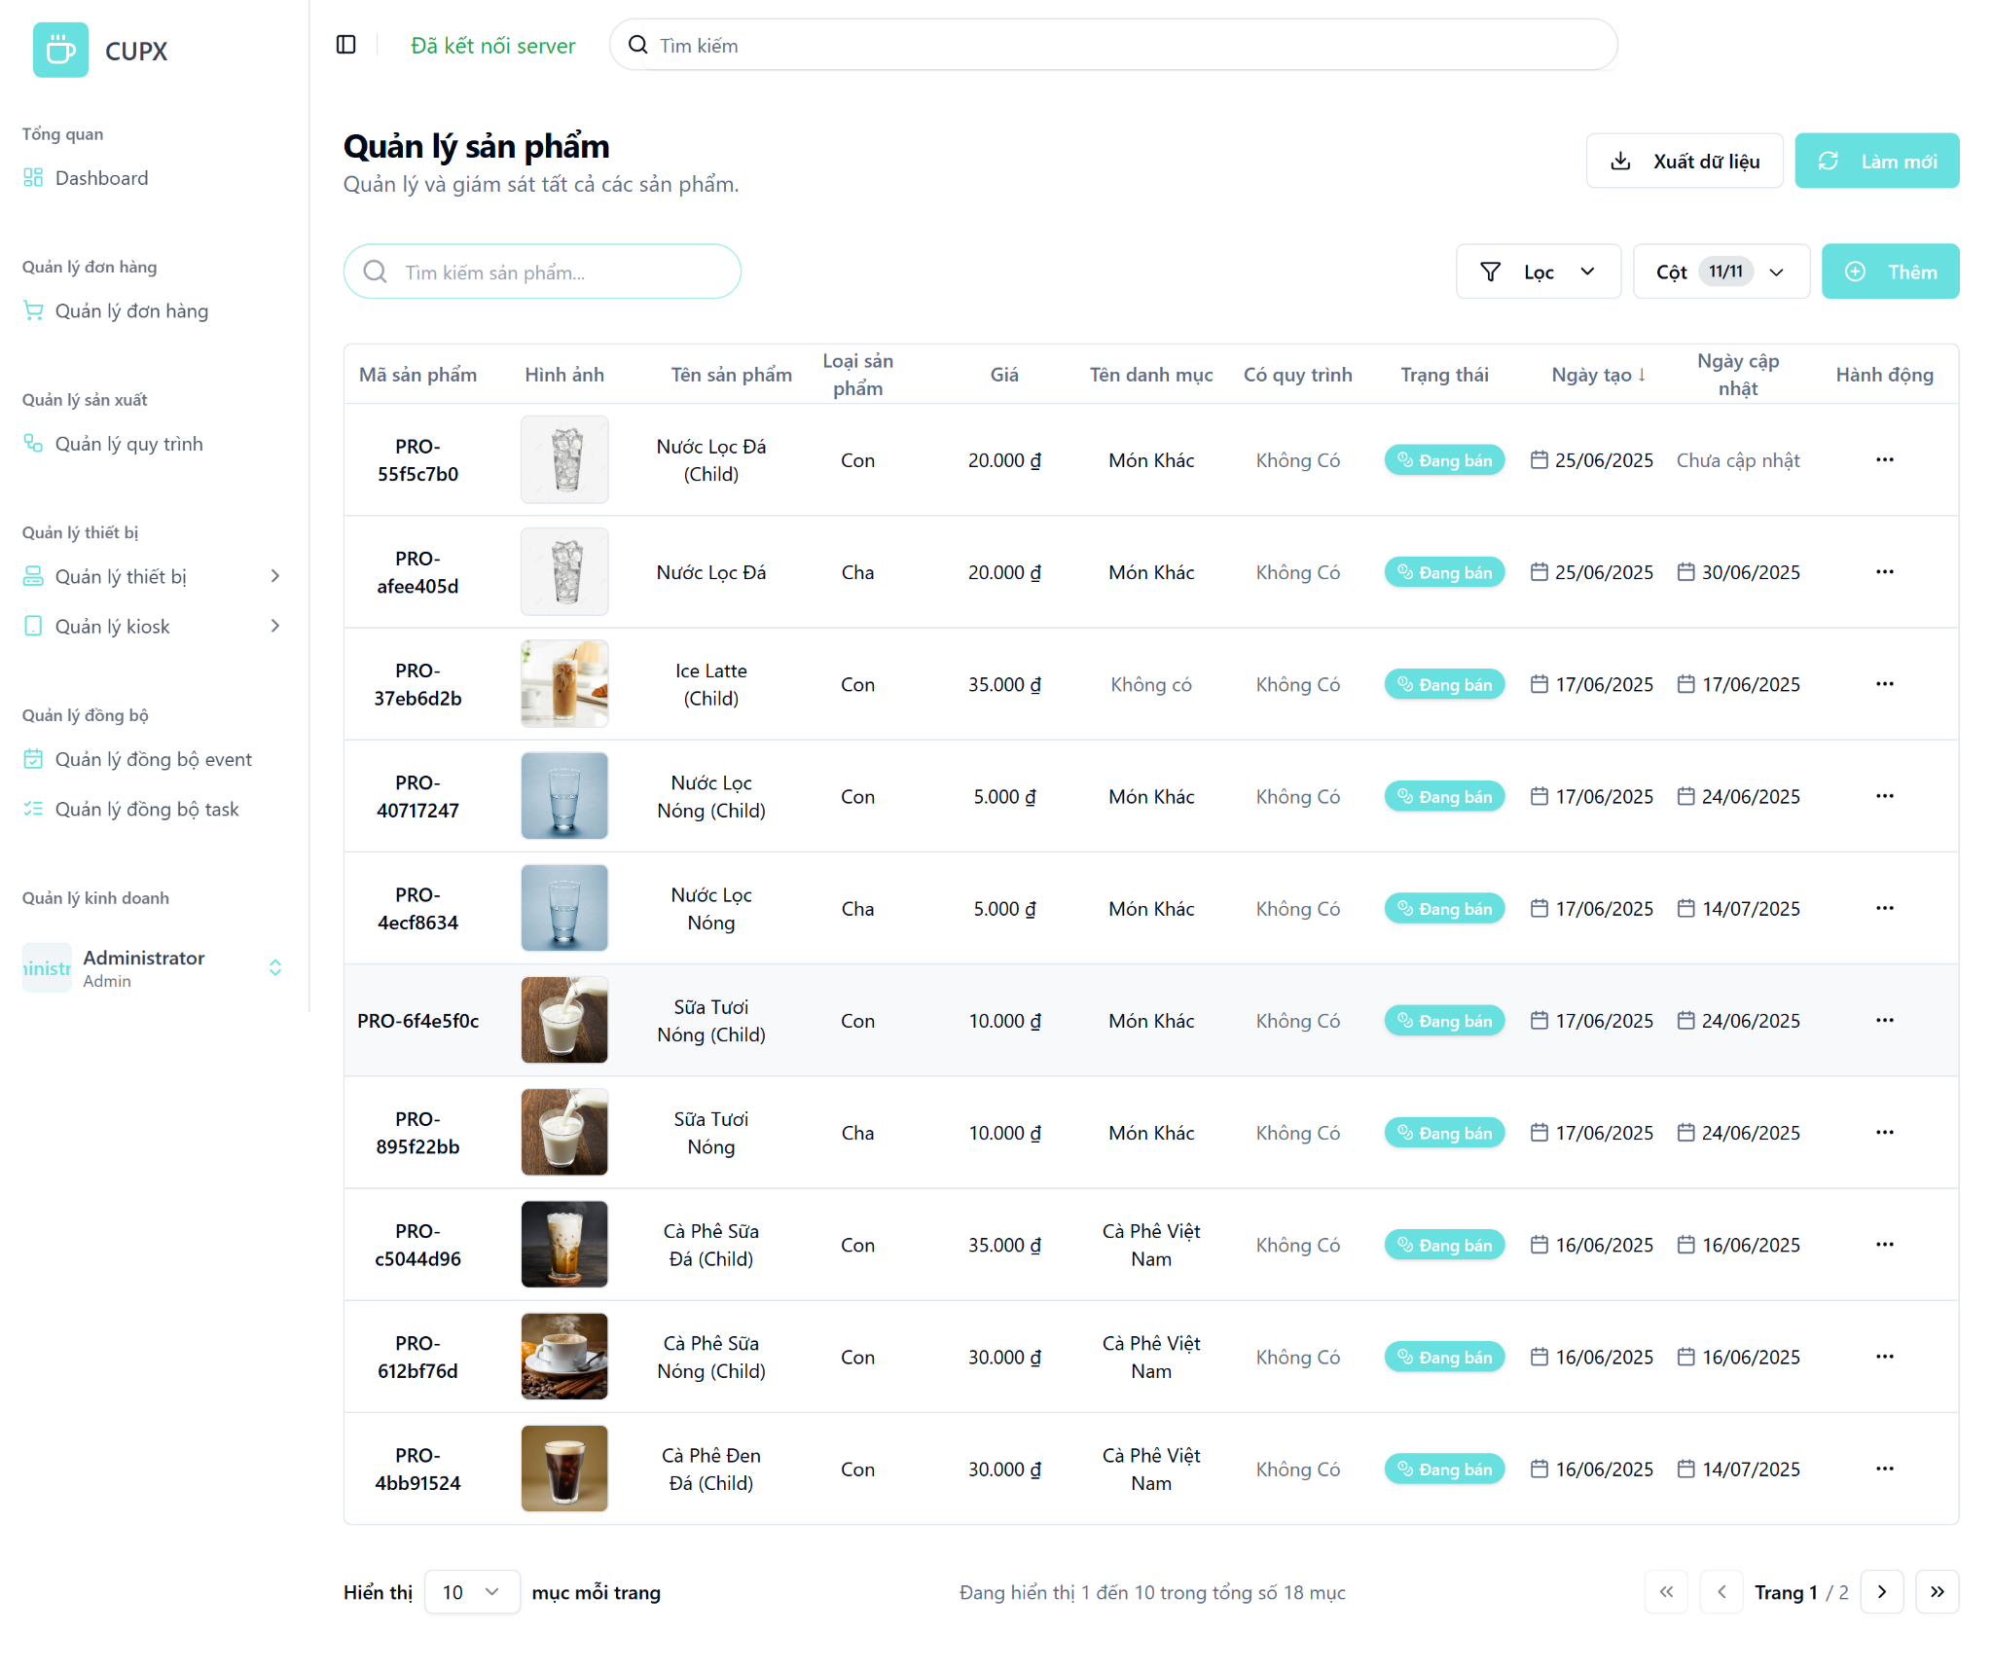
- Function details:
  - Data & Validation:
Data | Validations
ProductId | …
Name | …
ImageUrl | …
ProductType | …
Price | …
Category | …
LocationAddress | …
HasWorkflow | …
Status | …
CreatedDate | …
UpdatedDate | …

  - Functionalities:
Function | Normal Cases | Abnormal Cases
Access product list | Admin opens the screen and views the paginated product table. | If the API fails, show an error message with a retry option.
Search by keyword | Admin types product name or code into search bar to filter results. | If no result, display “Không tìm thấy sản phẩm.”
Apply filters | Admin filters by product status, workflow, or category. | If input is invalid, show warning and keep the last valid state.
Sort columns | Clicking headers sorts by Name, Price, Created Date, etc. | If sort fails, fallback to default sort and alert user.
Pagination navigation | Admin uses pagination arrows or jumps to page number. | If page is out of range, reset to page 1 with a warning.
Manual refresh | Admin clicks “Làm mới” to reload the product list. | If reload fails, display toast with a retry option.

  - Business Rules:

3.7.2 View detail of a product
- Function description:
  - Actors/Roles:
    - System Admin: Has full access to view product details across the system.
    - Organization Admin: Can only view details of products within their organization.
  - Purpose: This function allows administrators to view comprehensive information about a specific product, including pricing, classification, image, and timestamps. It supports validation, auditing, and product management processes.
  - Interface:
    - Basic Information Section:
      - Product Name
      - Parent Product
      - Size
      - Product Type (e.g., Cha)
      - Description (optional)
    - Pricing & Status Section:
      - Price (formatted with currency)
      - Active Status badge (e.g., "Đang bán", "Không")
    - Image Section:
      - Preview image (with URL if available)
    - Status Badge:
      - Display account status (e.g., “Hoạt động”).
    - Timestamp Section:
      - Created Date
      - Updated Date
    - Action Button:
      - Modal close button “X”
  - Data Processing:
    - Frontend sends a request to the backend using the product ID.
    - Backend returns all product information in detail.
- Function trigger:
  - Navigation path: “Quản lý sản phẩm” screen, admin clicks on the “Hành động” button, then selects “Xem chi tiết”.
  - Modal Display: A modal opens with all the product information divided into separate logical cards.
- Screen layout:
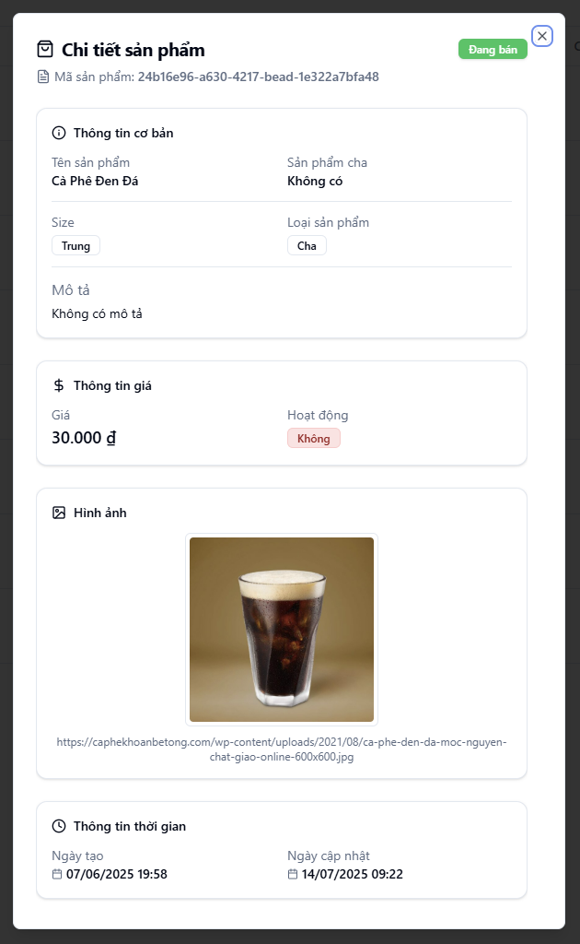
- Function details:
  - Data & Validation:
Data | Validations
ProductId | …
Name | …
ParentProduct | …
Size | …
Type | …
Description | ..
Price | …
Status | …
ImageUrl | …
CreatedDate | …
UpdatedDate | …

  - Functionalities:
Function | Normal Cases | Abnormal Cases
Open product detail | Admin clicks “Xem chi tiết” and modal opens showing full product details. | If the product is deleted or not found, show error: “Product not found.”
View basic information | Product name, type, parent, and description are shown clearly. | If missing data, show “Không có” or placeholder text.
View price & status | Price shown with proper currency formatting and badge shows active state. | If the price is null or invalid, show “N/A”.
View image | Product image is previewed, and full URL is visible. | If the image is broken/missing, fallback to the default image or icon.
View timestamps | Dates are formatted and presented clearly under “Thông tin thời gian”. | If update date is null, show “Chưa cập nhật”.
Close modal | Admin clicks the “×” button to close. | If modal fails to close, allow ESC fallback or click outside to dismiss.

  - Business Rules:

3.7.3 Create a product
- Function description:
  - Actors/Roles:
    - System Admin: Can create products for all organizations.
    - Organization Admin: Can create products only within their assigned organization.
  - Purpose: This function allows administrators to create a new product with detailed attributes including name, type, size, pricing, status, and associated ingredients.
  - Interface:
    - Fields include:
      - Product Image Upload
      - Product Name
      - Parent Product
      - Size
      - Product Type
      - Status
      - Price
      - Active flag
      - Category/Tag
      - Description
      - Product Ingredients Section
        - Each ingredient includes:
          - Label
          - Ingredient type
          - Description
          - Default quantity
          - Display order
          - Unit.
    - Contact Information Section:
      - Phone Number: Input for contact number.
      - Address: Input for the physical address.
    - Description Section:
      - Free-text field for any store-related notes or comments.
    - Action Button
      - Modal close button “X”
      - “Tạo” (Create): Submits the form to the backend.
      - “Hủy” (Cancel): Closes modal without saving.
  - Data Processing:
    - When the admin submits the form, the frontend validates input data and sends it to the backend.
    - Backend persists the new product and returns success/failure response.
    - Upon success, modal closes and the product list is refreshed.
- Function trigger:
  - Navigation path: From the “Quản lý sản phẩm” screen, admin clicks the “Thêm” button.
  - Modal Display: A modal opens, showing a form with input fields.
- Screen layout:
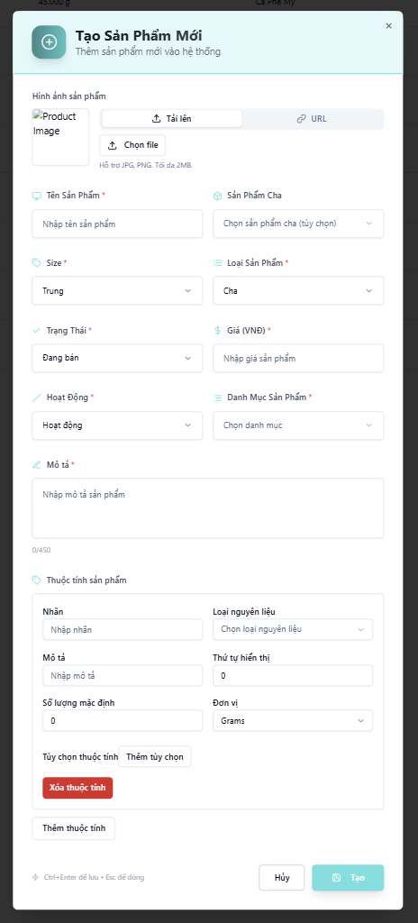
- Function details:
  - Data & Validation:
Data | Validations
ProductId | Auto-generated by backend
Name | Required, max 255 characters
ParentProduct | Optional, must refer to existing product
Size | Optional, select from predefined options
ProductType | Required, Enum ("Cha", "Con")
Status | Required, Enum ("Đang bán", "Ngừng bán")
Price | Required, positive number, displayed in VND
IsActive | Boolean, required
Description | Optional, max 450 characters
Category | Optional, must match predefined categories
Image | Optional, must be JPG or PNG, max 2MB
Ingredient.Label | Optional, text
Ingredient.Type | Required, must be in IngredientType list
Ingredient.Description | Optional
Ingredient.DefaultQty | Required, numeric
Ingredient.Unit | Required, enum ("Grams", "Milliliters", etc.)
Ingredient.Order | Optional, numeric, defines ingredient sort order
CreatedDate | Auto-set by backend

  - Functionalities:
Function | Normal Cases | Abnormal Cases
Open creation modal | Admin clicks “Thêm”, modal opens for product entry. | If modal fails to open, show error notification.
Fill form | Admin enters product info including ingredients. | If required fields are missing, prevent submission and show error.
Upload image | Admin uploads JPG/PNG or provides URL. | If file size > 2MB or wrong format, show error and reject upload.
Add ingredients | Admin adds multiple attributes (ingredient type, label, etc.). | If duplicate or invalid values, show inline warnings.
Submit creation | Click “Tạo” sends data to backend and closes modal on success. | If the backend returns an error (e.g. validation fails), show an inline error message.
Cancel/Close modal | Admin clicks “Hủy” to close modal without saving. | If modal fails to close, allow fallback via ESC.

  - Business Rules:

3.7.4 Update a product
- Function description:
  - Actors/Roles:
    - System Admin: Can update any product across all organizations.
    - Organization Admin: Can update products within their organization.
  - Purpose: This function allows administrators to edit product information such as name, price, status, category, ingredients, and more.
  - Interface:
    - Editable Fields Section:
      - Product Image Upload
      - Product Name
      - Parent Product
      - Size
      - Product Type
      - Status
      - Price
      - Active flag
      - Category/Tag
      - Description
      - Product Ingredients Section
        - Each ingredient includes:
          - Label
          - Ingredient type
          - Description
          - Default quantity
          - Display order
          - Unit.

    - Action Button
      - Modal close button “X”
      - “Cập nhật” (Update): Saves the updated product data.
      - “Hủy” (Cancel): Closes the modal without saving.
  - Data Processing:
    - The frontend gathers updated data and sends a PUT request to the backend API to persist the changes.
- Function trigger:
  - Navigation path: From the product list (“Quản lý sản phẩm”), admin clicks the “Hành động” button, then selects “Chỉnh sửa”.
  - Modal Display:The update modal opens with all fields pre-filled with the store’s current data.
- Screen layout:
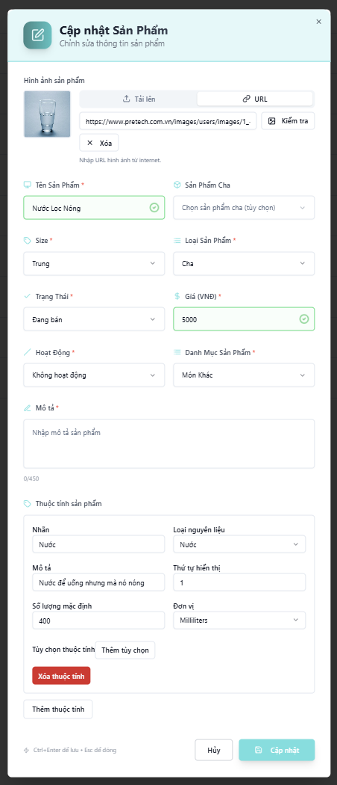
- Function details:
  - Data & Validation:
Data | Validations
Name | Required, max 255 characters
ParentProduct | Optional, must refer to existing product
Size | Optional, select from predefined options
ProductType | Required, Enum ("Cha", "Con")
Status | Required, Enum ("Đang bán", "Ngừng bán")
Price | Required, positive number, displayed in VND
IsActive | Boolean, required
Description | Optional, max 450 characters
Category | Optional, must match predefined categories
Image | Optional, must be JPG or PNG, max 2MB
Ingredient.Label | Optional, text
Ingredient.Type | Required, must be in IngredientType list
Ingredient.Description | Optional
Ingredient.DefaultQty | Required, numeric
Ingredient.Unit | Required, enum ("Grams", "Milliliters", etc.)
Ingredient.Order | Optional, numeric, defines ingredient sort order
UpdatedDate | Auto-set by backend

  - Functionalities:
Function | Normal Cases | Abnormal Cases
Open edit modal | Admin clicks “Chỉnh sửa” and sees pre-filled modal | Modal fails to open → show error popup
Modify product info | Admin edits product name, price, etc. and submits | Missing required fields → show inline error
Modify ingredients | Admin edits attributes, adds/removes ingredients | Invalid or duplicated ingredient → show error
Upload or change image | File selected or URL provided → image preview updates | Invalid format/oversized file → show validation error
Submit creation | Backend updates and returns success → modal closes, list updates | Backend error → show message, keep modal open
Cancel/Close modal | Admin clicks “Hủy” or presses Esc to close without saving | Modal stuck → allow ESC fallback or reload

  - Business Rules:

3.7.5 Delete a product
- Function description:
  - Actors/Roles:
    - System Admin: Has full access to delete any product in the system.
    - Organization Admin: Can delete products within their assigned organization.
  - Purpose: This function allows administrators to permanently delete a product from the system with a single action, helping maintain a clean and accurate product list.
  - Interface:
    - The Delete option is located inside the "Hành động" (Action) dropdown on the product list screen.
    - No confirmation modal is shown — clicking "Xóa" will immediately trigger the deletion process and remove the product.
    - The deleted product will disappear from the table after the operation.
  - Data Processing:
    - Frontend sends a DELETE request to the backend API with the product ID.
    - Backend verifies permission, deletes product record, and returns success status.
    - On success, frontend refreshes the list to remove the deleted product.
    - Error toast is displayed in case of API failure (e.g., 403, 500).
- Function trigger:
  - Navigation path: From the sidebar, admin selects “Quản lý sản phẩm” to open the product management screen.
- Layout:
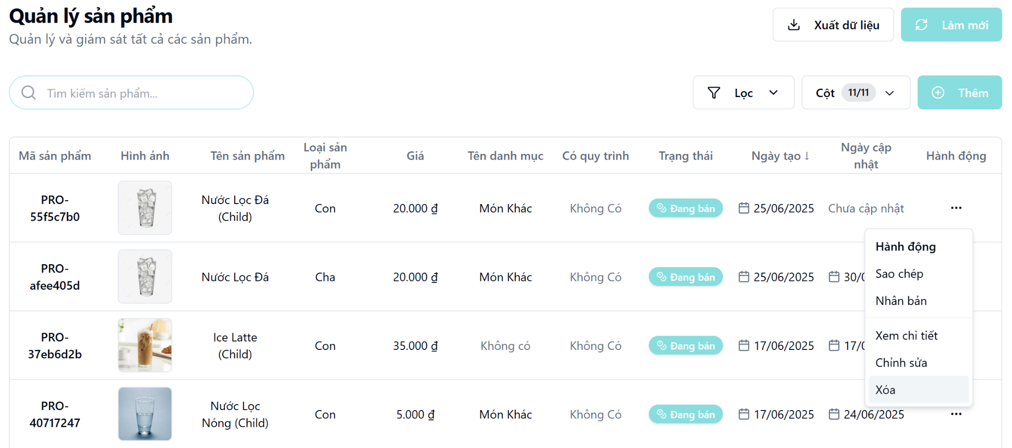

3.8 Menu Management Screen

3.8.1 View list of menus
- Function description:
  - Actors/Roles:
    - System Admin: Full access to all menu data across the system.
    - Organization Admin: Can only view menus assigned to their organization.
  - Purpose: This function allows administrators to view and monitor the list of available menus in the system with relevant details like name, associated organization, and status.
  - Interface:
    - Table: Displays a structured, paginated list of all menus with the following columns:
      - Mã menu (Menu ID)
      - Tên (Name)
      - Tên tổ chức (Organization Name)
      - Trạng thái (Status)
      - Hành động (Action)
    - Optional UI Element:
      - Search bar (Tìm kiếm tên menu...)
      - Filter dropdowns (Trạng thái - Status)
      - Pagination controls
      - Column visibility configuration (Cột - Columns)
      - “Làm mới” (Refresh) button
      - “Xuất dữ liệu” (Export data) button
      - “Thêm” (Add) button
  - Data Processing:
    - The server returns a list of menus for the client based on filter, search, sort, and paging parameters.
- Function trigger:
  - Navigation path: Admin accesses the table of the list of menus via the left sidebar by clicking the “Quản lý menu” (Menu Management) menu item.
  - Timing Frequency: Data is auto-refreshed periodically (e.g., every 60 seconds), or manually via browser reload or by clicking the “Làm mới” button.
- Screen layout:
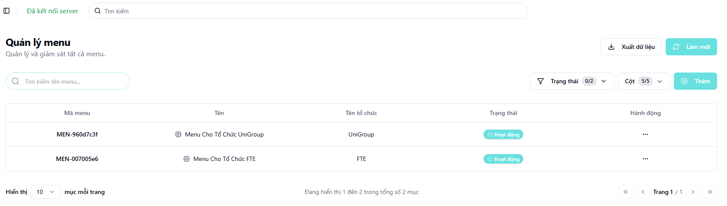
- Function details:
  - Data & Validation:
Data | Validations
MenuId | Auto-generated, unique identifier
Name | Required, textx
Organization | Required, refers to an existing organization
ProductType | Required, Enum ("Cha", "Con")
Status | Required, Enum ("Hoạt động" - Active, "Không hoạt động" - Inactive).
CreatedDate | Auto-set by the backend
UpdatedDate | Auto-set by the backend on update

  - Functionalities:
Function | Normal Cases | Abnormal Cases
Access menu list | Admin opens the screen and views the paginated menu table | If the API fails, show an error message with a retry option.
Search by keyword | Admin types a menu name into the search bar to filter results | If no results are found, display a message like “Không tìm thấy menu.”
Apply filters | Admin filters the list by menu status (Trạng thái) | If the filter input is invalid, show a warning and keep the last valid state
Pagination navigation | Admin uses pagination arrows or jumps to a specific page number | If the requested page is out of range, reset to page 1 with a warning
Manual refresh | Admin clicks the “Làm mới” button to reload the menu list | If the reload fails, display a notification toast with a retry option
- Business Rules:
  - Organization Admins can only view menus associated with their own organization.

3.8.2 View detail of a menu
- Function description:
  - Actors/Roles:
    - System Admin: Has full access to view menu details across the system.
    - Organization Admin: Can only view details of menus within their organization.
  - Purpose: This function allows administrators to view comprehensive information about a specific menu, including its description, status, and the list of products it contains
  - Interface:
    - Menu Information Section (Thông tin Menu):
      - Mã menu (Menu Code)
      - Tên menu (Menu Name)
      - Mô tả (Description)
      - Trạng thái (Status badge, e.g., "Hoạt động" - Active)
    - Product List Section ( A table listing all products in the menu with columns:
      - Hình ảnh (Image)
      - Tên sản phẩm (Product Name)
      - Giá (VND) (Price)
      - Thứ tự (Order)
      - Thao tác (Action - e.g., delete product from menu)
    - Action Button:
      - “Cập nhật” (Update) button to open the edit modal.
  - Data Processing:
    - The frontend sends a request to the backend using the menu ID.
    - The backend returns all menu information in detail, including the list of associated products.
- Function trigger:
  - Navigation path: From the “Quản lý menu” screen, the admin clicks on the “Hành động” (Action) button, then selects “Xem chi tiết” (View Detail).
  - The system navigates to a new page displaying the menu details.
- Screen layout:
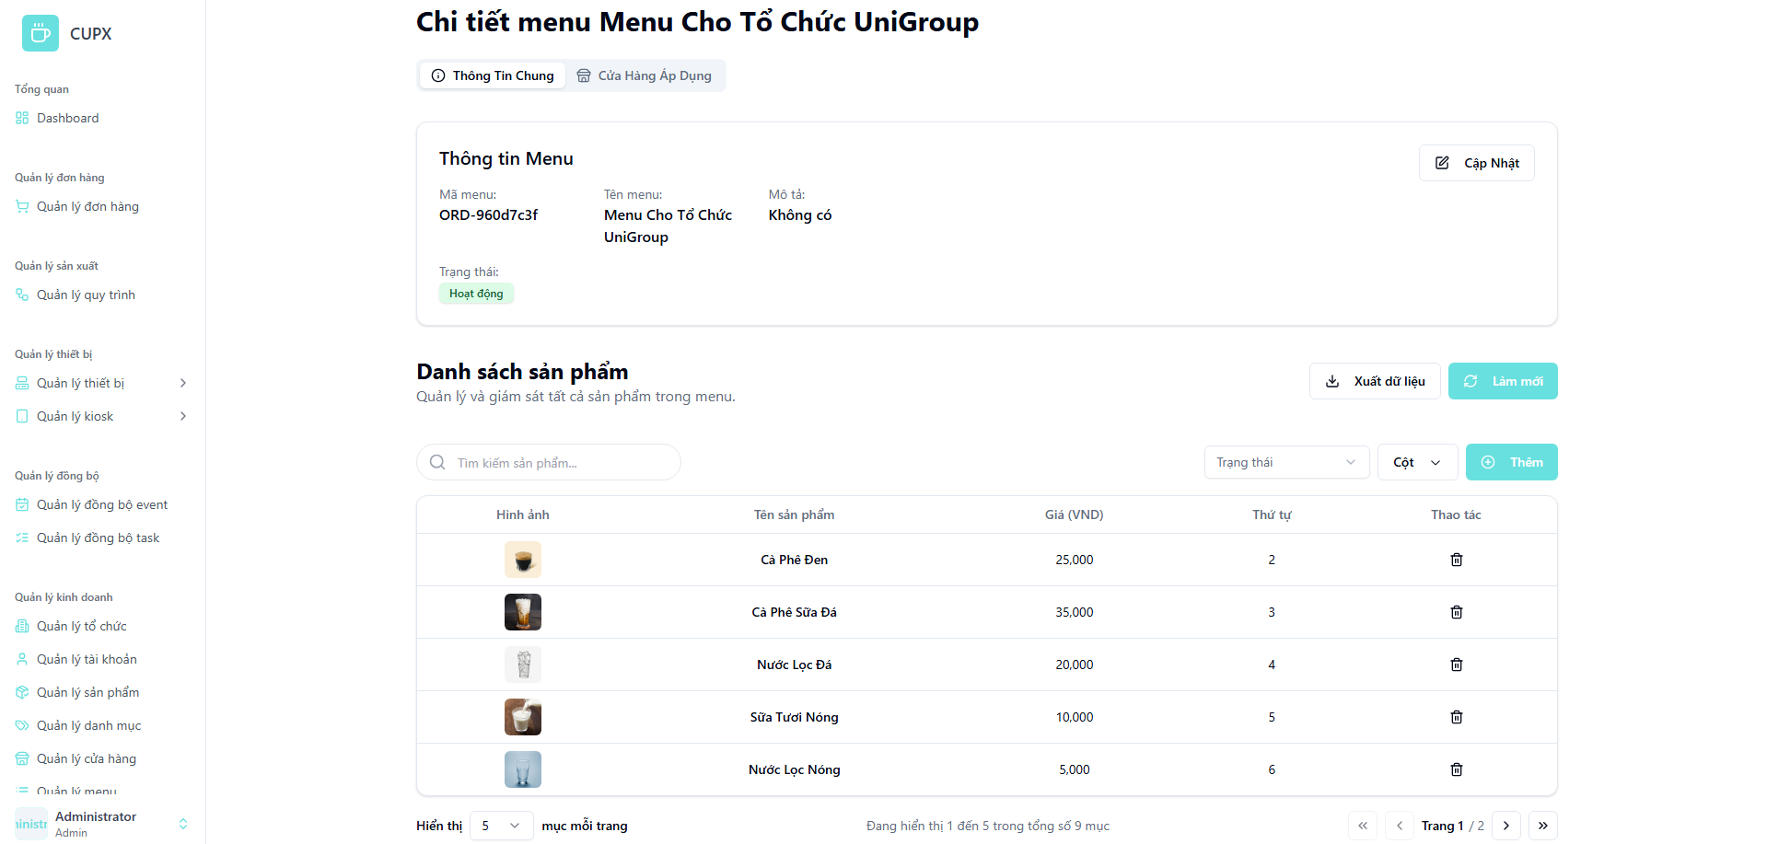
- Function details:
  - Data & Validation:
Data | Validations
MenuId | Auto-generated, unique identifier
Name | Required, textx
Description | Required, refers to an existing organization
Status | Required, Enum ("Hoạt động" - Active, "Không hoạt động" - Inactive).
Products | A list of product objects associated with the menu, each with an order number.

  - Functionalities:
Function | Normal Cases | Abnormal Cases
Open menu detail | Admin clicks “Xem chi tiết,” and the detail page opens, showing full menu details and the product list | If the menu is deleted or not found, show an error: “Menu not found.”
View basic information | Menu name, description, and status are displayed clearly | If data is missing (e.g., description), show “Không có” (Not available) or a placeholder
View product list | The table displays all products in the menu, sorted by the Thứ tự (Order) column | If the menu contains no products, display a message like "This menu has no products."
- Business Rules:
  - The Thứ tự (Order) column determines the display sequence of products within the menu.

3.8.3 Create a menu
- Function description:
  - Actors/Roles:
    - System Admin: Can create menus for any organization.
    - Organization Admin: Can create menus only for their assigned organization
  - Purpose: This function allows administrators to create a new menu by specifying its name, associated organization, status, and description.
  - Interface:
    - Fields include:
      - Tên Menu (Menu Name): Required text input.
      - Tổ chức (Organization): Required dropdown selection.
      - Trạng thái (Status): Required dropdown selection.
      - Mô tả (Description): Optional text area with a character counter.
    - Action Button:
      - Modal close button “X”.
      - “Tạo” (Create): Submits the form to the backend.
      - “Hủy” (Cancel): Closes the modal without saving
  - Data Processing:
    - When the admin submits the form, the frontend validates input data and sends it to the backend.
    - The backend persists the new menu and returns a success/failure response.
    - Upon success, the modal closes, and the menu list is refreshed.
- Function trigger:
  - Navigation path: From the “Quản lý menu” screen, the admin clicks the “Thêm” (Add) button.
  - Modal Display: A modal opens, showing a form with input fields for creating a new menu.
- Screen layout:
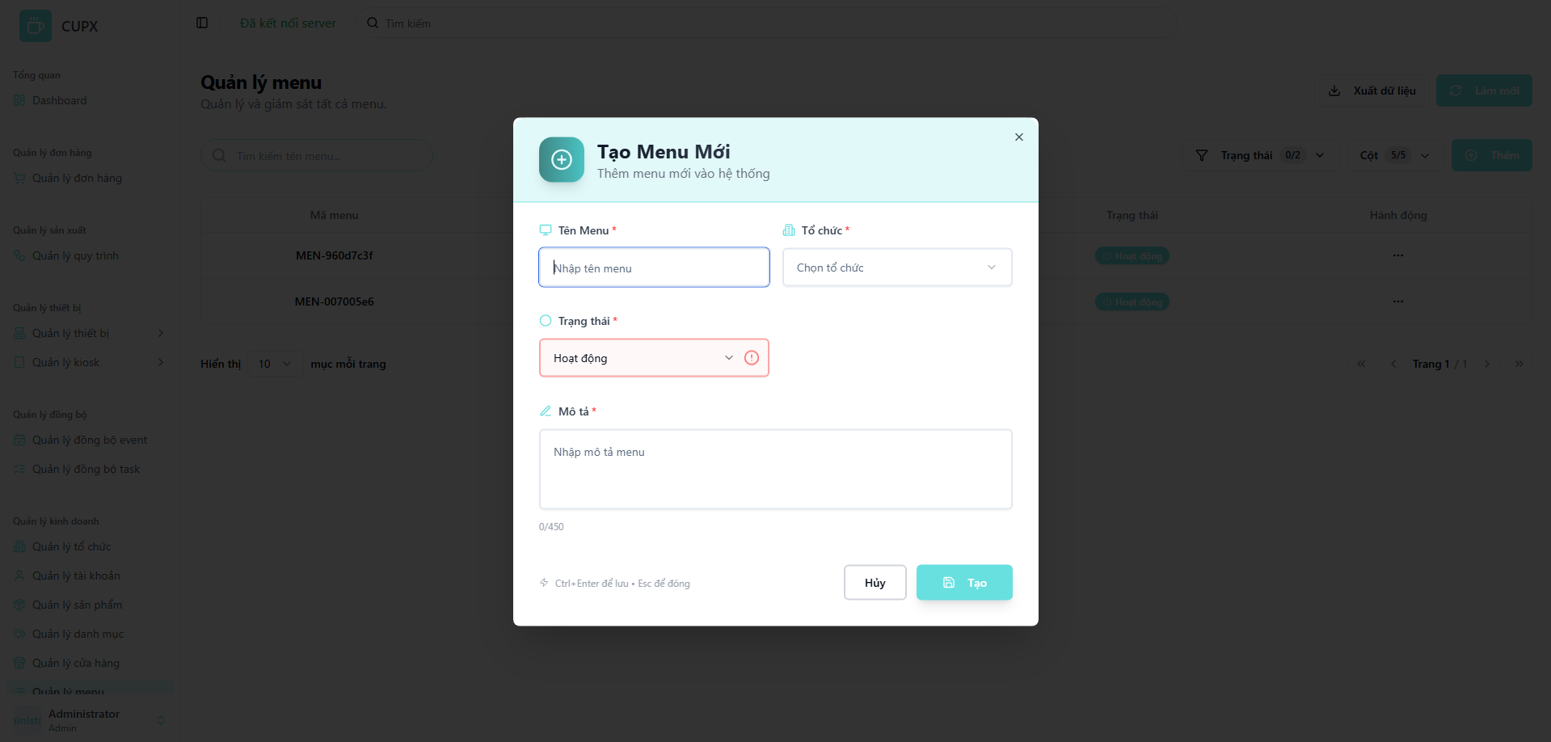
- Function details:
  - Data & Validation:
Data | Validations
MenuId | Auto-generated, unique identifier
Name | Required, text
OrganizationId | Required, must be a valid ID from the organization list
Status | Required, Enum ("Hoạt động" - Active, "Không hoạt động" - Inactive).
Description | Optional, max 450 characters

  - Functionalities:
Function | Normal Cases | Abnormal Cases
Open creation modal | Admin clicks “Thêm”, and the modal opens for menu entry | If the modal fails to open, show an error notification
Fill form | Admin enters menu information | If required fields are missing, prevent submission and show inline validation errors (e.g., red border and icon)
Submit creation | Clicking “Tạo” sends data to the backend, which validates it. On success, the modal closes and the list refreshes | If the backend returns an error (e.g., validation fails or the name already exists), show an informative error message
Cancel/Close modal | Admin clicks “Hủy” or presses the Esc key to close the modal without saving | If the modal fails to close, allow fallback closure via Esc key
- Business Rules:
  - A menu must be assigned to exactly one organization.
  - The menu name must be unique within the same organization.

3.8.4 Update a menu
- Function description:
  - Actors/Roles:
    - System Admin: Can update any menu across all organizations.
    - Organization Admin: Can update menus within their assigned organization.
  - Purpose: This function allows administrators to edit existing menu information such as its name, status, and description.
  - Interface:
    - Editable Fields Section:
      - Tên Menu (Menu Name)
      - Tổ chức (Organization) - May be non-editable
      - Trạng thái (Status)
      - Mô tả (Description)
    - Action Button:
      - Modal close button “X”.
      - “Cập nhật” (Update): Saves the updated menu data.
      - “Hủy” (Cancel): Closes the modal without saving changes.
  - Data Processing: The frontend pre-fills the form with existing menu data and sends a PUT or PATCH request to the backend API to persist changes
- Function trigger:
  - Navigation path: From the menu list (“Quản lý menu”), the admin clicks the “Hành động” (Action) button, then selects “Chỉnh sửa” (Edit).
  - Modal Display: The update modal opens with all fields pre-filled with the menu’s current data.
- Screen layout:
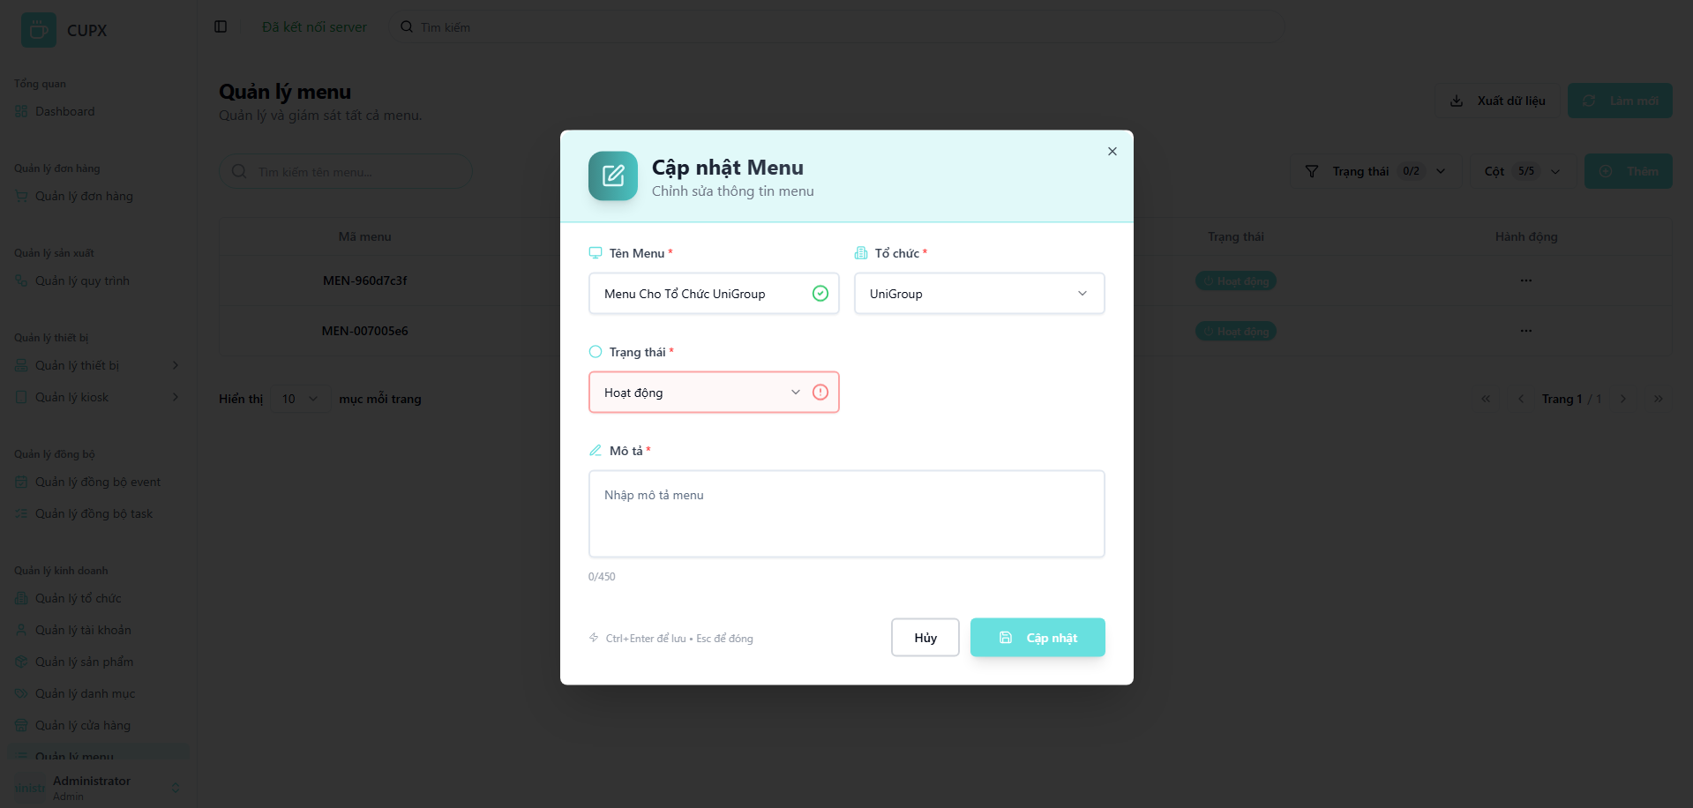
- Function details:
  - Data & Validation:
Data | Validations
Name | Required, text
OrganizationId | Required, must be a valid ID from the organization list
Status | Required, Enum ("Hoạt động" - Active, "Không hoạt động" - Inactive).
Description | Optional, max 450 characters
UpdatedDate | Auto-set by the backend

  - Functionalities:
Function | Normal Cases | Abnormal Cases
Open edit modal | Admin clicks “Chỉnh sửa,” and the modal opens with pre-filled data. | If the modal fails to open, or fails to fetch data, show an error popup
Modify menu info | Admin edits the menu name, status, etc., and submits | If required fields are left empty, show an inline validation error
Submit update | The backend updates the data and returns success → the modal closes, and the list updates | If the backend returns an error, show the message and keep the modal open for correction
Cancel/Close modal | Admin clicks “Hủy” or presses Esc to close without saving | If the modal gets stuck, allow fallback closure via the Esc key or a page reload
- Business Rules:
  - The organization associated with a menu may be non-editable after creation.

3.8.5 Delete a menu
- Function description:
  - Actors/Roles:
    - System Admin: Has full access to delete any menu in the system.
    - Organization Admin: Can delete menus within their assigned organization.
  - Purpose: This function allows administrators to permanently delete a menu from the system after confirming their intent in a separate dialog.
  - Interface:
    - The "Delete" option is located inside the "Hành động" (Action) dropdown.
    - Clicking “Xóa” (Delete) opens a confirmation modal.
    - The modal displays a warning: Bạn có chắc chắn muốn xóa menu "Menu Name"? Hành động này không thể hoàn tác. (Are you sure you want to delete the menu "Menu Name"? This action cannot be undone.)
    - The modal contains a “Hủy” (Cancel) button and a red “Xóa” (Delete) button to confirm.
  - Data Processing:
    - After user confirmation, the frontend sends a DELETE request to the backend API with the menu ID.
    - The backend verifies permission, deletes the menu record, and returns a success status.
    - On success, the frontend refreshes the list to remove the deleted menu.
- Function trigger:
  - Navigation path: From the menu list, the admin clicks the “Hành động” (Action) button, then selects “Xóa” (Delete).
- Screen layout:
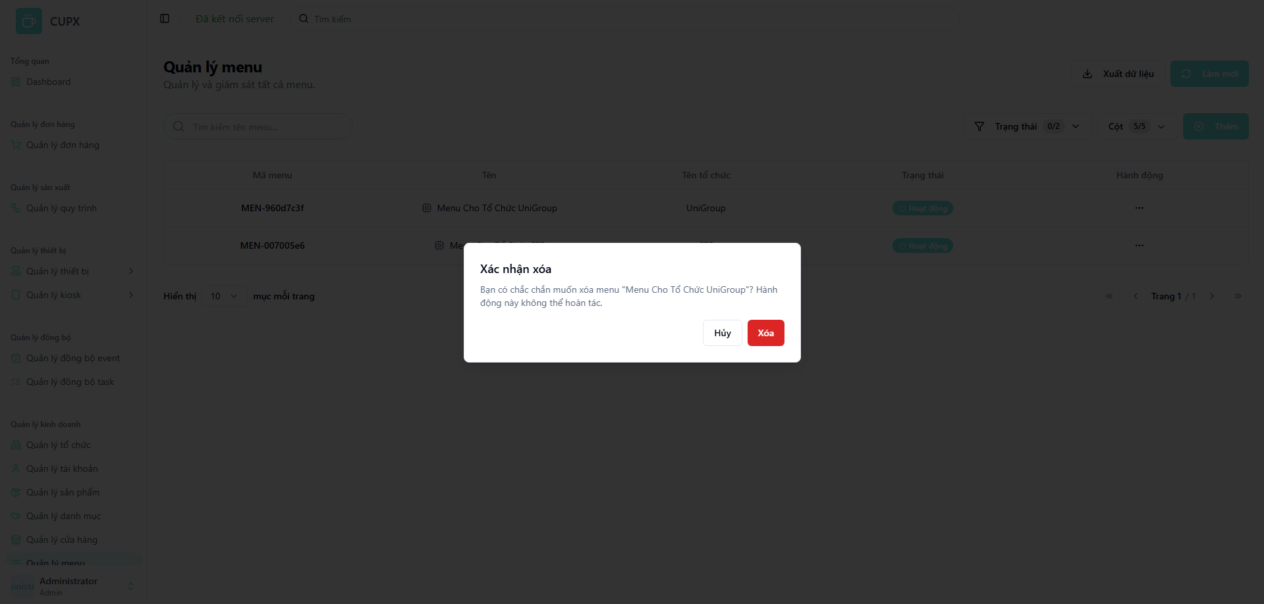
- Function details:
  - Data & Validation:
  - Functionalities:
Function | Normal Cases | Abnormal Cases
Initiate deletion | Admin clicks "Xóa," and the confirmation modal appears | If the modal fails to open, show an error notification
Confirm deletion | Admin clicks the red "Xóa" button. The menu is deleted, the modal closes, and the list refreshes | If the API call fails, show an error toast, and the modal remains open or closes
Cancel deletion | Admin clicks "Hủy" or closes the modal. No action is taken, and the menu remains in the list | If the modal fails to close, allow Esc key fallback
- Business Rules:
  - Deleting a menu only removes the menu entity and its associations with products. It does not delete the actual products from the system.

3.9 Category Management Screen

3.9.1 View list of categories
- Function description:
  - Actors/Roles: System Admin / Organization Admin: Has full access to view the list of categories, as they are typically system-wide.
  - Purpose: This function allows administrators to view, search, and manage the list of all product categories available in the system.
  - Interface:
    - Table: Displays a structured, paginated list of all categories with the following columns:
      - Category ID (Mã danh mục)
      - Image (Hình ảnh)
      - Category Name (Tên danh mục)
      - Description (Mô tả)
      - Order (Thứ tự)
      - Status (Trạng thái)
      - Action (Hành động)
    - Optional UI Element:
      - Search bar (Tìm kiếm danh mục...)
      - Filter dropdowns (Trạng thái - Status)
      - Pagination controls
      - Column visibility configuration (Cột - Columns)
      - Refresh button (Làm mới)
      - Export data button (Xuất dữ liệu)
      - Add button (Thêm)
  - Data Processing:
    - The client sends requests with filter, search, sort, and paging parameters to the server.
    - The server responds with a paginated list of category data.
- Function trigger:
  - Navigation path: The administrator accesses the category list by clicking the “Quản lý danh mục” (Category Management) item in the sidebar menu.
  - Timing Frequency: Data is re-fetched on page load, manual refresh, or after a create/update/delete action.
- Screen layout:
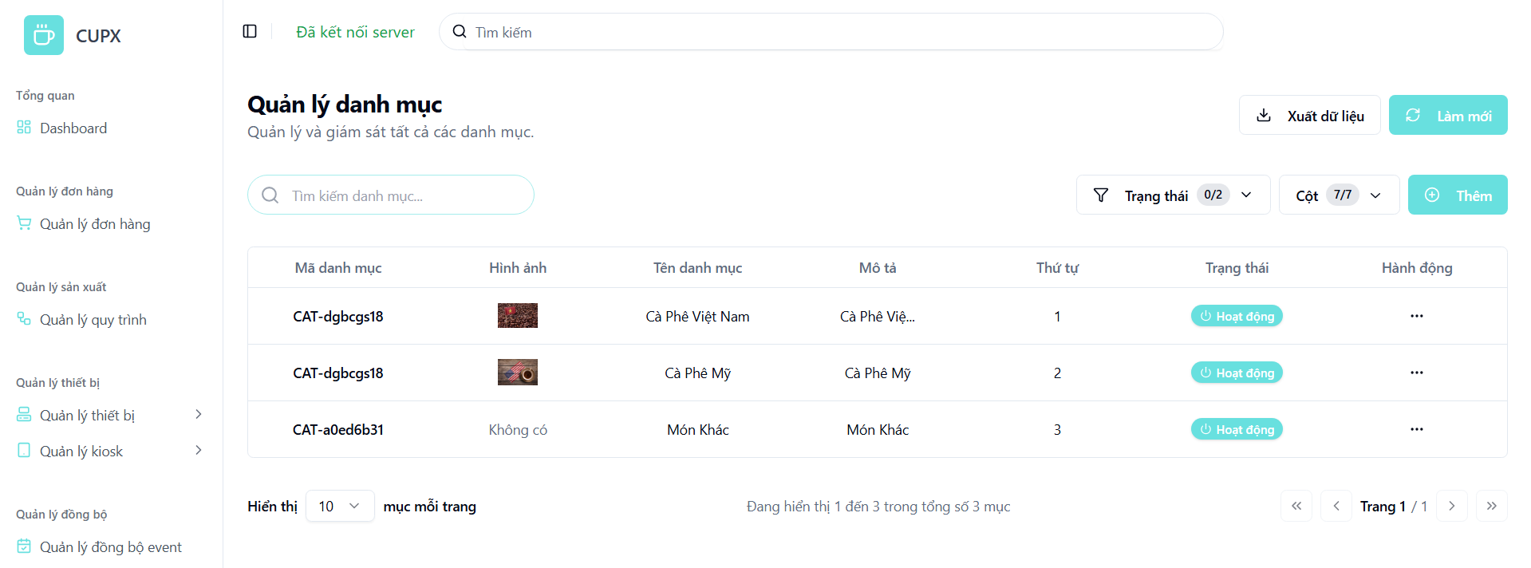
- Function details:
  - Data & Validation:
Data | Validations
CategoryId | Auto-generated, unique identifier
ImageUrl | Optional, must be a valid image URL
Name | Required, text
Description | Optional, text
Order | Required, integer, used for sorting
Status | Required, Enum ("Hoạt động" - Active, "Không hoạt động" - Inactive)

  - Functionalities:
Function | Normal Cases | Abnormal Cases
Access category list | Admin opens the screen and views the paginated category table | If the API fails, show an error message with a retry option
Search by keyword | Admin types a category name into the search bar to filter results | If no results are found, display a message like "No categories found.
Apply filters | Admin filters the list by category status | If the filter is invalid, show a warning and revert to the previous state
Pagination navigation | Admin uses pagination controls to navigate through pages | If a requested page is out of range, reset to page 1
- Business Rules:
  - The Order column dictates the default display sequence of categories in other parts of the application (e.g., on a customer-facing website).

3.9.2 View detail of a category
- Function description:
  - Actors/Roles: System Admin / Organization Admin: Can view the details of any category.
  - Purpose: This function provides a read-only, detailed view of a specific category's attributes, including its image, name, order, and status.
  - Interface:
    - Category ID Section: Displays the unique system ID of the category.
    - Representative Image Section (
      - Image preview.
      - Full Image URL.
    - Detailed Information Section (
      - Category Name (Tên danh mục)
      - Display Order (Thứ tự hiển thị)
      - Active Status (Trạng thái hoạt động) with a status badge.
      - Detailed Description (Mô tả chi tiết)
    - Action Button:
      - Modal close button "X".
  - Data Processing:
    - The frontend sends the category ID to the backend when the detail view is triggered.
    - The backend returns the full data object for that specific category.
- Function trigger:
  - Navigation path: From the “Quản lý danh mục” screen, the administrator clicks the “Hành động” (Action) button, then selects “Xem chi tiết” (View Detail).
  - Modal Display: A modal overlay appears with the read-only category information.
- Screen layout:
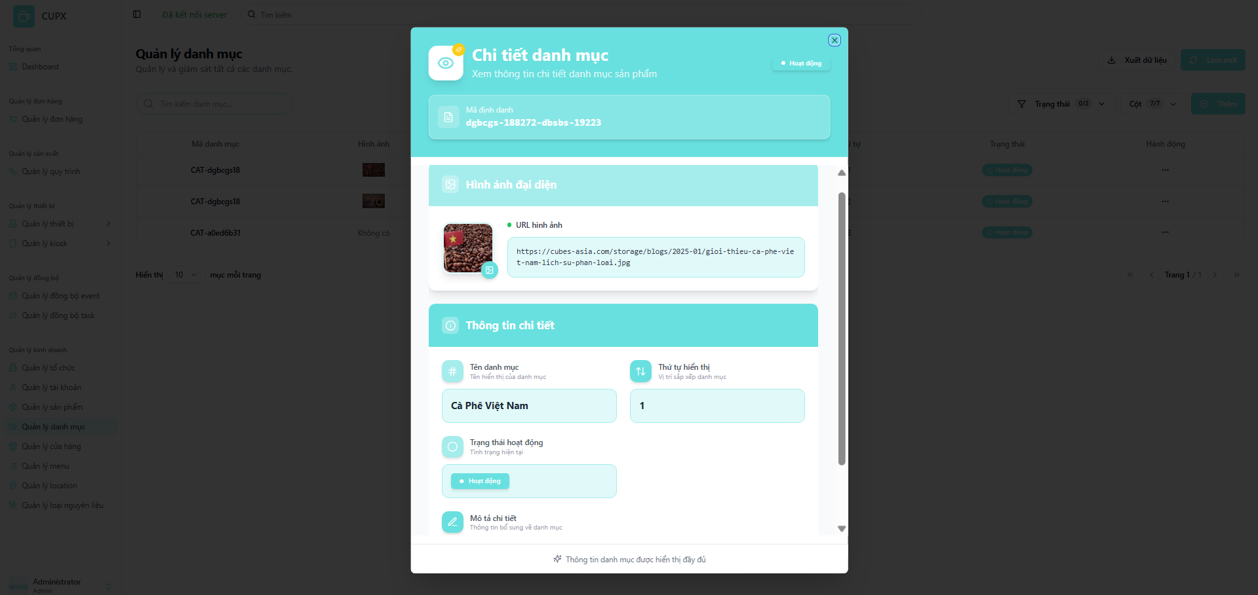
- Function details:
  - Data & Validation:
Data | Validations
CategoryId | Must be a valid, existing category ID
Name | Text
ImageUrl | Valid URL
Order | Optional, text
Status | Enum ("Hoạt động" - Active, "Không hoạt động" - Inactive)
Status | Required, Enum ("Hoạt động" - Active, "Không hoạt động" - Inactive)
Description | text

  - Functionalities:
Function | Normal Cases | Abnormal Cases
Open detail modal | Admin clicks “Xem chi tiết,” and the modal opens showing the category's full details. | If the category data cannot be fetched, show an error message
View image | The category image is previewed, and the full URL is displayed | If the image URL is broken or missing, display a default placeholder image
View information | All fields like name, order, status, and description are clearly displayed | If a field like "Description" is empty, display a placeholder like "N/A" or "No description."
Close modal | Admin clicks the “×” button or presses Esc to close the modal | If the modal fails to close, allow Esc key as a fallback
- Business Rules:
  - All information in this view is read-only.

3.9.3 Create a category
- Function description:
  - Actors/Roles: System Admin / Organization Admin: Can create new categories for the system.
  - Purpose: This function allows administrators to add a new product category by providing its details, such as name, image, display order, and status.
  - Interface:
    - Fields include:
      - Image Upload (Tải lên hình ảnh) / Image URL (URL hình ảnh).
      - Category Name (Tên Danh Mục): Required text input.
      - Order (Thứ tự): Required numeric input. (Inferred from list/detail view)
      - Status (Trạng thái): Required dropdown selection.
      - Description (Mô tả): Optional text area.
    - Action Button:
      - Modal close button “X”.
      - “Tạo” (Create): Submits the form.
      - “Hủy” (Cancel): Closes the modal without saving.
      - “Hủy” (Cancel): Closes the modal without saving.
  - Data Processing:
    - The frontend validates the form data. Upon submission, it sends the new category data to the backend.
    - The backend validates, creates the new category, and returns a success response. The category list is then refreshed.

  - Function trigger:
    - Navigation path: From the “Quản lý danh mục” screen, the administrator clicks the “Thêm” (Add) button.
    - Modal Display: A modal opens with an empty form for creating a new category.
- Screen layout:
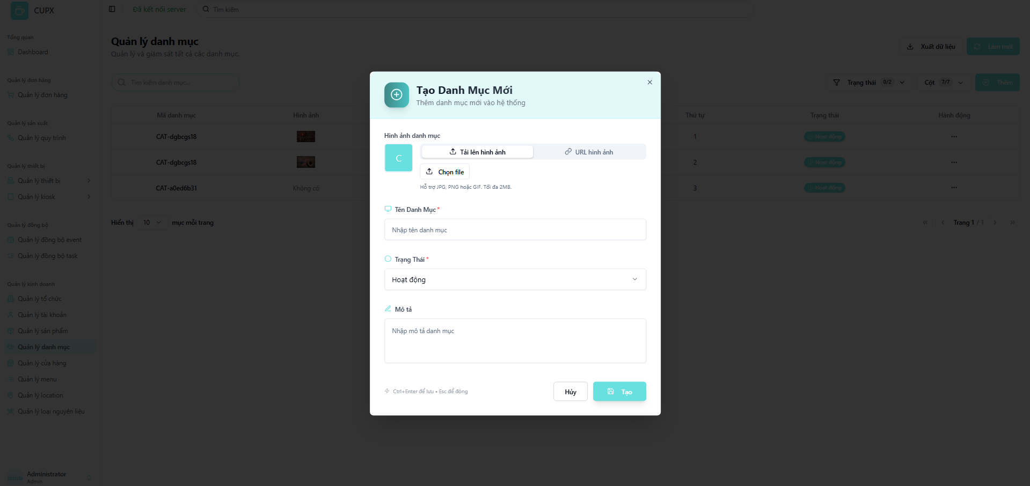
- Function details:
  - Data & Validation:
Data | Validations
Image | Optional, must be a valid image file
Name | Required, max 255 characters. Must be unique
DisplayOrder | Required, must be a positive integer
Order | Optional, text
Status | Enum ("Hoạt động" - Active, "Không hoạt động" - Inactive)
Description | Optional, text.

  - Functionalities:
Function | Normal Cases | Abnormal Cases
Open creation modal | Admin clicks “Thêm”, and the modal opens with a blank form | If the modal fails to open, show an error notification
Fill form | Admin enters category information | If required fields are missing, prevent submission and show inline validation errors
Add image | Admin uploads an image file or provides a URL | If the file format/size is invalid or the URL is malformed, show an error message
Submit creation | Clicking “Tạo” sends data to the backend. On success, the modal closes and the list refreshes | If the backend returns an error (e.g., name not unique), show an informative error message in the modal.
Cancel/Close modall | Admin clicks “Hủy” or presses Esc to close the modal | If the modal fails to close, allow fallback closure
- Business Rules:
  - The category Name must be unique across all categories.
  - The Order value should ideally be unique to ensure a predictable sort order.

3.9.4 Update a category
- Function description:
  - Actors/Roles: System Admin / Organization Admin can edit any existing category.
  - Purpose: This function allows administrators to modify the details of an existing product category.
  - Interface:
    - Editable Fields Section:
      - Image Upload (Tải lên hình ảnh) / Image URL (URL hình ảnh) with a delete option.
      - Category Name (Tên Danh Mục)
      - Order (Thứ tự) (Inferred from list/detail view)
      - Status (Trạng thái)
      - Description (Mô tả)
    - Action Button:
      - Modal close button “X”.
      - “Cập nhật” (Update): Saves the changes.
      - “Hủy” (Cancel): Closes the modal without saving.
  - Data Processing:
    - The frontend fetches the current category data and pre-fills the form. Upon submission, it sends the updated data to the backend via a PUT request.
  - Function trigger:
    - Navigation path: From the category list, the administrator clicks the “Hành động” (Action) button, then selects “Chỉnh sửa” (Edit).
    - Modal Display: The update modal opens with all fields pre-filled with the category’s current data.
- Screen layout:
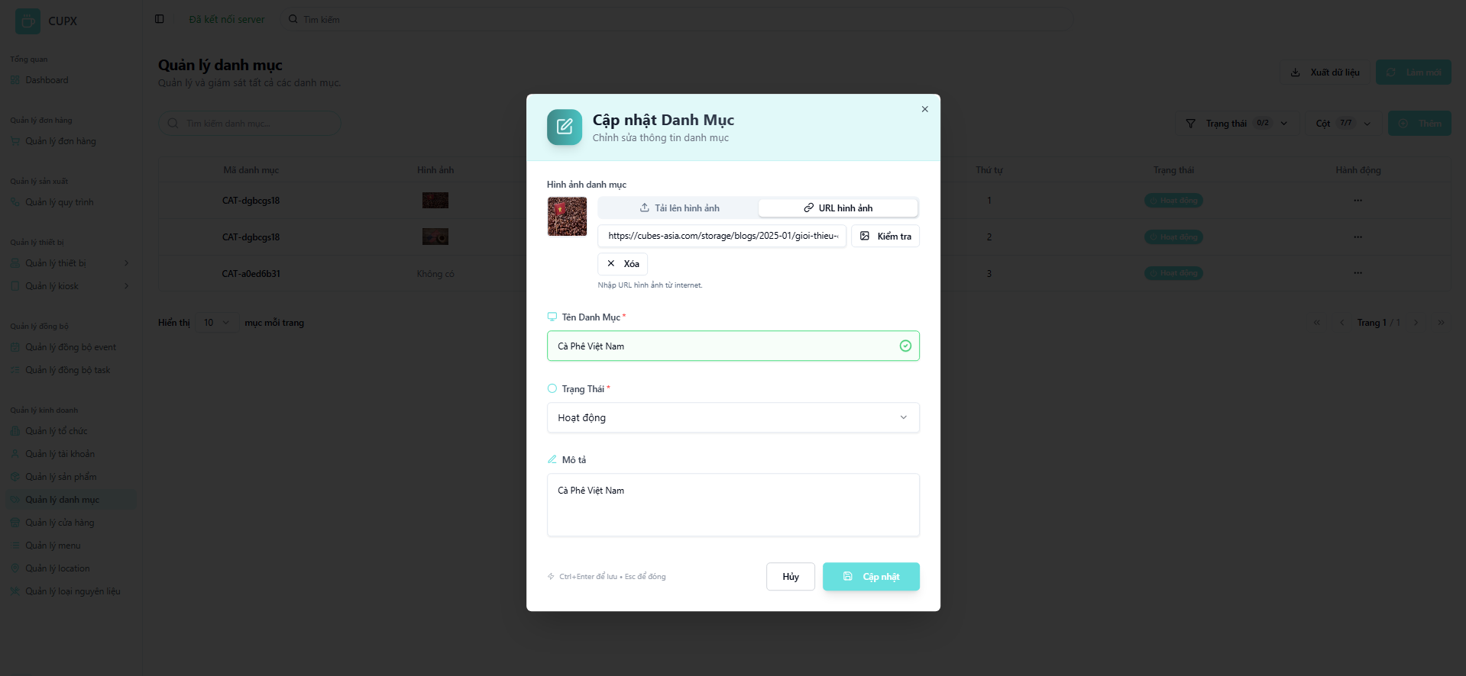
- Function details:
  - Data & Validation:
Data | Validations
Image | Optional, must be a valid image file
Name | Required, max 255 characters. Must be unique
DisplayOrder | Required, must be a positive integer
Order | Optional, text
Status | Enum ("Hoạt động" - Active, "Không hoạt động" - Inactive)
Description | Optional, text.

  - Functionalities:
Function | Normal Cases | Abnormal Cases
Open edit modal | Admin clicks “Chỉnh sửa,” and the modal opens with pre-filled data | If the modal fails to open or fetch data, show an error.
Modify information | Admin edits fields like name, order, etc., and submits | If required fields are empty, show an inline validation error
Change image | Admin uploads a new image, provides a new URL, or deletes the existing image | If the new image/URL is invalid, show a validation error.
Submit update | The backend updates the data and returns success. The modal closes, and the list refreshes | If the backend returns an error, display the message and keep the modal open
Cancel/Close modal | Admin clicks “Hủy” or presses Esc to close without saving | If the modal is stuck, allow Esc key fallback
- Business Rules:
  - The updated category Name must not conflict with any other existing category name.

3.9.5 Delete a category
- Function description:
  - Actors/Roles: System Admin / Organization Admin can delete any category.
  - Purpose: This function allows administrators to permanently remove a category from the system after confirmation.
  - Interface:
    - The "Delete" option is located inside the "Hành động" (Action) dropdown.
    - Clicking “Xóa” (Delete) opens a confirmation modal.
    - The modal displays a warning: Bạn có chắc chắn muốn xóa danh mục "[Category Name]"? Hành động này không thể hoàn tác. (Are you sure you want to delete the category "[Category Name]"? This action cannot be undone.)
    - The modal contains a “Hủy” (Cancel) button and a red “Xóa” (Delete) button.
  - Data Processing:
    - Upon confirmation, the frontend sends a DELETE request with the category ID to the backend.
    - The backend validates permissions, deletes the category, and returns a success response.
  - Function trigger:
    - Navigation path: From the category list, the administrator clicks the “Hành động” (Action) button, then selects “Xóa” (Delete).
- Screen layout:
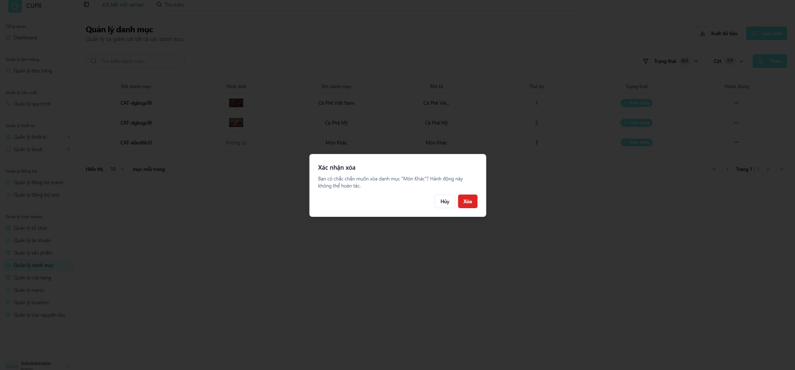
- Function details:
  - Data & Validation:
  - Functionalities:
Function | Normal Cases | Abnormal Cases
Initiate deletion | Admin clicks "Xóa," and the confirmation modal appears. | If the modal fails to open, show an error.
Confirm deletion | Admin clicks the red "Xóa" button. The category is deleted, the modal closes, and the list refreshes. | If the API call fails (e.g., category is in use), show an error toast and keep the user on the page.
Cancel deletion | Admin clicks "Hủy" or closes the modal. No action is taken | If the modal fails to close, allow Esc key fallback.
- Business Rules:
  - The system should prevent the deletion of a category if it is currently associated with one or more products. An appropriate error message should be displayed to the user in this case.

3.10 Location Management Screen

3.10.1 View list of locations
- Function description:
  - Actors/Roles: System Admin with full access to view and manage all locations
  - Purpose: This function allows administrators to view, search, and manage a list of predefined location types that can be used throughout the system.
  - Interface:
    - Table: Displays a structured, paginated list of all locations with the following columns:
      - Mã location (Location ID)
      - Tên (Name)
      - Mô tả (Description)
      - Ngày tạo (Created Date)
      - Ngày cập nhật (Updated Date)
      - Hành động (Action)
    - Optional UI Element:
      - Search bar (Tìm kiếm location...)
      - Filter dropdown (Trạng thái - Status)
      - Pagination controls
      - Column visibility configuration (Cột - Columns)
      - Refresh button (Làm mới)
      - Export data button (Xuất dữ liệu)
      - Add button (Thêm)
  - Data Processing:
    - The client sends requests with filter, search, and paging parameters to the server.
    - The server responds with a paginated list of location data.
  - Function trigger:
    - Navigation path: The administrator accesses the location list by clicking the “Quản lý location” (Location Management) item in the sidebar menu.
- Screen layout:
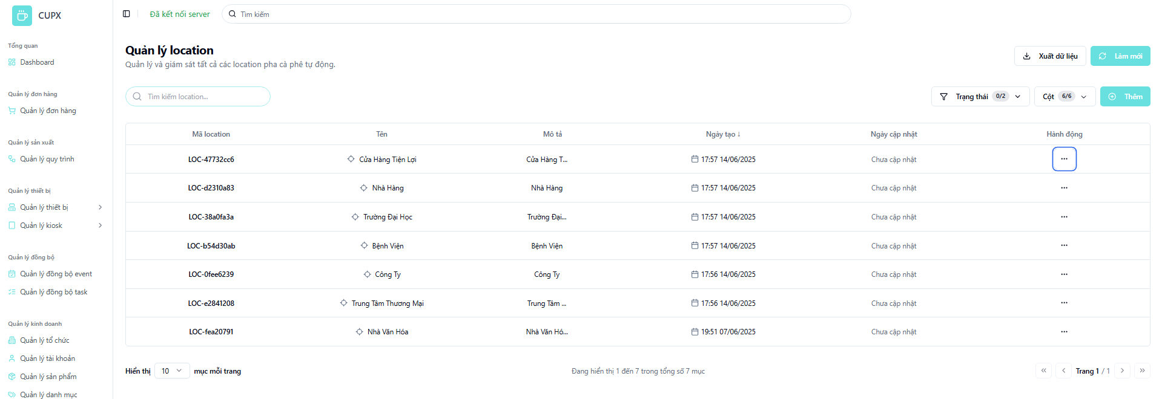
- Function details:
  - Data & Validation:
LocationId | Validations
Image | Auto-generated, unique identifier
Name | Required, max 255 characters.
DisplayOrder | Required, must be a positive integer
CreatedDate | Auto-set by the backend, displayed with time and date
UpdatedDate | Auto-set on update
Description | Optional, text.

  - Functionalities:
Function | Normal Cases | Abnormal Cases
Access location list | Admin opens the screen and views the paginated location table | If the API fails, show an error message with a retry option
Search by keyword | Admin types a location name into the search bar to filter results | If no results are found, display a message like "No locations found."
Duplicate a location | Admin clicks "Sao chép" (Duplicate) to open the create modal, pre-filled with the selected location's data | If duplication fails, show an error message
Pagination navigation | Admin uses pagination controls to navigate through pages | If a requested page is out of range, reset to page 1
- Business Rules:
  - Locations represent generic types or templates, not specific physical addresses.

3.10.2 View detail of a location
- Function description:
  - Actors/Roles: System admin can view the details of any location
  - Purpose: This function provides a quick, read-only summary of a specific location's information in a simple modal.
  - Interface:
    - Location Information Section (Thông tin location):
      - Mã location (Location ID)
      - Tên (Name)
      - Mô tả (Description)
    - Timestamp Section (
      - Ngày tạo (Created Date)
      - Ngày cập nhật (Updated Date)

    - Action Button:
      - Modal close button "X".
  - Data Processing:
    - When triggered, the frontend uses the location ID to request detailed data from the backend.
    - The backend returns the full object for the specified location.
  - Function trigger:
    - Navigation path: From the “Quản lý location” screen, the administrator clicks the “Hành động” (Action) button, then selects “Xem chi tiết” (View Detail).
    - Modal Display: A small, centered modal appears with the location's read-only information.
- Screen layout:
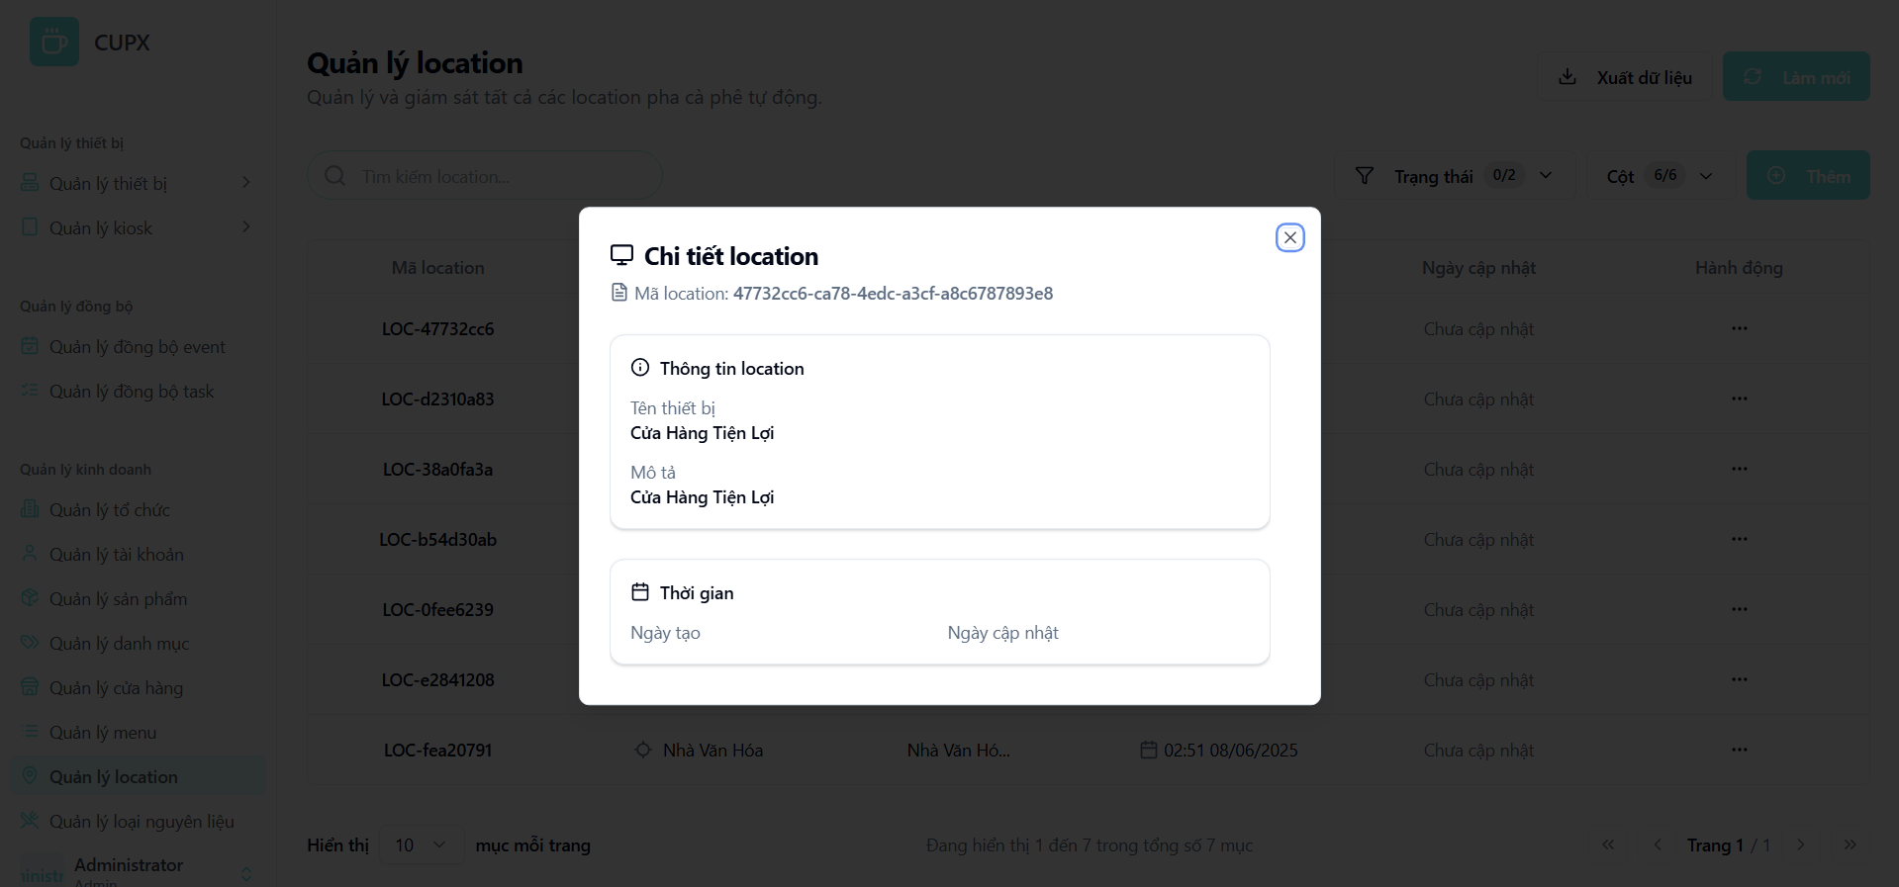
- Function details:
  - Data & Validation:
LocationId | Validations
Image | Auto-generated, unique identifier
Name | Required, max 255 characters.
CreatedDate | Auto-set by the backend, displayed with time and date
UpdatedDate | Auto-set on update
Description | Optional, text.

  - Functionalities:
Function | Normal Cases | Abnormal Cases
Open detail modal | Admin clicks “Xem chi tiết,” and the modal opens showing the location's details | If the location data cannot be fetched, show an error message
View information | All fields (ID, Name, Description, Timestamps) are clearly displayed. | If an optional field is empty, it is shown as such
Close modal | Admin clicks the “×” button or presses Esc to close the modal | If the modal fails to close, allow Esc key as a fallback
- Business Rules:
  - This view is for informational purposes only; no fields can be edited here.

3.10.3 Create a location
- Function description:
  - Actors/Roles: System admin can create new location types
  - Purpose: This function allows an administrator to add a new location type to the system by providing a name and a description
  - Interface:
    - Location Information Section (Thông tin location):
      - Mã location (Location ID)
      - Tên (Name)
      - Mô tả (Description)
    - Timestamp Section (
      - Ngày tạo (Created Date)
      - Ngày cập nhật (Updated Date)
    - Action Button:
      - Modal close button "X".
  - Data Processing:
    - When triggered, the frontend uses the location ID to request detailed data from the backend.
    - The backend returns the full object for the specified location.
  - Function trigger:
    - Navigation path: From the “Quản lý location” screen, the administrator clicks the “Hành động” (Action) button, then selects “Xem chi tiết” (View Detail).
    - Modal Display: A small, centered modal appears with the location's read-only information.
- Screen layout:

- Function details:
  - Data & Validation:
LocationId | Validations
Image | Auto-generated, unique identifier
Name | Required, max 255 characters.
CreatedDate | Auto-set by the backend, displayed with time and date
UpdatedDate | Auto-set on update
Description | Optional, text.

  - Functionalities:
Function | Normal Cases | Abnormal Cases
Open detail modal | Admin clicks “Xem chi tiết,” and the modal opens showing the location's details | If the location data cannot be fetched, show an error message
View information | All fields (ID, Name, Description, Timestamps) are clearly displayed. | If an optional field is empty, it is shown as such
Close modal | Admin clicks the “×” button or presses Esc to close the modal | If the modal fails to close, allow Esc key as a fallback
- Business Rules: The location Name must be unique across all locations.

3.10.4 Update a location
- Function description:
  - Actors/Roles: System Admin can edit any existing location.
  - Purpose: This function allows an administrator to modify the name and description of an existing location type.
  - Interface:
    - Editable Fields Section:
      - Location Name (Tên Location): Text input with character counter.
      - Description (Mô tả): Text area with character counter.
    - Action Button:
      - Modal close button “X”.
      - “Cập nhật” (Update): Saves the changes.
      - “Hủy” (Cancel): Closes the modal without saving.
  - Data Processing:
    - The frontend fetches the current location data and pre-fills the form. Upon submission, it sends the updated data to the backend via a PUT request.
  - Function trigger:
    - Navigation path: From the location list, the administrator clicks the “Hành động” (Action) button, then selects “Chỉnh sửa” (Edit).
    - Modal Display: The update modal opens with all fields pre-filled with the location’s current data.
- Screen layout:
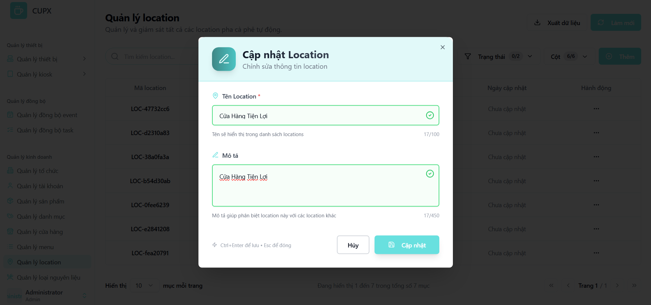
- Function details:
  - Data & Validation:
LocationId | Validations
Name | Required, max 255 characters.
UpdatedDate | Auto-set on update
Description | Optional, text.

  - Functionalities:
Function | Normal Cases | Abnormal Cases
Open edit modal | Admin clicks “Chỉnh sửa,” and the modal opens with pre-filled data | If the modal fails to open or fetch data, show an error.
Modify information | Admin edits fields like name or description and submits | If the required "Name" field is empty, show an inline validation error.
Submit update | The backend updates the data and returns success. The modal closes, and the list refreshes. | If the backend returns an error (e.g., name conflict), display the message and keep the modal open
Cancel/Close modal | Admin clicks “Hủy” or presses Esc to close without saving | If the modal is stuck, allow Esc key fallback
- Business Rules: The location Name must be unique across all locations.

3.10.5 Delete a location
- Function description:
  - Actors/Roles: System AdminCan delete any location.
  - Purpose: This function allows an administrator to permanently remove a location type from the system after confirmation.
  - Interface:
    - The "Delete" option is located inside the "Hành động" (Action) dropdown.
    - Clicking “Xóa” (Delete) opens a confirmation modal.
    - The modal displays a warning: Bạn có chắc chắn muốn xóa location "[Location Name]"? Hành động này không thể hoàn tác. (Are you sure you want to delete the location "[Location Name]"? This action cannot be undone.)
    - The modal contains a “Hủy” (Cancel) button and a red “Xóa” (Delete) button.
  - Data Processing:
    - Upon confirmation, the frontend sends a DELETE request with the location ID to the backend.
    - The backend validates permissions, deletes the record, and returns a success response.
  - Function trigger:
    - Navigation path: From the location list, the administrator clicks the “Hành động” (Action) button, then selects “Xóa” (Delete)
- Screen layout:
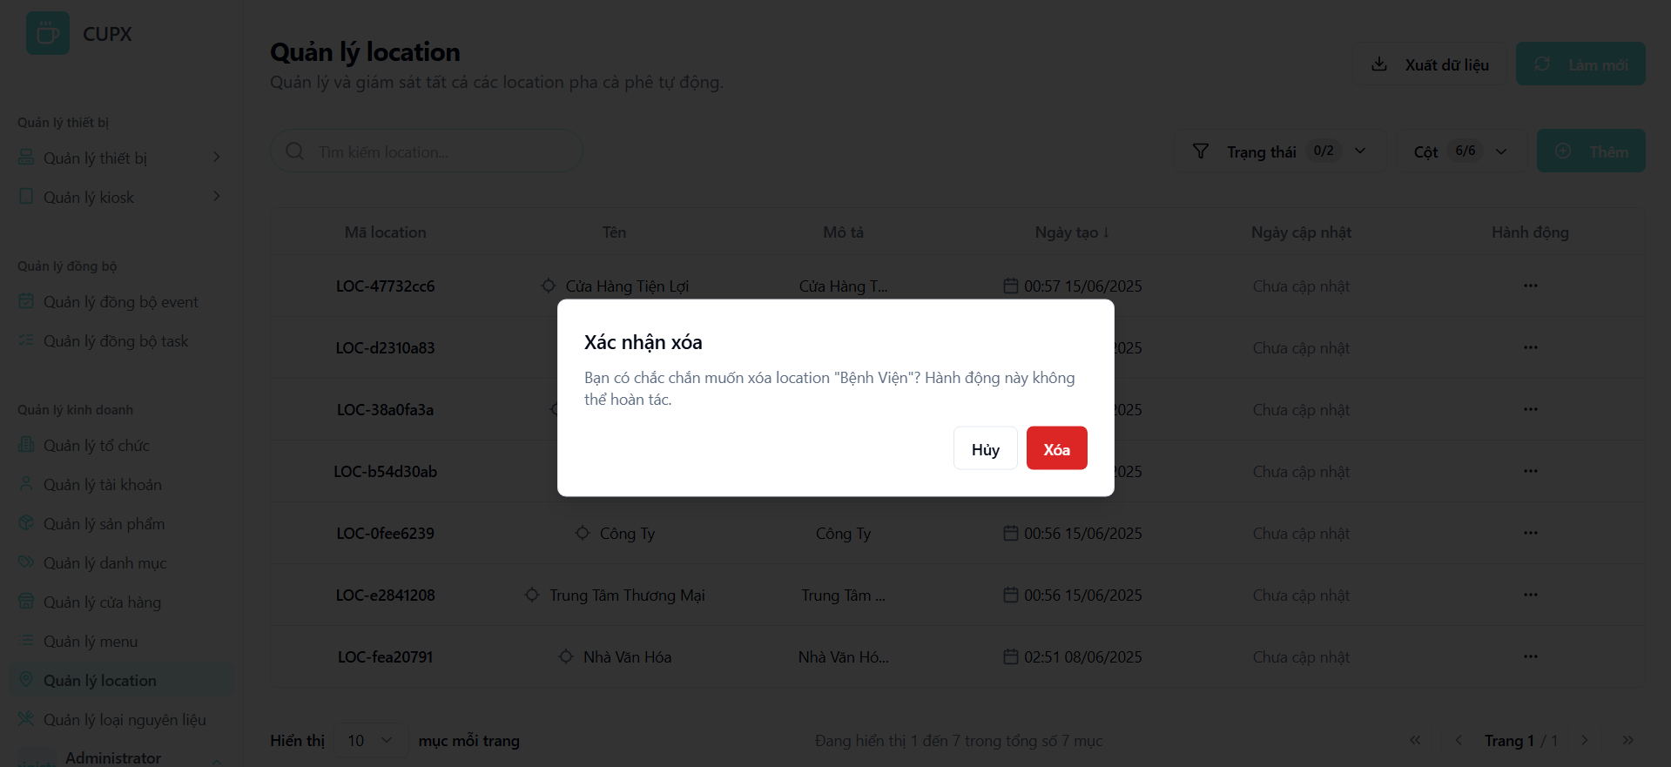
- Function details:
  - Data & Validation:
  - Functionalities:
Function | Normal Cases | Abnormal Cases
Initiate deletion | Admin clicks "Xóa," and the confirmation modal appears | If the modal fails to open, show an error
Confirm deletion | Admin clicks the red "Xóa" button. The location is deleted, the modal closes, and the list refreshes | If the API call fails (e.g., location is in use), show an error toast and keep the user on the page
Cancel deletion | Admin clicks "Hủy" or closes the modal. No action is taken | If the modal fails to close, allow Esc key fallback
- Business Rules: The system should prevent the deletion of a location if it is currently assigned to any other entity in the system. An appropriate error message should be displayed to the user in this case.

3.11 Ingredient Type Management Screen

3.11.1 View list of ingredient types
- Function description:
  - Actors/Roles: System Admin: Has full access to view and manage all core ingredient types.
  - Purpose: This function allows administrators to manage the master list of ingredient types (e.g., Cup, Condensed Milk, Ice, Sugar) that can be used to define product recipes throughout the system.
  - Interface:
    - Table: Displays a structured, paginated list of all ingredient types with the following columns:
      - Ingredient Type ID (Mã loại nguyên liệu)
      - Name (Tên)
      - Description (Mô tả)
      - Status (Trạng thái)
      - Action (Hành động)
    - Optional UI Element:
      - Search bar (Tìm kiếm loại nguyên liệu...)
      - Filter dropdown (Trạng thái - Status)
      - Pagination controls
      - Column visibility configuration (Cột - Columns)
      - Refresh button (Làm mới)
      - Export data button (Xuất dữ liệu)
      - Add button (Thêm)
  - Data Processing:
    - The client sends requests with filter, search, sort, and paging parameters to the server.
    - The server responds with a paginated list of ingredient type data.
  - Function trigger:
    - Navigation path: The administrator accesses the list by clicking the “Quản lý loại nguyên liệu” (Ingredient Type Management) item in the sidebar menu.
    - Timing Frequency: Data is re-fetched on page load, manual refresh, or after a create/update/delete action.
- Screen layout:
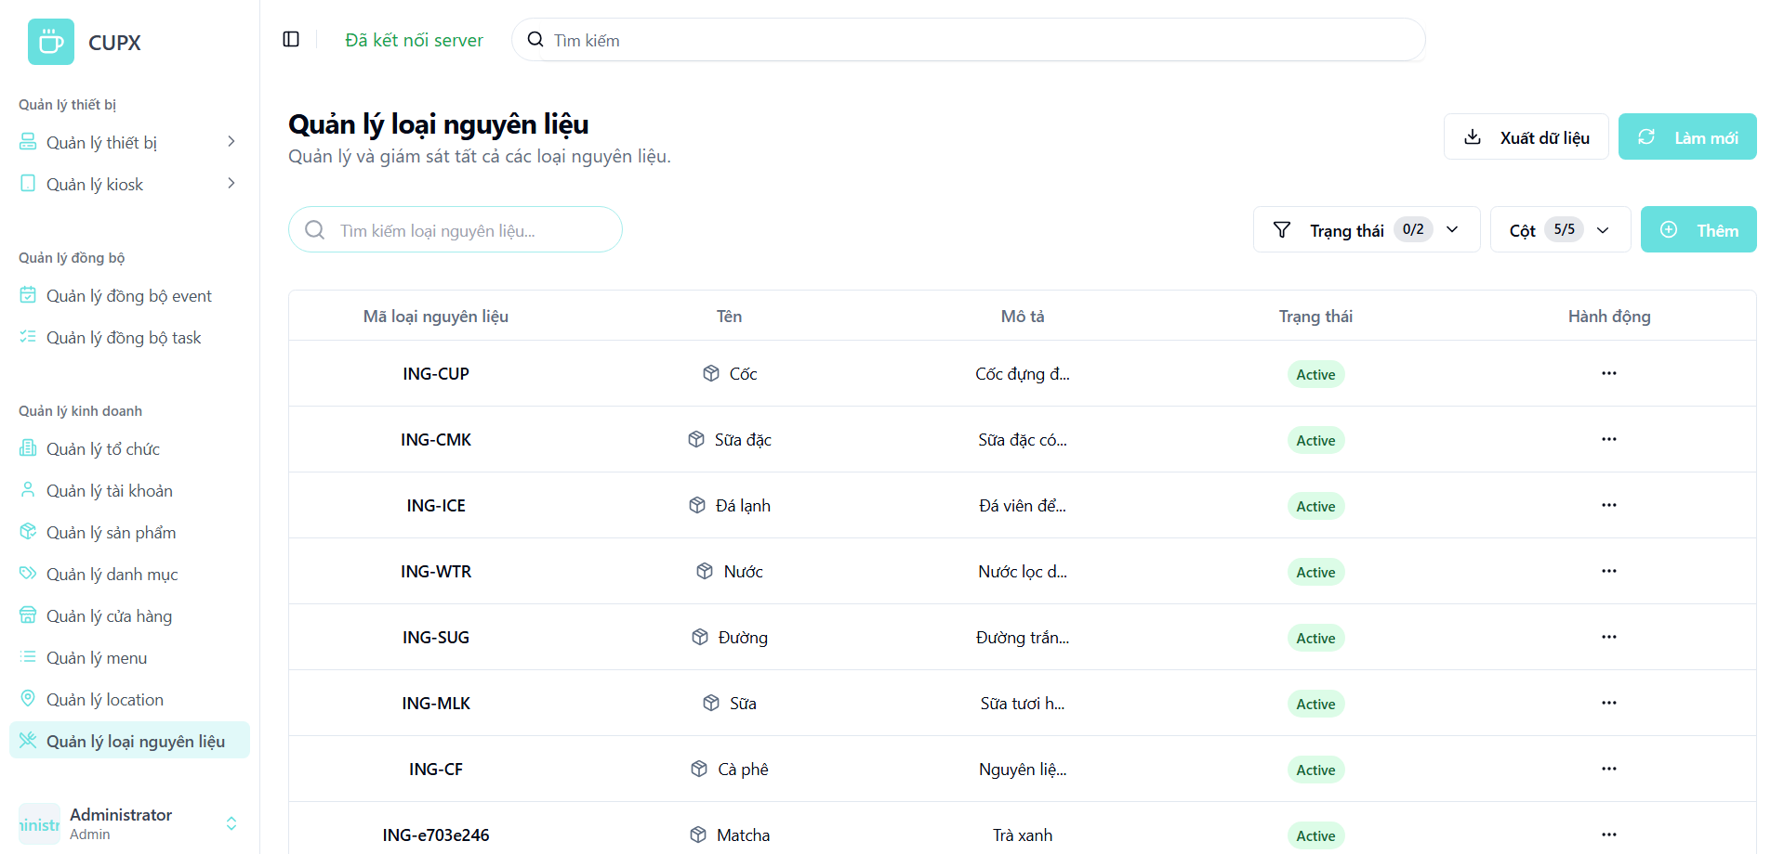
- Function details:
  - Data & Validation:
IngredientTypeId | Auto-generated, unique identifier
Name | Required, text.
Description | Optional, text
Status | Required, Enum

  - Functionalities:
Function | Normal Cases | Abnormal Cases
Access list | Admin opens the screen and views the paginated table of ingredient types | If the API fails, show an error message with a retry option
Search by keyword | Admin types a name into the search bar to filter results | If no results are found, display a message like "No ingredient types found."
Apply filters | Admin filters the list by status using the Trạng thái dropdown | If the filter is invalid, show a warning and revert to the previous state
Pagination navigation | Admin uses pagination controls to navigate through pages | If a requested page is out of range, reset to page 1
- Business Rules: These ingredient types serve as master data for defining product components.

3.11.2 View detail of an ingredient type
- Function description:
  - Actors/Roles: System Admin: Can view the details of any ingredient type.
  - Purpose: This function provides a read-only, detailed view of a specific ingredient type's attributes in a modal.
  - Interface:
    - Header Section: Displays the ingredient type's name (e.g., CUP) and overall status badge.
    - Basic Information Section (
      - Ingredient Type Name (Tên loại nguyên liệu)
      - Status (Trạng thái)
      - Identifier Code (Mã định danh)
      - Description (Mô tả)

    - Additional Information Section ( A section for future or custom fields (currently shown as empty).
    - Action Button:
      - Modal close button "X".
  - Data Processing:
    - The frontend sends the ingredient type ID to the backend when the detail view is triggered.
    - The backend returns the full data object for that specific ingredient type.
  - Function trigger:
    - Navigation path: From the ingredient type list, the admin clicks the “Hành động” (Action) button, then selects “Xem chi tiết” (View Detail).
    - Modal Display: A modal overlay appears with the read-only ingredient type information.
- Screen layout:
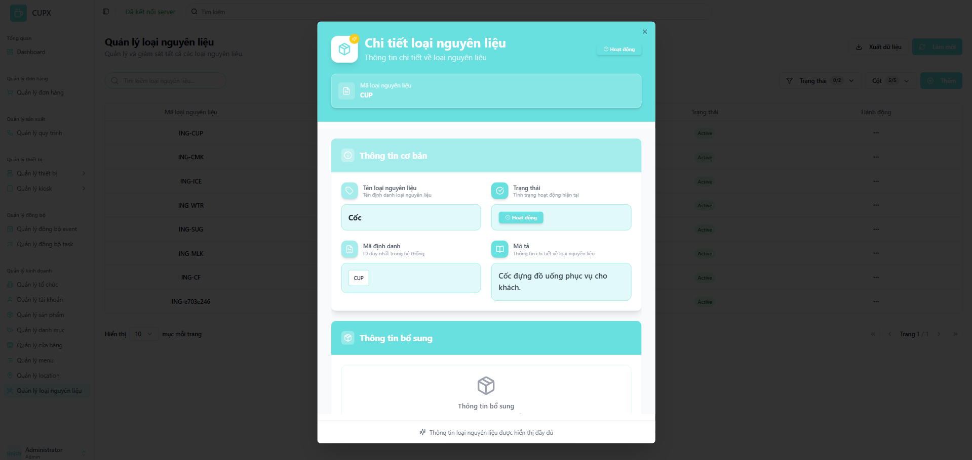
- Function details:
  - Data & Validation:
IngredientTypeId | Must be a valid, existing ingredient type ID
Name | text.
Description | text
Status | Enum

  - Functionalities:
Function | Normal Cases | Abnormal Cases
Open detail modal | Admin clicks “Xem chi tiết,” and the modal opens showing the full details. | If the data cannot be fetched, show an error message
View information | All fields in the "Basic Information" section are clearly displayed | If an optional field like "Description" is empty, it is shown as such.
View additional info | The "Additional Information" section is displayed, even if it has no content.
Close modal | Admin clicks the “×” button or presses Esc to close the modal | If the modal fails to close, allow Esc key as a fallback
- Business Rules: All information in this view is read-only.

3.11.3 Create an ingredient type
- Function description:
  - Actors/Roles: System Admin: Can create new ingredient types.
  - Purpose: This function allows an administrator to add a new ingredient type to the system by providing a name, description, and status.
  - Interfaces:
    - Fields include:
      - Ingredient Type Name (Tên Loại Nguyên Liệu): Required text input.
      - Description (Mô tả): Optional text area.
      - Status (Trạng thái): Required dropdown selection.
    - Action Button:
      - Modal close button “X”.
      - “Tạo” (Create): Submits the form.
      - “Hủy” (Cancel): Closes the modal without saving.
  - Data Processing:
    - The frontend validates the form data. Upon submission, it sends the new data to the backend.
    - The backend validates, creates the new record, and returns a success response. The list is then refreshed.
  - Function trigger:
    - Navigation path: From the ingredient type list, the administrator clicks the “Thêm” (Add) button.
    - Modal Display: A modal opens with an empty form for creating a new ingredient type.
- Screen layout:
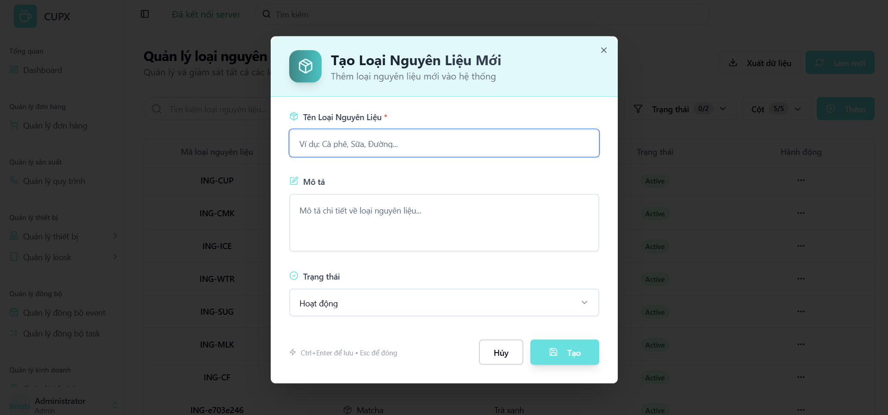
- Function details:
  - Data & Validation:
Name | Required, text, max 255 characters. Must be unique
Description | Optional, text, max 500 characters
Status | Required, Enum ("Hoạt động" - Active, "Không hoạt động" - Inactive). Defaults to "Active".

  - Functionalities:
Function | Normal Cases | Abnormal Cases
Open creation modal | Admin clicks “Thêm”, and the modal opens with a blank form | If the modal fails to open, show an error notification
Fill form | Admin enters a unique name, an optional description, and selects a status | If the required "Name" field is empty, prevent submission and show an inline validation error.
Submit creation | Clicking “Tạo” sends data to the backend. On success, the modal closes, and the list refreshes | If the backend returns an error (e.g., name is not unique), show an informative error message in the modall
Cancel/Close modal | Admin clicks “Hủy” or presses Esc to close the modal | If the modal fails to close, allow fallback closure via the Esc key.
- Business Rules:The ingredient type Name must be unique.

3.11.4 Update an ingredient type
- Function description:
  - Actors/Roles: System Admin: Can edit any existing ingredient type..
  - Purpose: This function allows an administrator to modify the details of an existing ingredient type.
  - Interfaces:
    - Editable Fields Section:
      - Ingredient Type Name (Tên Loại Nguyên Liệu)
      - Description (Mô tả)
      - Status (Trạng thái)
    - Action Button:
      - Modal close button “X”.
      - “Cập nhật” (Update): Saves the changes.
      - “Hủy” (Cancel): Closes the modal without saving.
  - Data Processing:
    - The frontend fetches the current data to pre-fill the form. Upon submission, it sends the updated data to the backend via a PUT request.
  - Function trigger:
    - Navigation path: From the ingredient type list, the administrator clicks the “Hành động” (Action) button, then selects “Chỉnh sửa” (Edit).
    - Modal Display: The update modal opens with all fields pre-filled with the ingredient type’s current data.
- Screen layout:
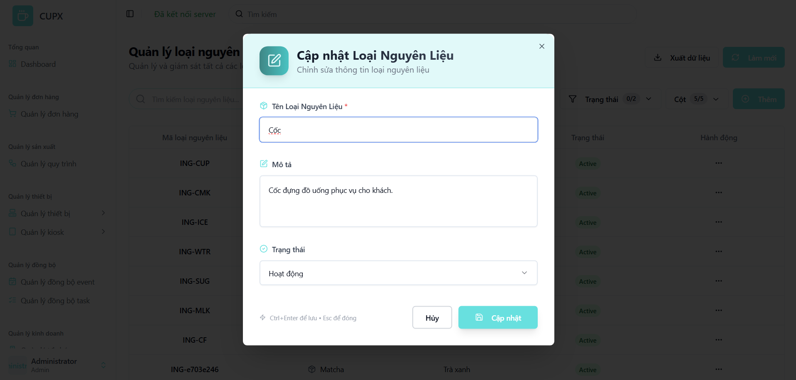
- Function details:
  - Data & Validation:
Name | Required, text, max 255 characters. Must be unique
Description | Optional, text, max 500 characters
Status | Required, Enum ("Hoạt động" - Active, "Không hoạt động" - Inactive). Defaults to "Active".

  - Functionalities:
Function | Normal Cases | Abnormal Cases
Open edit modal | Admin clicks “Chỉnh sửa”, and the modal opens with a blank form | If the modal fails to open, show an error notification
Fill form | Admin enters a unique name, an optional description, and selects a status | If the required "Name" field is empty, prevent submission and show an inline validation error.
Submit creation | Clicking “Tạo” sends data to the backend. On success, the modal closes, and the list refreshes | If the backend returns an error (e.g., name is not unique), show an informative error message in the modall
Cancel/Close modal | Admin clicks “Hủy” or presses Esc to close the modal | If the modal fails to close, allow fallback closure via the Esc key.
- Business Rules:The ingredient type Name must be unique.

3.11.5 Delete an ingredient type
- Function description:
  - Actors/Roles: System Admin: Can delete any ingredient type
  - Purpose: This function allows an administrator to permanently remove an ingredient type from the system after confirmation
  - Interfaces:
    - The "Delete" option is located inside the "Hành động" (Action) dropdown.
    - Clicking “Xóa” (Delete) opens a confirmation modal.
    - The modal displays a warning: Bạn có chắc chắn muốn xóa loại nguyên liệu "[Name]"? Hành động này không thể hoàn tác. (Are you sure you want to delete the ingredient type "[Name]"? This action cannot be undone.)
    - The modal contains a “Hủy” (Cancel) button and a red “Xóa” (Delete) button.
  - Data Processing:
    - Upon confirmation, the frontend sends a DELETE request with the ingredient type ID to the backend.
    - The backend validates permissions, deletes the record, and returns a success response.
  - Function trigger:
    - Navigation path: From the ingredient type list, the administrator clicks the “Hành động” (Action) button, then selects “Xóa” (Delete).
- Screen layout:
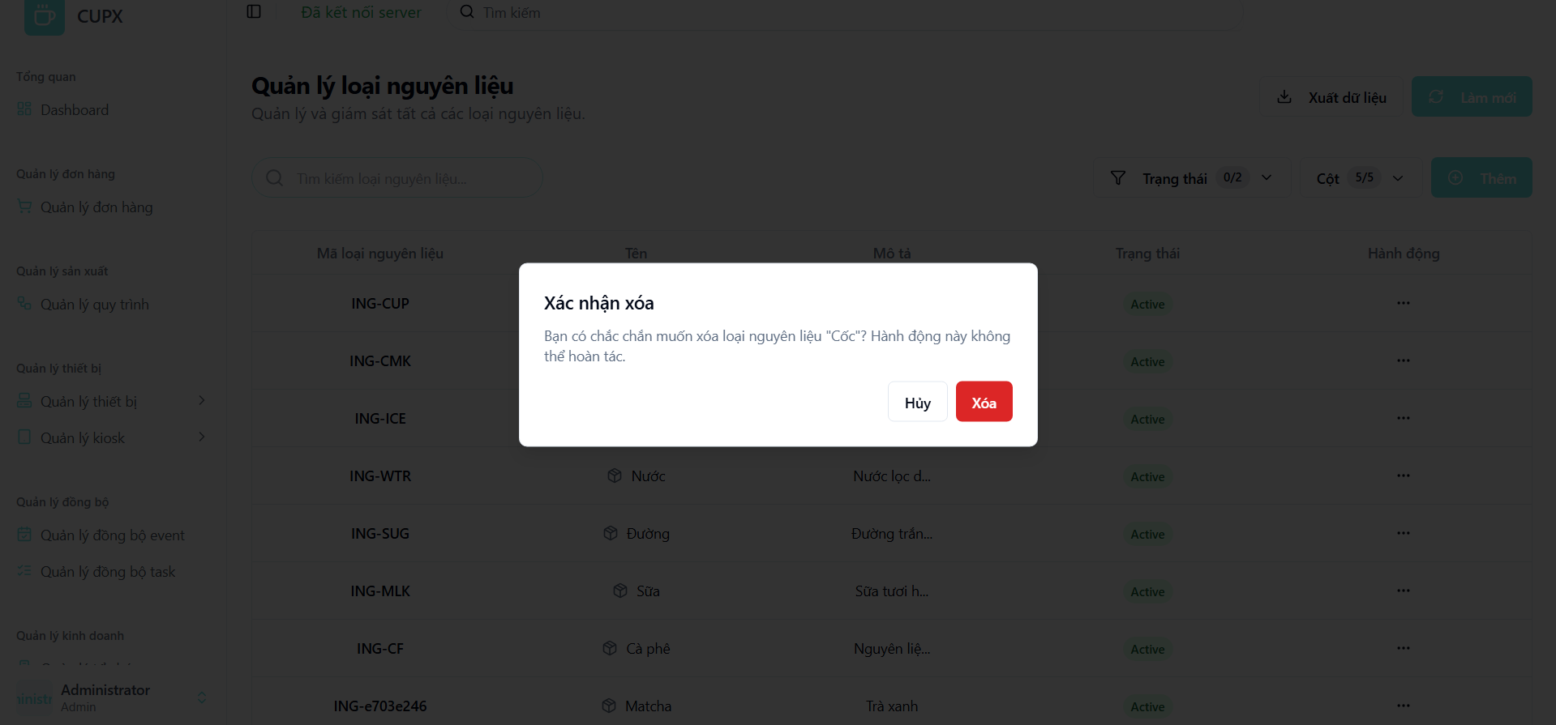
- Function details:
  - Data & Validation:
  - Functionalities:
Function | Normal Cases | Abnormal Cases
Initiate deletion | Admin clicks "Xóa," and the confirmation modal appears | If the modal fails to open, show an error.
Confirm deletion | Admin clicks the red "Xóa" button. The ingredient type is deleted, the modal closes, and the list refreshes | If the API call fails (e.g., type is in use), show an error toast and keep the user on the page.
Cancel deletion | Admin clicks "Hủy" or closes the modal. No action is taken | If the modal fails to close, allow Esc key fallback.
- Business Rules: The system should prevent the deletion of an ingredient type if it is currently associated with any product's recipe. An appropriate error message should be displayed.

3.12 Sync Event Management Screen

3.12.1 View list of sync events
- Function description:
  - Actors/Roles: System Admin: Has full access to view system-level synchronization logs.
  - Purpose: This function allows administrators to monitor and audit system-generated synchronization events. It serves as a log for debugging data consistency issues between different system components or services.
  - Interface:
    - Table: Displays a structured, paginated list of all sync events with the following columns:
      - Event ID (Mã sự kiện)
      - Event Type (Loại sự kiện)
      - Entity Type (Loại thực thể)
      - Created Date (Ngày tạo)
      - Number of Tasks (Số tác vụ)
      - Action (Hành động)
    - Optional UI Element:
      - Search bar (Tìm kiếm theo mã thực thể...)
      - Filter dropdown (Loại sự kiện - Event Type)
      - Pagination controls
      - Column visibility configuration (Cột - Columns)
      - Refresh button (Làm mới)
      - Export data button (Xuất dữ liệu)
  - Data Processing:
    - The client sends requests with filter, search, and paging parameters to the server.
    - The server responds with a paginated list of sync event log data.
  - Function trigger:
    - Navigation path: The administrator accesses the list by clicking the “Quản lý đồng bộ event” (Sync Event Management) item in the sidebar menu.
    - Timing Frequency: Data is re-fetched on page load, manual refresh, or periodically to show the latest events.
- Screen layout:

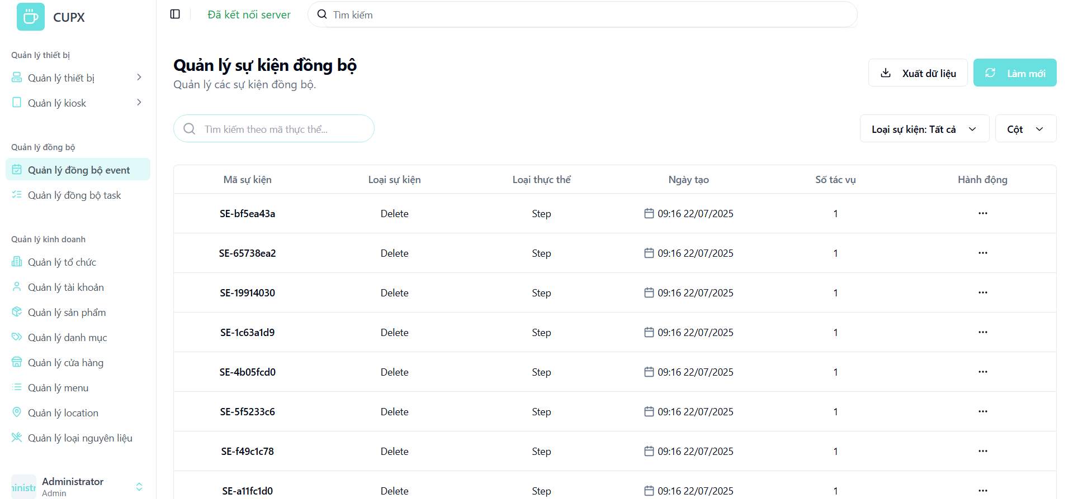
- Function details:
  - Data & Validation:
EventId | Auto-generated, unique identifier
EventType | Required, Enum
EntityType | Required, text, represents the type of data being synced
CreatedDate | Auto-set by the system, displayed with time and date
TaskCount | Integer representing the number of sync tasks associated with this event

  - Functionalities:
Function | Normal Cases | Abnormal Cases
Access event list | Admin opens the screen and views the paginated log table | f the API fails, show an error message with a retry option
Search by keyword | Admin types an entity ID into the search bar to find related sync events | f no results are found, display a message like "No events found."
Apply filters | Admin filters the list by Loại sự kiện (Event Type | If the filter is invalid, show a warning and revert to the previous state
Pagination navigation | Admin uses pagination controls to navigate through pages | If a requested page is out of range, reset to page 1
- Business Rules: This screen is a read-only log. Events are generated automatically by the system and cannot be created, updated, or deleted by the user from this interface.
- The Hành động (Action) column is expected to only contain an option to "View Detail".

3.12.2 View detail of a sync event
- Function description:
  - Actors/Roles: System Admin: Can view the detailed breakdown of any sync event.
  - Purpose: This function provides a detailed, read-only view of a specific sync event, including the associated entity IDs and the status of the synchronization tasks.
  - Interface:
    - Header Section: Displays the full Event ID (Mã sự kiện) and the event's creation timestamp.
    - Event Information Section (
      - Event Type (Loại sự kiện)
      - Entity Type (Loại thực thể)
      - Entity ID (Mã thực thể): The ID of the specific record that triggered the event.

    - Task List Section (
      - Lists the individual sync task IDs associated with the event.
      - Displays the status of each task with a badge (e.g., Chưa đồng bộ - Not Synced).

    - Action Button:
      - Modal close button "X".
  - Data Processing:
    - The frontend sends the event ID to the backend when the detail view is triggered.
    - The backend returns the full data object for that specific event, including its related tasks.
  - Function trigger:
    - Navigation path: From the “Quản lý sự kiện đồng bộ” screen, the administrator clicks the “Hành động” (Action) button on a specific row, then selects "View Detail".
    - Modal Display: A modal overlay appears with the read-only event information.
- Screen layout:
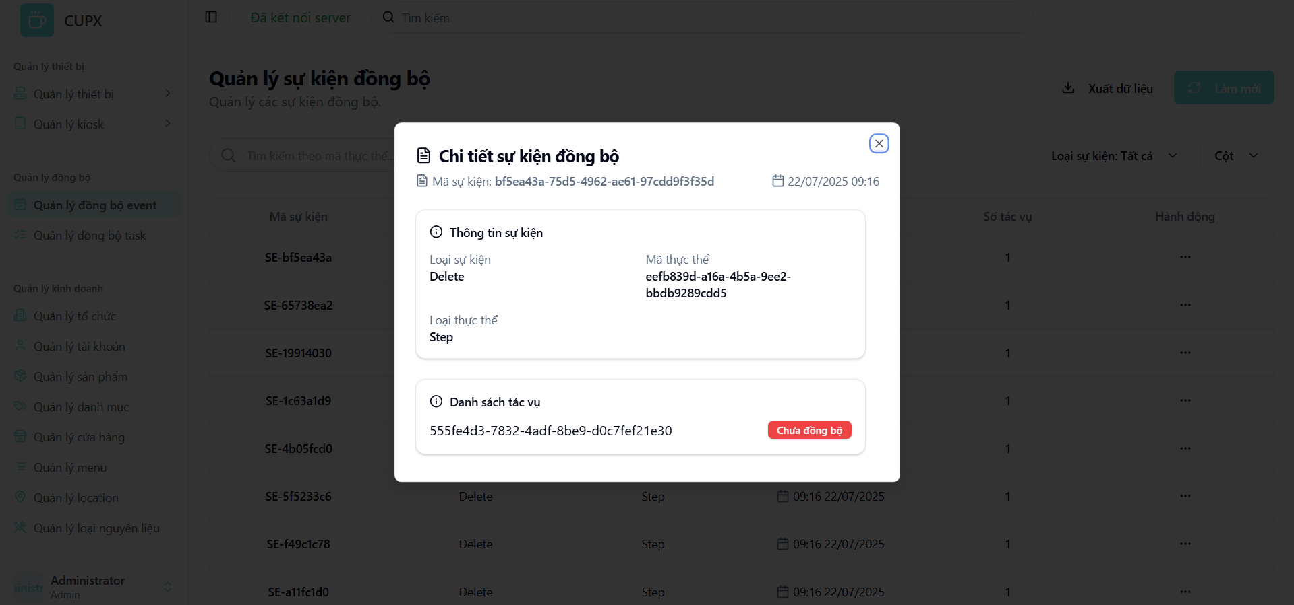
- Function details:
  - Data & Validation:
EventId | Auto-generated, unique identifier
EventType | Required, Enum
EntityType | Required, text, represents the type of data being synced
EntityId | A unique identifier (UUID) for the source record
TaskId | A unique identifier (UUID) for the sync task
TaskStatus | Enum

  - Functionalities:
Function | Normal Cases | Abnormal Cases
Open detail modal | Admin clicks to view details, and the modal opens showing the full event information | If the event data cannot be fetched, show an error message
View information | All fields, including IDs and types, are clearly displayed. The status of each sync task is visible | If data is missing from the backend response, corresponding fields may be empty or show a placeholder
Close modal | Admin clicks the “×” button or presses Esc to close the modal | If the modal fails to close, allow Esc key as a fallback
- Business Rules:
  - All information in this view is read-only and intended for diagnostic purposes.
  - The status badge on each task (Chưa đồng bộ, etc.) is a critical indicator for debugging the synchronization process.

3.13 Sync Task Management Screen

3.13.1 View list of sync tasks
- Function description:
  - Actors/Roles: System Admin: Has full access to view system-level synchronization tasks.
  - Purpose: This function allows administrators to monitor the status of individual synchronization tasks. Each task represents an attempt to sync a specific event (like a data change) to a target entity (like a kiosk). This screen is crucial for diagnosing issues at a granular level.
  - Interface:
    - Table: Displays a structured, paginated list of all sync tasks with the following columns:
      - Task ID (Mã tác vụ)
      - Kiosk ID (Mã kiosk)
      - Created Date (Ngày tạo)
      - Status (Trạng thái)
      - Action (Hành động)
    - Optional UI Element:
      - Search bar (Tìm kiếm theo mã kiosk...)
      - Filter dropdown (Trạng thái - Status)
      - Pagination controls
      - Column visibility configuration (Cột - Columns)
      - Refresh button (Làm mới)
      - Export data button (Xuất dữ liệu)
  - Data Processing:
    - The client sends requests with filter, search, and paging parameters to the server.
    - The server responds with a paginated list of sync task data.
  - Function trigger:
    - Navigation path: The administrator accesses the list by clicking the “Quản lý đồng bộ task” (Sync Task Management) item in the sidebar menu.
    - Timing Frequency: Data is re-fetched on page load, manual refresh, or periodically to show the latest task statuses.
- Screen layout:
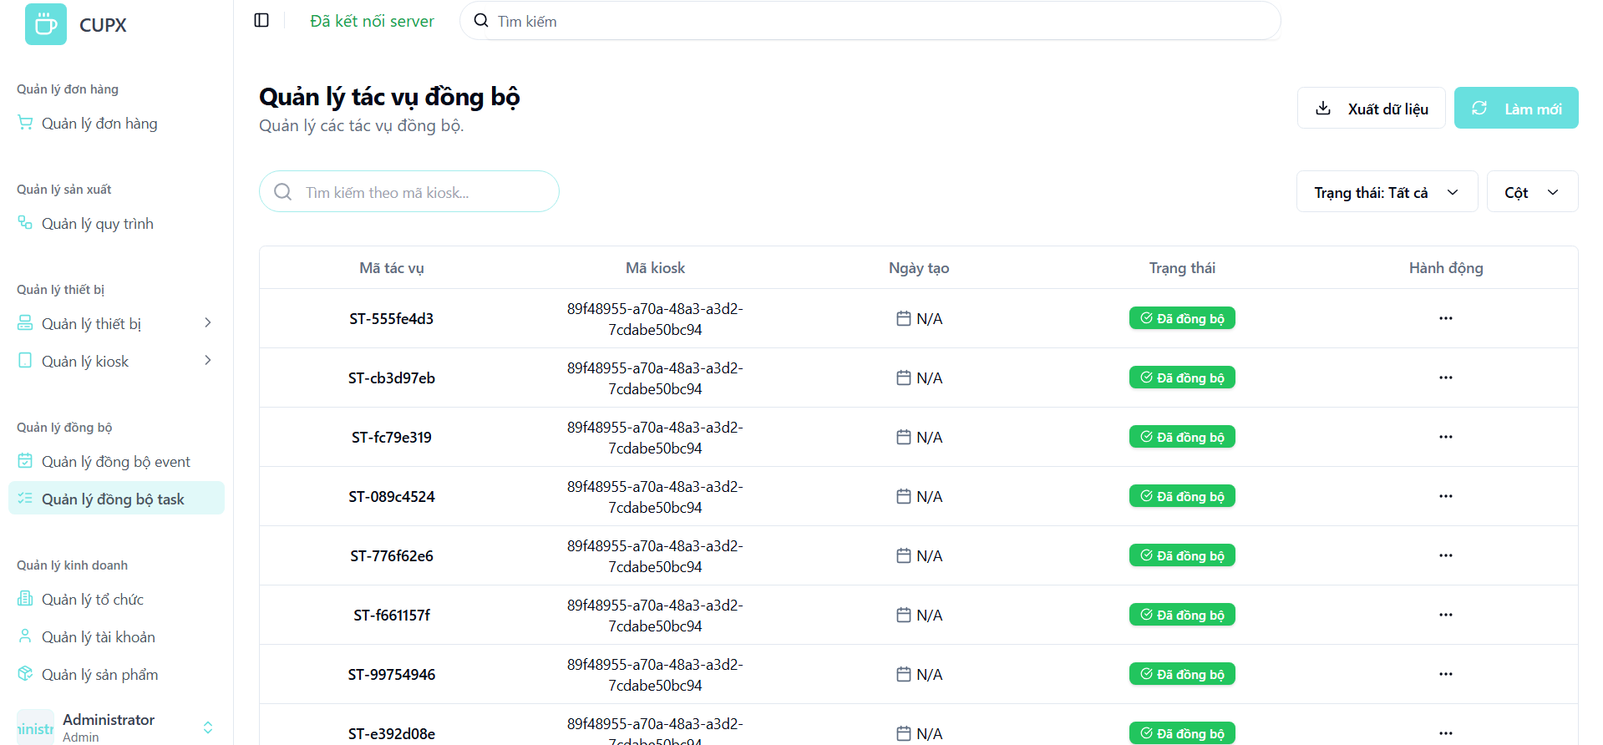
- Function details:
  - Data & Validation:
TaskId | Auto-generated, unique identifier
KioskId | The unique identifier (UUID) of the target kiosk for the sync
CreatedDate | The date the task was created. Displayed as "N/A" if not available
Status | Required, Enum

  - Functionalities:
Function | Normal Cases | Abnormal Cases
Access task list | Admin opens the screen and views the paginated log table | If the API fails, show an error message with a retry option.
Search by keyword | Admin types a Kiosk ID into the search bar to find all tasks related to that kiosk | If no results are found, display a message like "No tasks found."
Apply filters | Admin filters the list by Trạng thái (Status). | If the filter is invalid, show a warning and revert to the previous state
Pagination navigation | Admin uses pagination controls to navigate through pages | If a requested page is out of range, reset to page 1
- Business Rules:
  - This screen is a read-only log. Tasks are generated and updated automatically by the system and cannot be manually changed by the user.
  - The Ngày tạo (Created Date) being "N/A" might indicate a data issue or that the timestamp is not a primary concern for this view.

3.13.2 View detail of an sync task
- Function description:
  - Actors/Roles: System Admin: Can view the detailed breakdown of any sync task.
  - Purpose:This function provides a detailed, read-only view of a specific sync task, linking it back to the originating event and the target kiosk, and showing its current status.
  - Interface:
    - Header Section: Displays the full Task ID (Mã tác vụ).
    - Task Information Section (
      - Event ID (Mã sự kiện): The ID of the parent sync event.
      - Kiosk ID (Mã kiosk): The ID of the target kiosk.
      - Status (Trạng thái): The current status of the task, displayed as a colored badge.

    - Action Button:
      - Modal close button "X".
  - Data Processing:
    - The frontend sends the task ID to the backend when the detail view is triggered.
    - The backend returns the full data object for that specific task.
  - Function trigger:
    - Navigation path: From the “Quản lý tác vụ đồng bộ” screen, the administrator clicks the “Hành động” (Action) button on a specific row, then selects "View Detail".
    - Modal Display: A small, centered modal appears with the read-only task information.
- Screen layout:
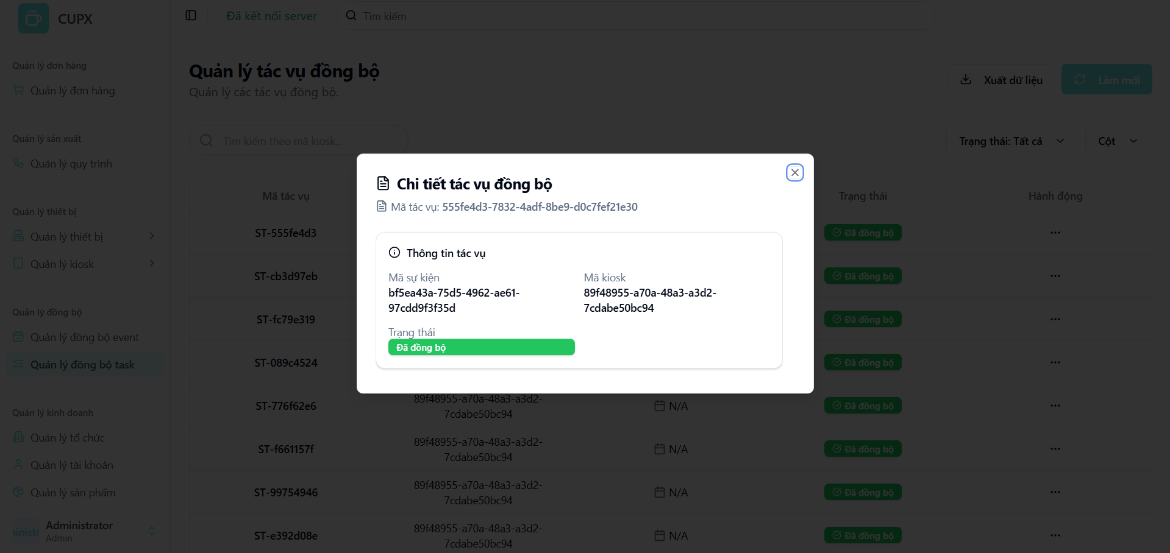
- Function details:
  - Data & Validation:
TaskId | Auto-generated, unique identifier
KioskId | The unique identifier (UUID) of the target kiosk for the sync
EventId | The unique identifier (UUID) of the parent event.
Status | Required, Enum

  - Functionalities:
Function | Normal Cases | Abnormal Cases
Open detail modal | Admin clicks to view details, and the modal opens showing the task's full information | If the task data cannot be fetched, show an error message.
View information | All relevant IDs and the task status are clearly displayed | If data is missing from the backend response, corresponding fields may be empty
Close modal | Admin clicks the “×” button or presses Esc to close the modal | If the modal fails to close, allow Esc key as a fallback
- Business Rules:
  - All information in this view is read-only and is used to trace a specific sync operation from its parent event to a specific target kiosk.

3.14 Device Management Screen

3.14.1 View list of devices
- Function description:
  - Actors/Roles:
    - System Admin: Has full access to view all devices across all kiosks and organizations.
    - Organization Admin: Can only view devices that belong to kiosks within their own organization.
  - Purpose: This screen allows administrators to monitor and manage all hardware devices (e.g., tablets, robot arms, pumps) connected to the smart coffee vending system. It supports oversight of device status, hardware type, and operational availability.
  - Interface:
    - Table: Displays a structured, paginated list of all organization with following columns:
      - Device Id
      - Device Name
      - Device Type
      - Serial Number
      - Device Model Name
      - Device Type Name
      - Status badge
      - Created Date
      - Updated Date
      - Action
    - Optional UI Element:
      - Search bar
      - Filter dropdowns
      - Pagination controls
      - Column visibility configuration
      - “Làm mới” (Refresh) button
      - “Xuất dữ liệu” button
  - Data Processing:
    - Server returns for the client a list of devices based on filter, search, sort and paging.
- Function trigger:
  - Navigation path: From the left sidebar, admin selects “Quản lý thiết bị” > “Thiết bị”.
  - Timing Frequency: Data is auto-refresh every 60 seconds, or manually via browser reload or clicking button “Làm mới”
- Screen layout:
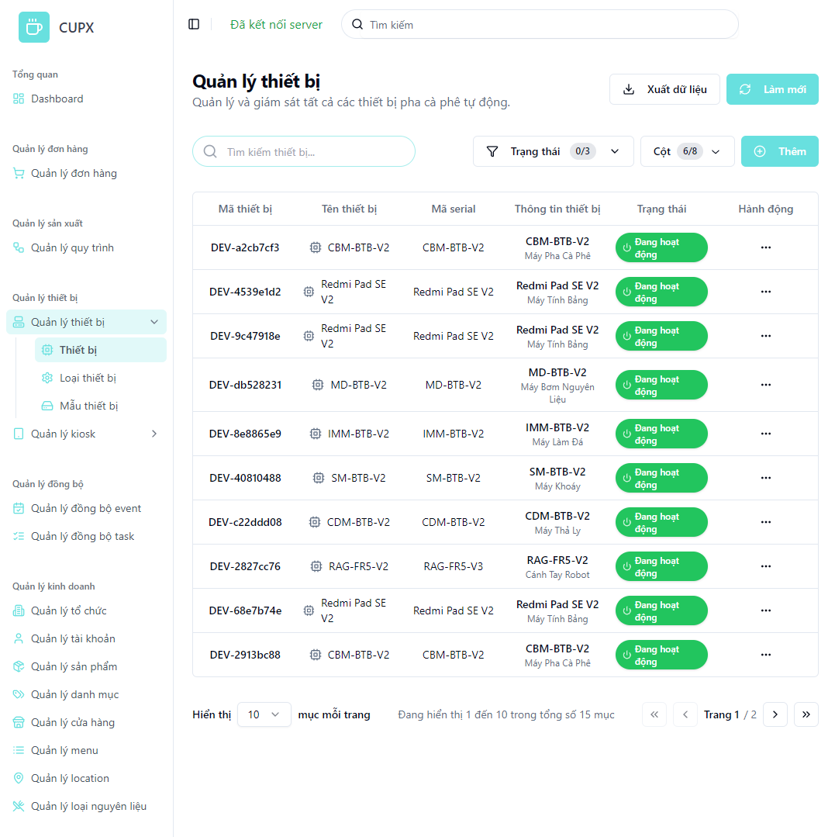
- Function details:
  - Data & Validation:
Data | Validations
DeviceId | …
DeviceName | …
SerialNumber | …
DeviceModelName | …
DeviceTypeName | …
Status | …
CreatedDate | …
UpdatedDate | …

  - Functionalities:
Function | Normal Cases | Abnormal Cases
Access device list | Admin opens the screen and views the paginated device table. | If the API fails, show an error message with a retry option.
Search by keyword | Admin types device name or code into search bar to filter results. | If no match, display “Không tìm thấy thiết bị”
Filter by status | Admin filters by “Đang hoạt động”, “Không hoạt động” | If invalid input, keep previous filter
Sort by column | Admin clicks column headers (e.g., Created Date) | If sort fails, fallback to default order
Pagination navigation | Admin changes pages with controls (next, prev, index) | If out-of-bound index, reset to page 1 with warning
Manual refresh | Admin clicks “Làm mới” to reload the product list. | If reload fails, display toast with a retry option.
Action menu | Admin opens “…” dropdown → access to view, edit, delete options | If permission denied, hide or disable the option

  - Business Rules:

3.14.2 View detail of a device
- Function description:
  - Actors/Roles:
    - System Admin: Has full access to view device details across all organizations.
    - Organization Admin: Can only view devices that belong to their own organization (if linked).
  - Purpose: This screen allows administrators to view detailed information about a specific physical device in the system, including identity, status, serial number, device model, type, and timestamps. It ensures traceability, inventory management, and device status verification.
  - Interface:
    - Basic Information Section:
      - Device Name
      - Serial Number
      - Description
    - Device Model Information Section:
      - Model Name
      - Manufacturer
      - Device Type (e.g., Coffee Machine, Tablet, etc.)
      - Model Status (e.g., “Active”)
    - Status Badge:
      - Display account status (e.g., “Hoạt động”).
    - Timestamp Section:
      - Created Date
      - Updated Date
    - Action Button:
      - Modal close button “X”
  - Data Processing:
    - Frontend sends a request to the backend using the device ID.
    - Backend returns all device information in detail.
- Function trigger:
  - Navigation path: “Quản lý thiết bị” screen, admin clicks on the “Hành động” button, then selects “Xem chi tiết”.
  - Modal Display: A modal opens with all the product information divided into separate logical cards.
- Screen layout:
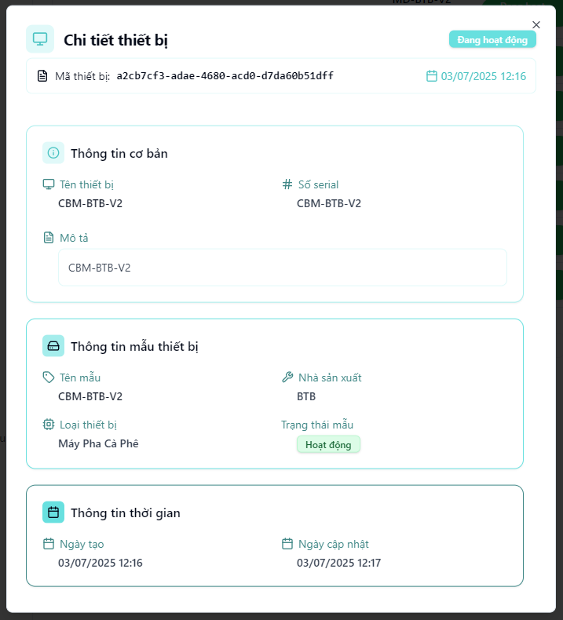
- Function details:
  - Data & Validation:
Data | Validations
DeviceId | …
DeviceName | …
SerialNumber | …
Description | …
DeviceModelName | …
Manufacturer | ..
DeviceTypeName | …
DeviceTypeName | …
CreatedDate | …
UpdatedDate | …

  - Functionalities:
Function | Normal Cases | Abnormal Cases
Open device detail | Admin clicks “View detail”, a modal appears showing all device info. | If the device is deleted or inaccessible, show “Không tìm thấy thiết bị”
View basic info | Device name, serial number, and description displayed properly. | If missing data, show “Không có” or placeholder text.
View model info | Displays model name, manufacturer, type, and status clearly. | If model data is unavailable, show “Không rõ”
View timestamps | Dates are formatted and presented clearly under “Thông tin thời gian”. | If update date is null, show “Chưa cập nhật”.
Close modal | Admin clicks the “×” button to close. | If modal fails to close, allow ESC fallback or click outside to dismiss.

  - Business Rules:

3.14.3 Create a device
- Function description:
  - Actors/Roles:
    - System Admin: Can create devices for all device models in the system.
    - Organization Admin: No access to this feature.
  - Purpose: This screen enables the administrator to create a new physical device in the system by assigning a name, serial number, model, and operational status. This action registers the device into the platform for tracking, configuration, and synchronization.
  - Interface:
    - Fields include:
      - Device Name
      - Serial Number
      - Device Model
      - Status
      - Description
    - Action Button
      - Modal close button “X”
      - “Tạo” (Create): Submits the form to the backend.
      - “Hủy” (Cancel): Closes modal without saving.
  - Data Processing:
    - When the admin submits the form, the frontend validates input data and sends it to the backend.
    - Backend persists the new product and returns success/failure response.
    - Upon success, modal closes and the list is refreshed.
- Function trigger:
  - Navigation path: From the “Device Management” screen, admin clicks the "Thêm" (Add) button in the top-right corner.
  - Modal Display: A modal opens, showing a form with input fields.
- Screen layout:
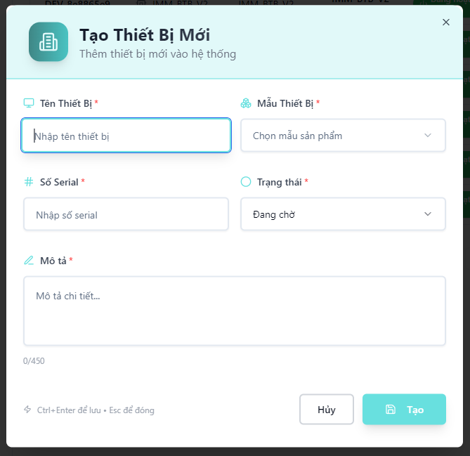
- Function details:
  - Data & Validation:
Data | Validations
DeviceName | Required, max 100 characters
SerialNumber | Required, must be unique across all devices
DeviceModelId | Required, must refer to a valid existing device model
Status | Required, valid enum: “Pending”, “Active”, “Inactive”, etc.
Description | Optional, max 450 characters

  - Functionalities:
Function | Normal Cases | Abnormal Cases
Open create modal | Admin clicks “Thêm”, modal opens with empty fields | If modal fails to load, show error and retry option
Fill form & submit | All required fields filled, click “Tạo” to create device | If validation fails (e.g., duplicate serial), show field-level error messages
Validate uniqueness | Serial number must be unique; backend checks before saving | f duplicate found, return error: “Serial number already exists”
Cancel creation | Admin clicks “Hủy” or “Esc”, modal closes without changes | If close fails, fallback via ESC or page reload
Submit creation | Click “Tạo” sends data to backend and closes modal on success. | If the backend returns an error (e.g. validation fails), show an inline error message.
Cancel/Close modal | Admin clicks “Hủy” to close modal without saving. | If modal fails to close, allow fallback via ESC.

  - Business Rules:

3.14.4 Update a device
- Function description:
  - Actors/Roles:
    - System Admin: Can update any device across the system.
    - Organization Admin: No access to this feature.
  - Purpose: This screen allows the administrator to modify existing information of a registered physical device, such as name, serial, model, status, or description. This ensures that device metadata remains accurate and up to date.
  - Interface:
    - Editable Fields Section:
      - Device Name
      - Serial Number
      - Device Model
      - Status
      - Description
    - Action Button
      - Modal close button “X”
      - “Cập nhật” (Update): Saves the updated device data.
      - “Hủy” (Cancel): Closes the modal without saving.
  - Data Processing:
    - The frontend gathers updated data and sends a PUT request to the backend API to persist the changes.
- Function trigger:
  - Navigation path: From “Quản lý thiết bị” screen → Click "Chỉnh sửa" in the action menu of a device row.
  - Modal Display:The update modal opens with all fields pre-filled with the store’s current data.
- Screen layout:
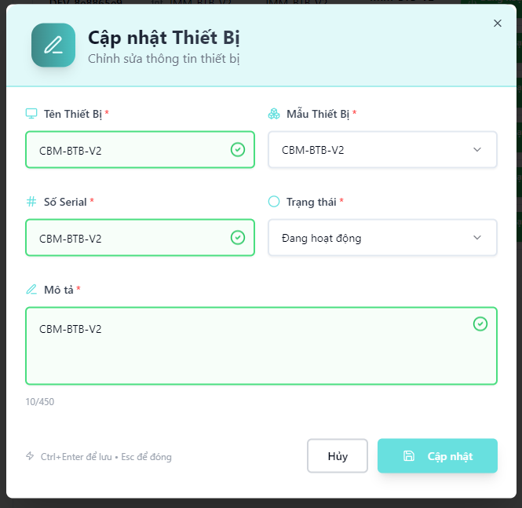
- Function details:
  - Data & Validation:
Data | Validations
DeviceName | Required, max 100 characters
SerialNumber | Required, must be unique (if changed)
DeviceModelId | Required, must refer to a valid device model
Status | Required, valid enum: Active, Pending, Inactive, etc.
Description | Optional, max 450 characters

  - Functionalities:
Function | Normal Cases | Abnormal Cases
Open update modal | Admin clicks "Chỉnh sửa", modal opens with current info | If device not found (404), show error toast
Modify fields | Admin updates name, status, description, etc. | If invalid value (e.g., empty required field), show inline validation error
Change serial | Admin updates serial and submits | If duplicate serial, show backend error message
Submit update | Admin clicks “Cập nhật” to save changes | If backend error, show retry option
Cancel/Close modal | Admin clicks “Hủy” or presses Esc to close without saving | If modal close fails, reload page fallback

  - Business Rules:

3.14.5 Delete a device
- Function description:
  - Actors/Roles:
    - System Admin: Has full access to delete any device across the entire system..
    - Organization Admin: Can delete products within their assigned organization.
  - Purpose: This function allows administrators to permanently delete a device from the system. It helps clean up unused or deprecated devices, ensuring a tidy and accurate device inventory.
  - Interface:
    - The Delete option is located inside the "Hành động" (Action) dropdown on the device list screen.
    - A confirmation modal is shon — clicking "Xác nhận" will immediately trigger the deletion process and remove the device.
    - The deleted device will disappear from the table after the operation.
  - Data Processing:
    - Frontend sends a DELETE request to the backend API with the device ID.
    - Backend verifies permission, deletes device record, and returns success status.
    - On success, frontend refreshes the list to remove the deleted device.
    - Error toast is displayed in case of API failure (e.g., 403, 500).
- Function trigger:
  - Navigation path: From the sidebar, admin selects "Quản lý thiết bị", clicks the "⋯" action button on a device row, and chooses "Xoá" to trigger the confirmation modal.
- Layout:
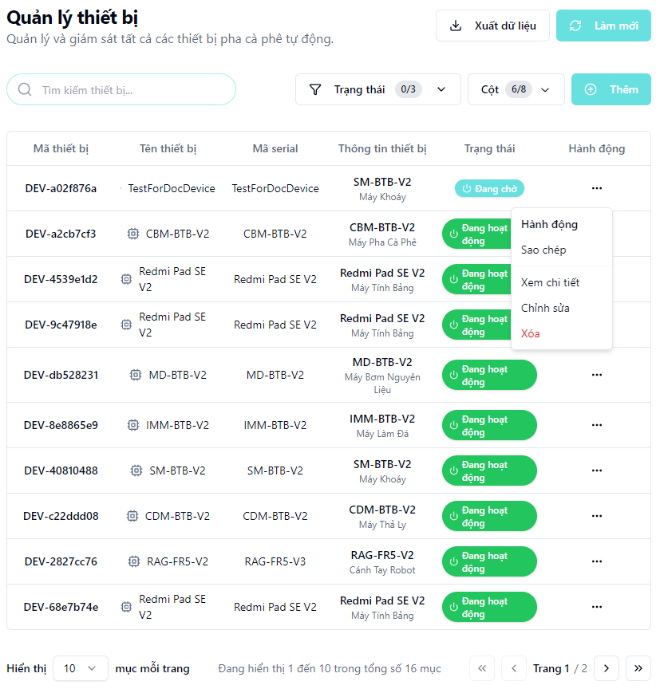
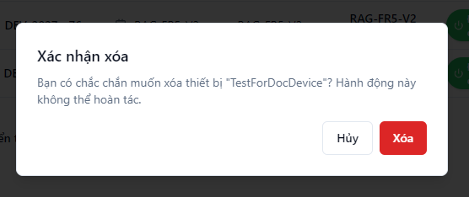

3.15 Device Model Management Screen

3.15.1 View list of device models
- Function description:
  - Actors/Roles:
    - System Admin: Has full access to view all device models registered in the system.
    - Organization Admin: Can only view device models that belong to kiosks within their own organization.
  - Purpose: This screen allows users to view and manage all device models (e.g., SM-BTB-V2, IMM-BTB-V2, etc.) which represent hardware templates used across different kiosks. It supports monitoring manufacturer, hardware category, and operational status.
  - Interface:
    - Table: Displays a structured, paginated list of all organization with following columns:
      - Device Model Id
      - Device Model Name
      - Manufacturer
      - Device Type Name
      - Status badge
      - Created Date
      - Updated Date
      - Action
    - Optional UI Element:
      - Search bar
      - Filter dropdowns
      - Pagination controls
      - Column visibility configuration
      - “Làm mới” (Refresh) button
      - “Xuất dữ liệu” button
  - Data Processing:
    - Server returns for the client a list of devices based on filter, search, sort and paging.
- Function trigger:
  - Navigation path: From the left sidebar, admin selects “Quản lý thiết bị” clicks “Mẫu thiết bị”.
  - Timing Frequency: Data is auto-refresh every 60 seconds, or manually via browser reload or clicking button “Làm mới”
- Screen layout:

- Function details:
  - Data & Validation:
Data | Validations
DeviceModelId | …
DeviceModelName | …
Manufacture | …
DeviceTypeName | …
Status | …
CreatedDate | …
UpdatedDate | …

  - Functionalities:
Function | Normal Cases | Abnormal Cases
Access device model list | Admin opens the screen and views the paginated device table. | If the API fails, show an error message with a retry option.
Search by keyword | Admin types device model name or code into search bar to filter results. | If no match, display “Không tìm thấy mẫu thiết bị”
Filter by status | Admin filters by “Đang hoạt động”, “Không hoạt động” | If invalid input, keep previous filter
Sort by column | Admin clicks column headers (e.g., Created Date) | If sort fails, fallback to default order
Pagination navigation | Admin changes pages with controls (next, prev, index) | If out-of-bound index, reset to page 1 with warning
Manual refresh | Admin clicks “Làm mới” to reload the device model list. | If reload fails, display toast with a retry option.
Action menu | Admin opens “…” dropdown → access to view, edit, delete options | If permission denied, hide or disable the option

  - Business Rules:

3.15.2 View detail of a device model
- Function description:
  - Actors/Roles:
    - System Admin: Has permission to view details of any device model across the system.
    - Organization Admin: Can view device models related to device types they manage.
  - Purpose: This function allows administrators to view complete information about a specific device model, including manufacturer, device type, functions, and supported parameters. It supports validation, troubleshooting, and configuration alignment across kiosks.
  - Interface:
    - Basic Information Section:
      - Device Model Name
      - Manufacturer
      - Device Type
      - Device Model ID
      - Created Date
      - Status badge
    - Device Function Section:
      - Function Name (e.g., runScript)
      - Function ID (Copyable)
      - List of Parameters:
        - Parameter Name
        - Parameter Type
        - Default Value
        - Available Choices
        - Parameter ID
    - Action Button:
      - Modal close button “X”
  - Data Processing:
    - Frontend sends a request to the backend using the device model ID.
    - Backend returns all device model information in detail.
- Function trigger:
  - Navigation path: “Quản lý mẫu thiết bị” screen, admin clicks on the “Hành động” button, then selects “Xem chi tiết”.
  - Modal Display: A modal opens with all the product information divided into separate logical cards.
- Screen layout:
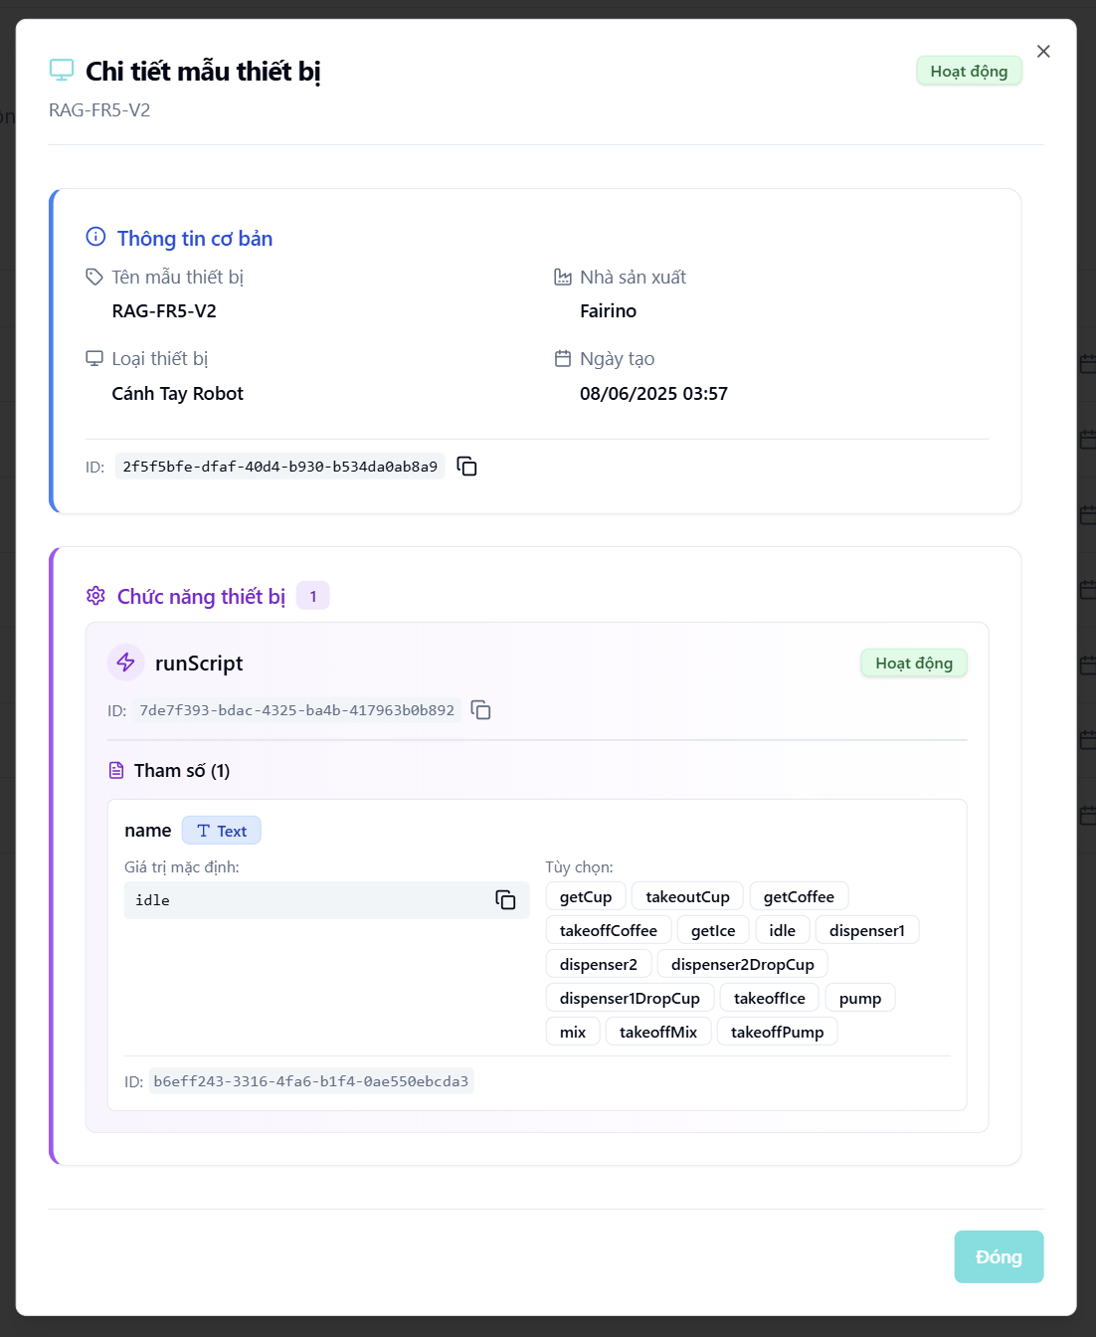
- Function details:
  - Data & Validation:
Data | Validations
DeviceModelId | …
Name | …
Manufacturer | …
DeviceTypeName | …
Status | …
Functions[] | …
Function.Name | …
Parameters[] | …
Parameter.Type
Parameter.Default
Parameter.Options
CreatedDate | …
UpdatedDate | …

  - Functionalities:
Function | Normal Cases | Abnormal Cases
Open device model detail | Admin clicks “View detail”, modal shows full device model info. | If model not found, show “Không tìm thấy mẫu thiết bị”
View base information | Shows name, manufacturer, type, created date. | If missing data, show “Không có” or placeholder
View status | Shows status badge (e.g., “Hoạt động”) | If unknown status, fallback to neutral display
View timestamps | Dates are formatted and presented clearly under “Thông tin thời gian”. | If update date is null, show “Chưa cập nhật”.
View functions | List device functions clearly with function name + ID | If no function, display “Không có chức năng nào”
View parameters | Shows param name, type, default, and choice list if applicable | If invalid config, show warning badge or placeholder text
Close modal | Admin clicks the “×” button to close. | If modal fails to close, allow ESC fallback or click outside to dismiss.

  - Business Rules:

3.15.3 Create a device model
- Function description:
  - Actors/Roles:
    - System Admin: Can create any device model in the system.
    - Organization Admin: No access to this feature.
  - Purpose: This function allows authorized users to register a new device model, define its core specifications (name, type, manufacturer), and configure its supported functions and ingredient components. This enables centralized control and modular usage across various kiosks.
  - Interface:
    - Basic Information Section:
      - Device Model Name
      - Manufacturer
      - Device Type
      - Status
    - Device Function Section:
      - List of functions:
        - Function Name
        - Label
        - Status
        - Parameters:
          - Name
          - Type
          - Options
          - Default Value
          - Description
    - Device Ingredient Section:
      - List of ingredients used by this model:
        - Label
        - Ingredient Type
        - Min / Max capacity
        - Warning Percentage
        - Unit
        - Status
        - Is Main
        - Is Refillable
        - Optional: Binding to device function and mapping with specific parameters (selection value, target parameter)
    - Action Button
      - Modal close button “X”
      - “Tạo” (Create): Submits the form to the backend.
      - “Hủy” (Cancel): Closes modal without saving.
      - “Thêm chức năng” (Add function)
      - “Thêm tham số” (Add parameter)
      - “Thêm nguyên liệu” (Add ingredient)
  - Data Processing:
    - When the admin submits the form, the frontend validates input data and sends it to the backend.
    - Backend persists the new product and returns success/failure response.
    - Upon success, modal closes and the list is refreshed.
- Function trigger:
  - Navigation path: From the “Quản lí mẫu thiết bị” screen, admin clicks the "Thêm" (Add) button in the top-right corner.
  - Modal Display: A modal opens, showing a form with input fields.
- Screen layout:

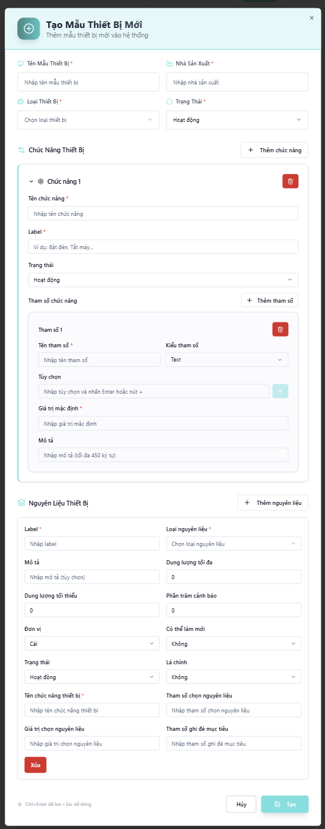
- Function details:
  - Data & Validation:
Data | Validations
DeviceModelName | Required, unique, max 255 chars
Manufacturer | Required, max 255 chars
DeviceTypeId | Required, must match an existing type
Status | Optional, default to “Active”
Functions[] | Optional, but each function must be valid if added
Function.Name | Required, max 255 chars
Function.Label | Optional, max 255 chars
Function.Status | Must be “Active” or “Inactive”
Parameters[] | Optional; each must have valid name/type
Parameter.Name | Required, unique within function
Parameter.Type | Required, must be supported (Text, Number, Enum, etc.)
Parameter.Default | Required, must match type
Parameter.Choices[] | Optional for Enum/Text types only
Parameter.Description | Optional, max 450 chars
Ingredients[] | Optional; if added must include full mapping
Ingredient.Label | Required, max 255 chars
Ingredient.TypeId | Required, must match valid ingredient type
Ingredient.MinCapacity | Must be ≥ 0
Ingredient.MaxCapacity | Must be > MinCapacity
Ingredient.WarningPercent | Must be between 0 and 100
Ingredient.Unit | Required, from pre-defined enum
Ingredient.IsMain | Boolean
Ingredient.IsRefillable | Boolean
Ingredient.FunctionMappingName | Optional, must match existing function
Ingredient.ParameterName | Optional, must match parameter in the mapped function
Ingredient.ParameterValue | Optional, string
Ingredient.ParameterTarget | Optional, for target result parameter

  - Functionalities:
Function | Normal Cases | Abnormal Cases
Open create modal | Admin opens “Create Device Model” modal | If modal fails to open, show toast message
Input base info | Admin fills name, type, manufacturer | If required fields missing, show red validation
Add function | Admin adds function and enters parameters | If param missing or invalid, highlight in red
Add ingredient | Admin maps ingredients with values and function links | If min greater than max capacity, show validation error
Submit form | All fields pass validation new model saved | If any validation fails, block submission and scroll to error
Cancel/Close modal | Admin clicks “Hủy” to close modal without saving. | If modal fails to close, allow fallback via ESC.

  - Business Rules:

3.15.4 Update a device model
- Function description:
  - Actors/Roles:
    - System Admin: Can update all device models across the platform.
    - Organization Admin: No access to this feature.
  - Purpose: This function allows authorized users to update the configuration of an existing device model, including its basic information (name, type, manufacturer, status), associated functions, parameters, and related ingredient configuration.
  - Interface:
    - Basic Information Section:
      - Device Model Name
      - Manufacturer
      - Device Type
      - Status
    - Device Function Section:
      - List of functions:
        - Function Name
        - Label
        - Status
        - Parameters:
          - Name
          - Type
          - Options
          - Default Value
          - Description
    - Device Ingredient Section:
      - List of ingredients used by this model:
        - Label
        - Ingredient Type
        - Min / Max capacity
        - Warning Percentage
        - Unit
        - Status
        - Is Main
        - Is Refillable
        - Optional: Binding to device function and mapping with specific parameters (selection value, target parameter)
    - Action Button
      - Modal close button “X”
      - “Cập nhật” (Update): Submits the form to the backend.
      - “Hủy” (Cancel): Closes modal without saving.
      - “Thêm chức năng” (Add function)
      - “Thêm tham số” (Add parameter)
      - “Thêm nguyên liệu” (Add ingredient)

  - Data Processing:
    - The frontend gathers updated data and sends a PUT request to the backend API to persist the changes.
- Function trigger:
  - Navigation path: From “Quản lý mẫu thiết bị” screen and Click "Chỉnh sửa" in the action menu of a device row.
  - Modal Display:The update modal opens with all fields pre-filled with the store’s current data.
- Screen layout:
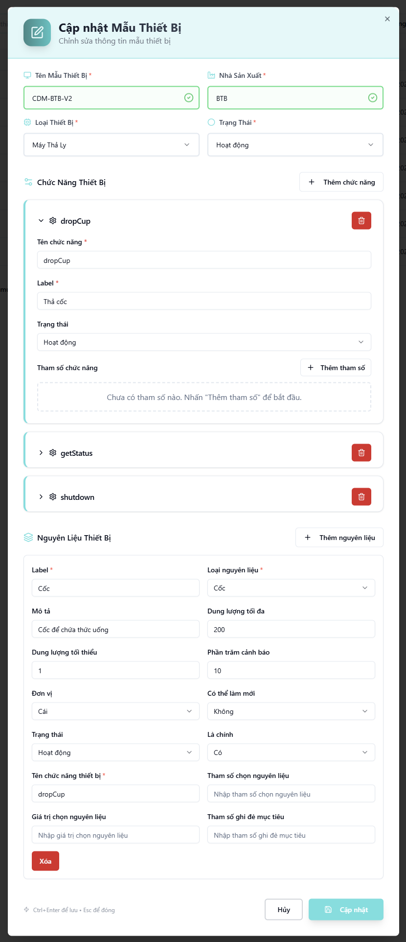
- Function details:
  - Data & Validation:
Data | Validations
DeviceModelName | Required, unique, max 255 chars
Manufacturer | Required, max 255 chars
DeviceTypeId | Required, must match an existing type
Status | Optional, default to “Active”
Functions[] | Optional, but each function must be valid if added
Function.Name | Required, max 255 chars
Function.Label | Optional, max 255 chars
Function.Status | Must be “Active” or “Inactive”
Parameters[] | Optional; each must have valid name/type
Parameter.Name | Required, unique within function
Parameter.Type | Required, must be supported (Text, Number, Enum, etc.)
Parameter.Default | Required, must match type
Parameter.Choices[] | Optional for Enum/Text types only
Parameter.Description | Optional, max 450 chars
Ingredients[] | Optional; if added must include full mapping
Ingredient.Label | Required, max 255 chars
Ingredient.TypeId | Required, must match valid ingredient type
Ingredient.MinCapacity | Must be ≥ 0
Ingredient.MaxCapacity | Must be > MinCapacity
Ingredient.WarningPercent | Must be between 0 and 100
Ingredient.Unit | Required, from pre-defined enum
Ingredient.IsMain | Boolean
Ingredient.IsRefillable | Boolean
Ingredient.FunctionMappingName | Optional, must match existing function
Ingredient.ParameterName | Optional, must match parameter in the mapped function
Ingredient.ParameterValue | Optional, string
Ingredient.ParameterTarget | Optional, for target result parameter

  - Functionalities:
Function | Normal Cases | Abnormal Cases
Open update modal | Admin clicks edit and sees populated form | If data fetch fails, show error toast
Edit and save changes | Admin modifies any field and clicks “Cập nhật” | If validation fails, prevent submit and scroll to invalid field
Add/remove functions | Admin clicks "+ Thêm chức năng" to add or delete logic blocks | Missing function name triggers red border
Add/remove ingredients | Admin modifies ingredients section with full binding config | Missing required ingredient field disables saving
Bind function to ingredient | Admin links ingredient with a function and a parameter | If binding target not found, show warning and prevent saving
Save successfully | Valid changes are saved to DB, modal closes | Backend fails then show retryable error toast
Cancel changes | Admin clicks “Hủy” to discard changes and close modal | -
Use shortcut keys | Ctrl+Enter to save, Esc to close | -

  - Business Rules:

3.15.5 Delete a device model
- Function description:
  - Actors/Roles:
    - System Admin: Has full access to delete any device model across the entire system..
    - Organization Admin: No access to this feature.
  - Purpose: This function enables users to manage and oversee all registered device models (e.g., pump model, robot model, tablet model, etc.) used within the automated coffee vending system. It helps ensure visibility over model versions, manufacturers, types, and operational status.
  - Interface:
    - The Delete option is located inside the "Hành động" (Action) dropdown on the device model list screen.
    - A confirmation modal is shon — clicking "Xác nhận" will immediately trigger the deletion process and remove the device.
    - The deleted device model will disappear from the table after the operation.
  - Data Processing:
    - Frontend sends a DELETE request to the backend API with the device model ID.
    - Backend verifies permission, deletes device model record, and returns success status.
    - On success, frontend refreshes the list to remove the deleted device model.
    - Error toast is displayed in case of API failure (e.g., 403, 500).
- Function trigger:
  - Navigation path: From the sidebar, admin selects "Quản lý mẫu thiết bị", clicks the "⋯" action button on a device row, and chooses "Xoá" to trigger the confirmation modal.
- Layout:
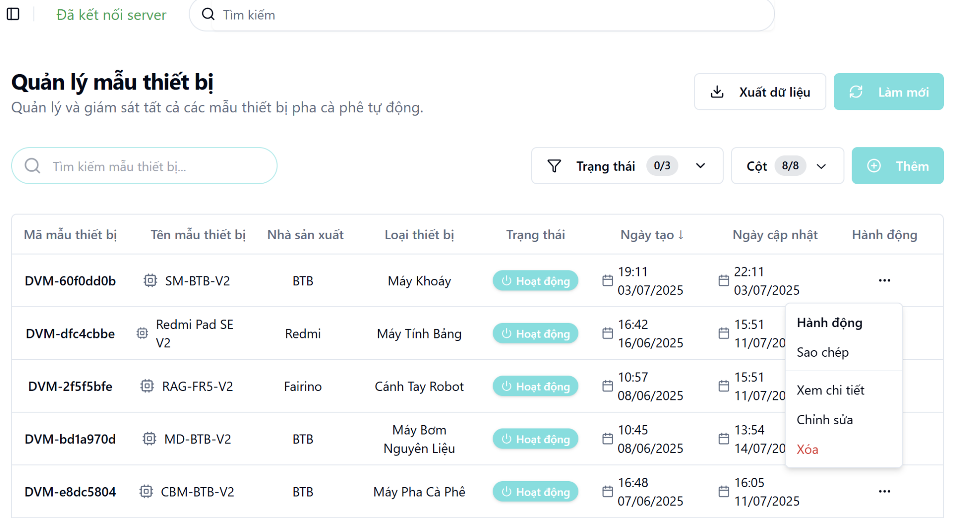
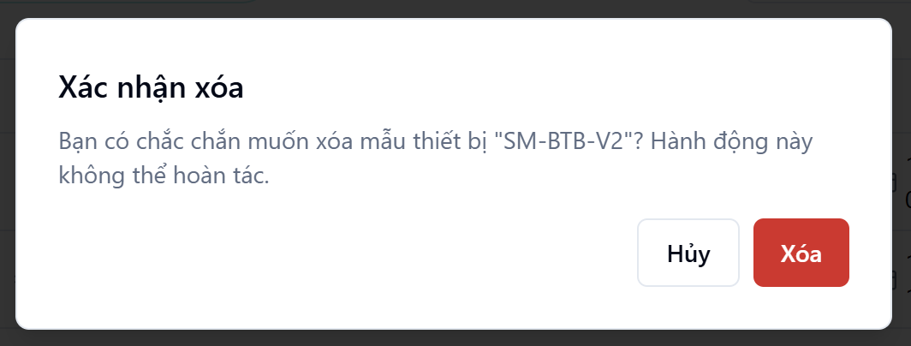

3.16 Device Type Management Screen

3.16.1 View list of device types
- Function description:
  - Actors/Roles:
    - System Admin: Has full access to view all device types across all kiosks and organizations.
    - Organization Admin: Can only view device types that belong to kiosks within their own organization.
  - Purpose: To display and manage the list of all predefined device types (e.g., coffee machine, tablet, cup dispenser), used for categorizing device models in the system.
  - Interface:
    - Table: Displays a structured, paginated list of all organization with following columns:
      - Device Type ID
      - Device Type Name
      - Description
      - Mobile Supported
      - Status badge
      - Created Date
      - Updated Date
      - Action
    - Optional UI Element:
      - Search bar
      - Filter dropdowns
      - Pagination controls
      - Column visibility configuration
      - “Làm mới” (Refresh) button
      - “Xuất dữ liệu” button
  - Data Processing:
    - Server returns for the client a list of device types based on filter, search, sort and paging.
- Function trigger:
  - Navigation path: From the left sidebar, admin selects “Quản lý thiết bị” choose “Loại Thiết bị”.
  - Timing Frequency: Data is auto-refresh every 60 seconds, or manually via browser reload or clicking button “Làm mới”
- Screen layout:
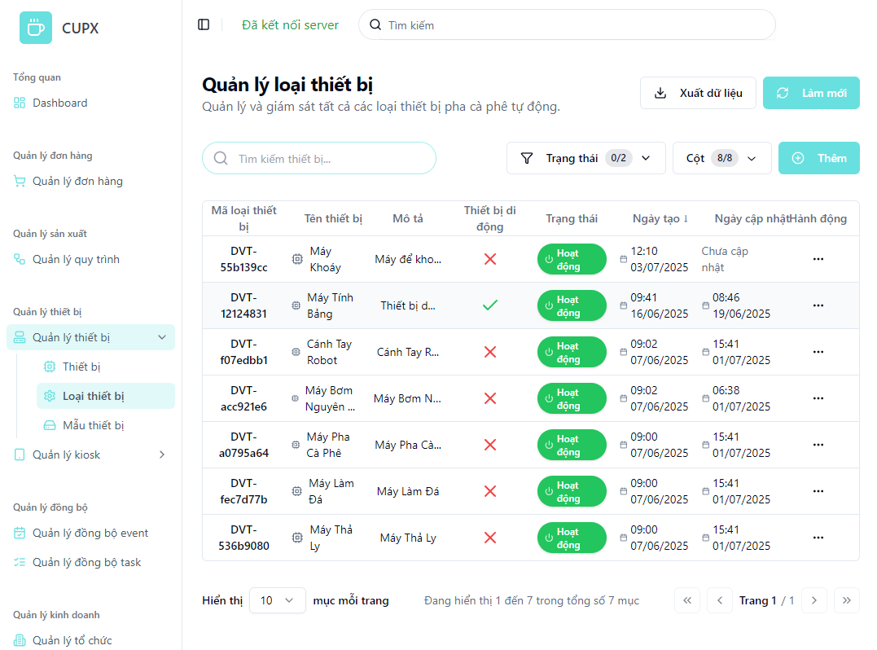
- Function details:
  - Data & Validation:
Data | Validations
DeviceTypeId | …
DeviceTypeName | …
Description | …
IsMobileDevice | …
Status | …
CreatedDate | …
UpdatedDate | …

  - Functionalities:
Function | Normal Cases | Abnormal Cases
Access device type list | Admin opens the screen and views the paginated device type table. | If the API fails, show an error message with a retry option.
Search by keyword | Admin types device type name or code into search bar to filter results. | If no match, display “Không tìm thấy loại thiết bị”
Filter by status | Admin filters by “Đang hoạt động”, “Không hoạt động” | If invalid input, keep previous filter
Sort by column | Admin clicks column headers (e.g., Created Date) | If sort fails, fallback to default order
Pagination navigation | Admin changes pages with controls (next, prev, index) | If out-of-bound index, reset to page 1 with warning
Manual refresh | Admin clicks “Làm mới” to reload the product list. | If reload fails, display toast with a retry option.
Action menu | Admin opens “…” dropdown → access to view, edit, delete options | If permission denied, hide or disable the option

  - Business Rules:

3.16.2 View detail of a device type
- Function description:
  - Actors/Roles:
    - System Admin: Has permission to view all device types in the system.
    - Organization Admin: Can view device types associated with their organization or kiosks (if authorized).
  - Purpose: This function allows users to view the full details of a device type for review, verification, and auditing purposes.
  - Interface:
    - Basic Information Section:
      - Device Type Name
      - Description
      - Is Mobile Device (Yes/No)
    - Device Model Information Section:
      - Model Name
      - Manufacturer
      - Device Type (e.g., Coffee Machine, Tablet, etc.)
      - Model Status (e.g., “Active”)
    - Status Badge:
      - Display account status (e.g., “Hoạt động”).
    - Timestamp Section:
      - Created Date
      - Updated Date
    - Action Button:
      - Modal close button “X”
  - Data Processing:
    - Frontend sends a request to the backend using the device type ID.
    - Backend returns all device type information in detail.
- Function trigger:
  - Navigation path: “Quản lý loại thiết bị” screen, admin clicks on the “Hành động” button, then selects “Xem chi tiết”.
  - Modal Display: A modal opens with all the device type information divided into separate logical cards.
- Screen layout:
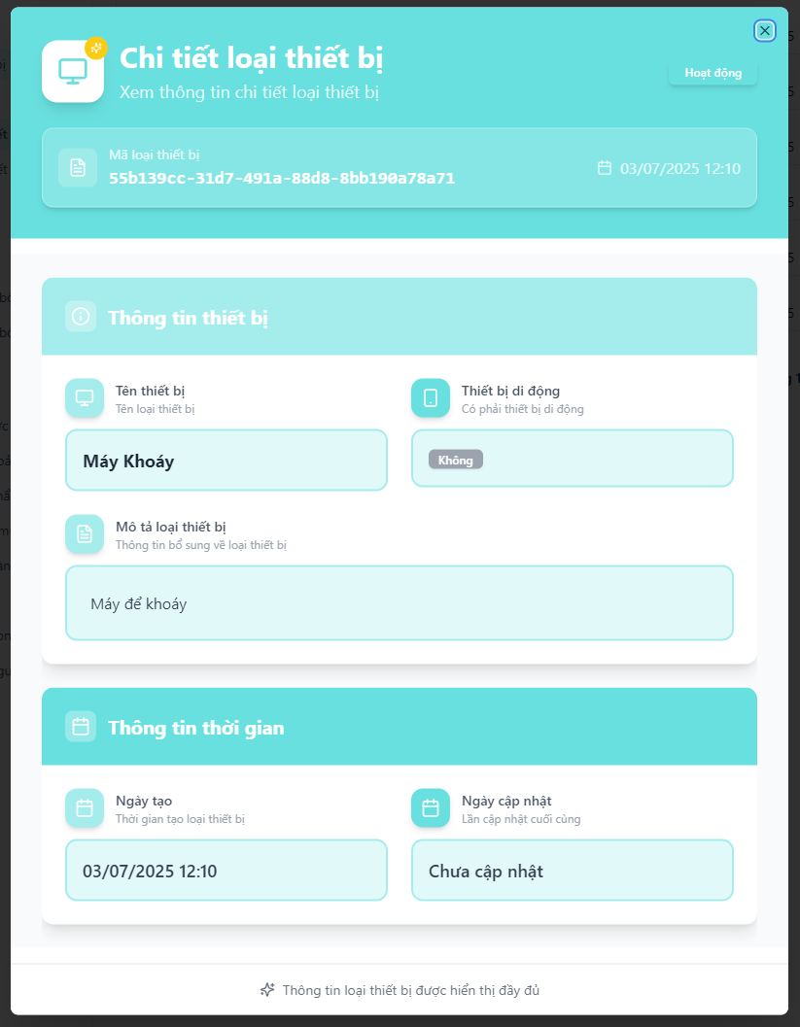
- Function details:
  - Data & Validation:
Data | Validations
DeviceTypeId | …
DeviceTypeName | …
Description | …
IsMobileDevice | …
Status | …
CreatedDate | …
UpdatedDate | …

  - Functionalities:
Function | Normal Cases | Abnormal Cases
Open device type detail | Admin clicks “View detail”, a modal appears showing all device info. | If the device type is deleted or inaccessible, show “Không tìm thấy loại thiết bị”.
View basic info | Device type name, description, and mobile support are displayed properly. | If missing data, show “Không có” or placeholder.
View status badge | Status is shown as a badge (e.g., “Hoạt động”). | If status is invalid, display “Không rõ”.
View timestamps | Created and updated dates are shown clearly. | If update date is null, show “Chưa cập nhật”.
Close modal | Admin clicks the “×” button to close. | If modal fails to close, allow ESC fallback or click outside to dismiss.

  - Business Rules:

3.16.3 Create a device type
- Function description:
  - Actors/Roles:
    - System Admin: Can create device types across the entire system.
    - Organization Admin: No access to this feature.
  - Purpose: This function allows administrators to create and register a new device type into the system, enabling better classification and management of hardware components.
  - Interface:
    - Fields include:
      - Device Type Name
      - Status
      - Device Type Category
        - Distributor
        - Mobile
      - Description
    - Action Button
      - Modal close button “X”
      - “Tạo” (Create): Submits the form to the backend.
      - “Hủy” (Cancel): Closes modal without saving.
  - Data Processing:
    - When the admin submits the form, the frontend validates input data and sends it to the backend.
    - Backend persists the new device type and returns success/failure response.
    - Upon success, modal closes and the list is refreshed.
- Function trigger:
  - Navigation path: From the “Quản lý loại thiết bị” screen, admin clicks the "Thêm" (Add) button in the top-right corner.
  - Modal Display: A modal opens, showing a form with input fields.
- Screen layout:
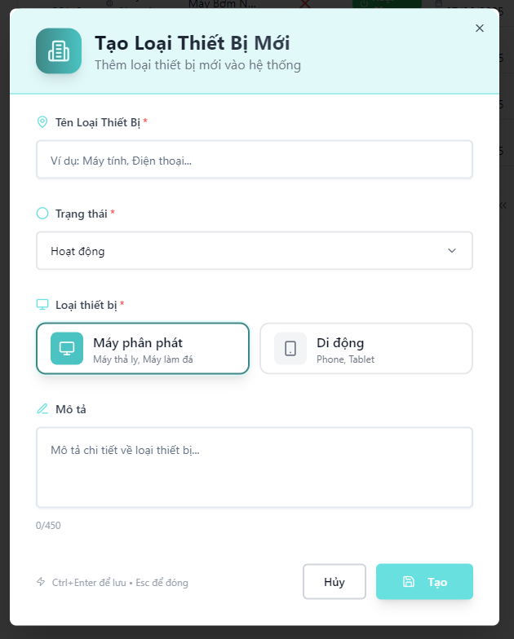
- Function details:
  - Data & Validation:
Data | Validations
DeviceTypeName | Required, non-empty, and max 100 characters
Status | Required, must be unique across all devices
IsMobileDevice | Required – boolean (true if "Mobile", false if "Distributor")
Status | Required – must be either “Active” or “Inactive”
Description | Optional, max 450 characters
CreatedDate | Auto-generated at time of creation

  - Functionalities:
Function | Normal Cases | Abnormal Cases
Open create modal | Admin clicks “Thêm”, modal opens with empty fields | If modal fails to load, show error and retry option
Fill form & submit | All required fields filled, click “Tạo” to create device type | If validation fails (e.g., duplicate serial), show field-level error messages
Validate uniqueness | Admin fills required fields correctly | If required fields missing, disable “Tạo” button and show inline error messages
Cancel creation | Admin clicks “Hủy” or “Esc”, modal closes without changes | If close fails, fallback via ESC or page reload
Submit creation | Click “Tạo” sends data to backend and closes modal on success. | If the backend returns an error (e.g. validation fails), show an inline error message.
Cancel/Close modal | Admin clicks “Hủy” to close modal without saving. | If modal fails to close, allow fallback via ESC.

  - Business Rules:

3.16.4 Update a device type
- Function description:
  - Actors/Roles:
    - System Admin: Has full rights to update any device type in the system.
    - Organization Admin: No access to this feature.
  - Purpose: This function allows administrators to create and register a new device type into the system, enabling better classification and management of hardware components.
  - Interface:
    - Editable Fields Section:
      - Device Type Name
      - Status
      - Device Type Category
        - Distributor
        - Mobile
      - Description
    - Action Button
      - Modal close button “X”
      - “Tạo” (Create): Submits the form to the backend.
      - “Hủy” (Cancel): Closes modal without saving.
  - Data Processing:
    - When the admin submits the form, the frontend validates input data and sends it to the backend.
    - Backend persists the new device type and returns success/failure response.
    - Upon success, modal closes and the list is refreshed.
- Function trigger:
  - Navigation path: From the sidebar, admin navigates to “Quản lý thiết bị” → “Loại thiết bị”, clicks “Hành động” on a row, selects “Chỉnh sửa”, and a pre-filled modal appears for editing.
  - Modal Display: A modal opens, showing a form with input fields.
- Screen layout:
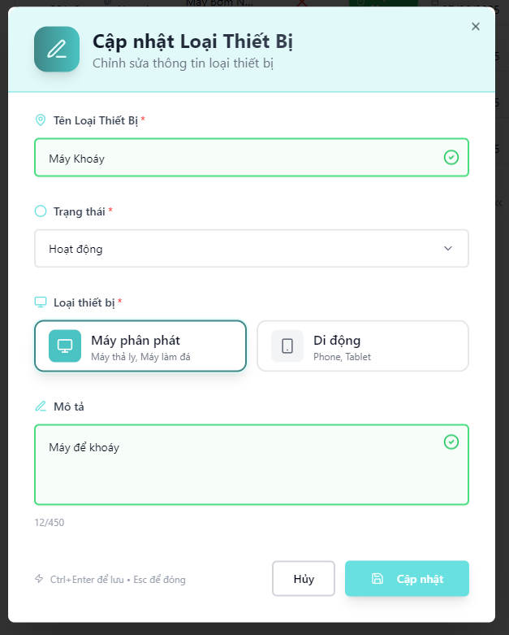
- Function details:
  - Data & Validation:
Data | Validations
DeviceTypeName | Required, non-empty, and max 100 characters
Status | Required, must be unique across all devices
IsMobileDevice | Required – boolean (true if "Mobile", false if "Distributor")
Status | Required – must be either “Active” or “Inactive”
Description | Optional, max 450 characters
CreatedDate | Auto-generated at time of creation

  - Functionalities:
Function | Normal Cases | Abnormal Cases
Open update modal | Admin clicks "Chỉnh sửa", modal opens with current info | If device not found (404), show error toast
Modify fields | Admin updates name, status, description, etc. | If invalid value (e.g., empty required field), show inline validation error
Change serial | Admin updates serial and submits | If duplicate serial, show backend error message
Submit update | Admin clicks “Cập nhật” to save changes | If backend error, show retry option
Cancel/Close modal | Admin clicks “Hủy” or presses Esc to close without saving | If modal close fails, reload page fallback

  - Business Rules:

3.16.5 Delete a device type
- Function description:
  - Actors/Roles:
    - System Admin: Has full access to delete any device type across the entire system..
    - Organization Admin: No access to this feature.
  - Purpose: This function allows administrators to permanently delete a device type from the system.
  - Interface:
    - The Delete option is located inside the "Hành động" (Action) dropdown on the device list screen.
    - A confirmation modal is shon — clicking "Xác nhận" will immediately trigger the deletion process and remove the device type.
    - The deleted device type will disappear from the table after the operation.
  - Data Processing:
    - Frontend sends a DELETE request to the backend API with the device type ID.
    - Backend verifies permission, deletes device type record, and returns success status.
    - On success, frontend refreshes the list to remove the deleted device type.
    - Error toast is displayed in case of API failure (e.g., 403, 500).
- Function trigger:
  - Navigation path: From the sidebar, admin selects "Quản lý loại thiết bị", clicks the "⋯" action button on a device row, and chooses "Xoá" to trigger the confirmation modal.
- Layout:
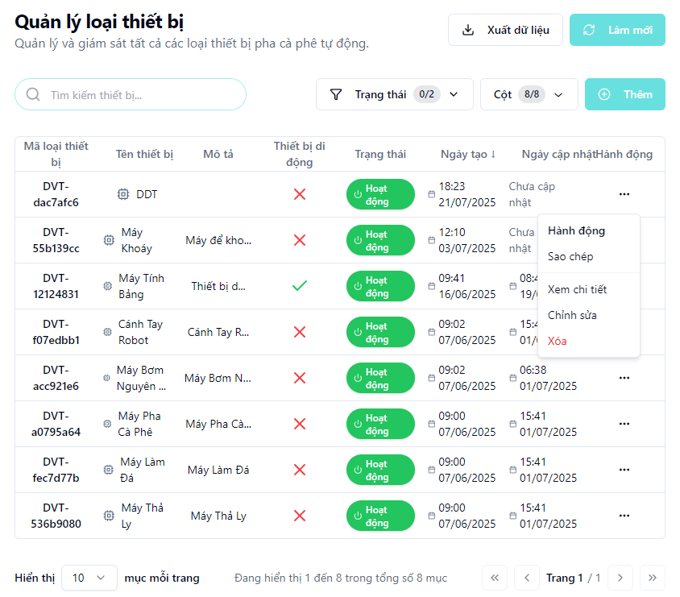
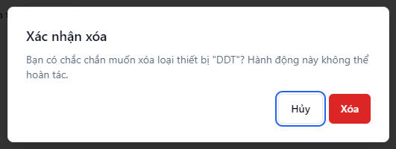

3.17 Kiosk Management Screen

3.17.1 View list of kiosks

3.17.2 View detail of a kiosk

3.17.3 Create a kiosk

3.17.4 Update a kiosk

3.17.5 Delete a kiosk

3.18 Kiosk Version Management Screen

3.18.1 View list of kiosk versions

3.18.2 View detail of a kiosk version

3.18.3 Create a kiosk version

3.18.4 Update a kiosk version

3.18.5 Delete a kiosk version

3.19 Kiosk Type Management Screen

3.19.1 View list of kiosk types
- Function description:
  - Actors/Roles:
    - System Admin:Can view all kiosk types across all organizations.
    - Organization Admin: Can view kiosk types relevant to their organization.
  - Purpose: This feature allows administrators to manage and monitor all types of automated coffee kiosks in the system, such as Kiosk Trà (Tea Kiosk), Kiosk Cà Phê (Coffee Kiosk), Kiosk Kem (Ice Cream Kiosk), etc.
  - Interface:
    - Table: Displays a structured, paginated list of all organization with following columns:
      - Kiosk Type ID
      - Kiosk Type Name
      - Description
      - Status
      - Created Date
      - Updated Date
      - Action
    - Optional UI Element:
      - Search bar
      - Filter dropdowns
      - Pagination controls
      - Column visibility configuration
      - “Làm mới” (Refresh) button
      - “Xuất dữ liệu” button
  - Data Processing:
    - Server returns for the client a list of kiosk types based on filter, search, sort and paging.
- Function trigger:
  - Navigation path: From the left sidebar, admin selects “Quản lý kiosk” choose “Loại kiosk”.
  - Timing Frequency: Data is auto-refresh every 60 seconds, or manually via browser reload or clicking button “Làm mới”
- Screen layout:
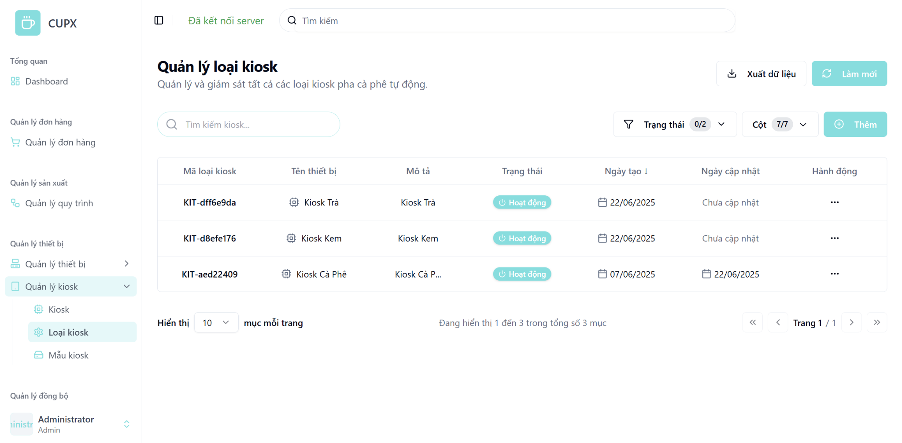
- Function details:
  - Data & Validation:
Field | Validation
KioskTypeId | …
Name | …
Description | …
Status | …
CreatedDate | …
UpdatedDate | …

  - Functionalities:
Function | Normal Cases | Abnormal Cases
Load kiosk type list | List is loaded successfully on page open or refresh | API error → show retry message
Search kiosk type | Filters list by keyword (name or ID) | No match → show “Không tìm thấy loại kiosk”
Filter by status | Filters kiosk types by operational status | Invalid value → reset filter
Sort by column | Sorts by created date, name, etc. | Fallback to default if invalid
View pagination | Paginate results properly | Invalid page → fallback to page 1
Manual refresh | Refresh list with latest data | API failure → show toast
Export data | Admin clicks “Xuất dữ liệu” to download | Export fails → show error message

  - Business Rules:

3.19.2 View detail of a kiosk type
- Function description:
  - Actors/Roles:
    - System Admin: Has permission to view all kiosk types in the system.
    - Organization Admin: Can view kiosk types associated with their organization or kiosks (if authorized).
  - Purpose: To display detailed information of a specific kiosk type, including metadata such as name, description, creation date, update date, and operational status.
  - Interface:
    - Basic Information Section:
      - Kiosk Type Name
      - Description
    - Status Badge:
      - Display account status (e.g., “Hoạt động”).
    - Timestamp Section:
      - Created Date
      - Updated Date
    - Action Button:
      - Modal close button “X”
  - Data Processing:
    - Frontend sends a request to the backend using the kiosk type ID.
    - Backend returns all kiosk type information in detail.
- Function trigger:
  - Navigation path: “Quản lý loại kiosk” screen, admin clicks on the “Hành động” button, then selects “Xem chi tiết”.
  - Modal Display: A modal opens with all the kiosk type information divided into separate logical cards.
- Screen layout:
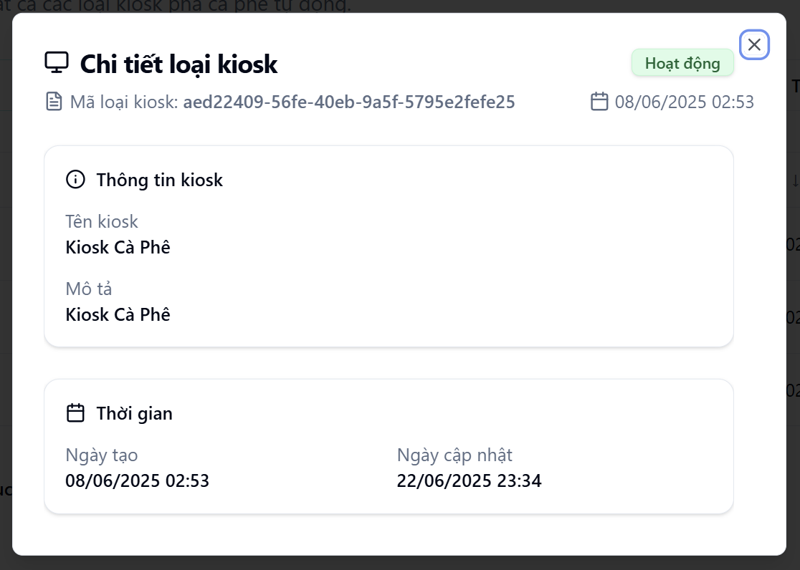
- Function details:
  - Data & Validation:
Data | Validations
KioskTypeId | …
Name | …
Description | …
Status | …
CreatedDate | …
UpdatedDate | …

  - Functionalities:
Function | Normal Cases | Abnormal Cases
Open kiosk type detail | Admin clicks “Xem chi tiết”, a modal appears showing all kiosk type info. | If the kiosk type is deleted or inaccessible, show “Không tìm thấy loại kiosk”.
View basic info | Kiosk type name and description are displayed properly. | If missing data, show “Không có” or placeholder text.
View status badge | Status is shown as a badge (e.g., “Hoạt động”). | If status is invalid or null, display a badge with text “Không rõ”.
View timestamps | Created and updated dates are shown clearly in their respective fields. | If update date is null, show “Chưa cập nhật”.
Close modal | Admin clicks the “×” button and the modal closes properly. | If modal fails to close, allow fallback: pressing ESC key or clicking outside modal to dismiss it.

  - Business Rules:

3.19.3 Create a kiosk type
- Function description:
  - Actors/Roles:
    - System Admin: Allowed to create new kiosk types across the system.
    - Organization Admin: No access to this feature.
  - Purpose: This function allows system administrators to create and register a new kiosk type, supporting better classification and management of kiosk deployments.
  - Interface:
    - Fields include:
      - Kiosk Type Name
      - Status
      - Description
    - Action Button
      - Modal close button “X”
      - “Tạo” (Create): Submits the form to the backend.
      - “Hủy” (Cancel): Closes modal without saving.
  - Data Processing:
    - When the admin submits the form, the frontend validates input data and sends it to the backend.
    - Backend persists the new device type and returns success/failure response.
    - Upon success, modal closes and the list is refreshed.
- Function trigger:
  - Navigation path: From the “Quản lý loại kiosk” screen, admin clicks the "Thêm" (Add) button in the top-right corner.
  - Modal Display: A modal opens, showing a form with input fields.
- Screen layout:
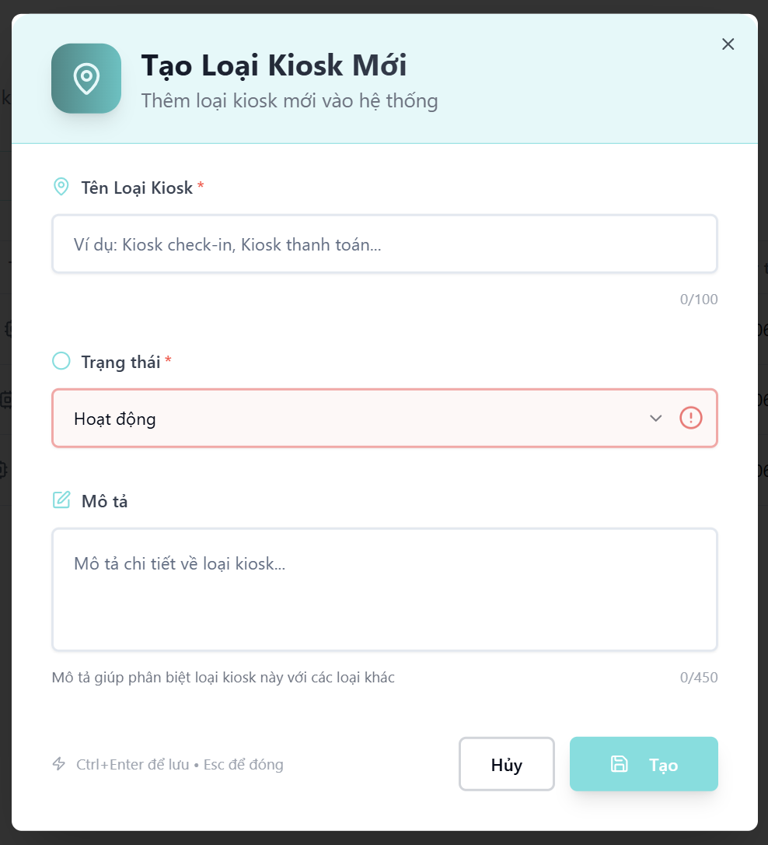
- Function details:
  - Data & Validation:
Field | Validation Rules
KioskTypeName | Required, non-empty, max 100 characters
Status | Required, must be either “Hoạt động” or “Không hoạt động”
Description | Optional, max 450 characters

  - Functionalities:
Function | Normal Cases | Abnormal Cases
Open create modal | Admin clicks “Thêm”, modal appears with empty fields | Modal fails to open → show retry message
Fill form & submit | Admin fills valid data and clicks “Tạo” → kiosk type is created successfully | Backend error → show inline error or toast notification
Field validation | Required fields missing → disable “Tạo” and show inline error | Input exceeds character limit → show validation message
Submit creation | Click “Tạo” sends data to backend and closes modal on success. | If the backend returns an error (e.g. validation fails), show an inline error message.
Cancel/Close modal | Admin clicks “Hủy” to close modal without saving. | If modal fails to close, allow fallback via ESC.

  - Business Rules:

3.19.4 Update a kiosk type
- Function description:
  - Actors/Roles:
    - System Admin: Has full rights to update any device type in the system.
    - Organization Admin: No access to this feature.
  - Purpose: This function allows administrators to create and register a new device type into the system, enabling better classification and management of hardware components.
  - Interface:
    - Editable Fields Section:
      - Kiosk Type Name
      - Status
      - Description
    - Action Button
      - Modal close button “X”
      - “Tạo” (Create): Submits the form to the backend.
      - “Hủy” (Cancel): Closes modal without saving.
  - Data Processing:
    - When the admin submits the form, the frontend validates input data and sends it to the backend.
    - Backend persists the new device type and returns success/failure response.
    - Upon success, modal closes and the list is refreshed.
- Function trigger:
  - Navigation path: From the sidebar, admin navigates to “Quản lý kiosk” choose “Loại kiosk”, clicks “Hành động” on a row, selects “Chỉnh sửa”, and a pre-filled modal appears for editing.
  - Modal Display: A modal opens, showing a form with input fields.
- Screen layout:

- Function details:
  - Data & Validation:
Data Field | Validation Rules
KioskTypeName | Required, non-empty, max 100 characters
Status | Required, must be either “Hoạt động” or “Không hoạt động”
Description | Optional, max 450 characters

  - Functionalities:
Function | Normal Cases | Abnormal Cases
Open update modal | Admin clicks "Chỉnh sửa", modal opens with current info | If kiosk type not found (404), show error toast
Modify fields | Admin updates name/status/description, then submits | Empty required field then Show inline validation error
Submit update | Admin clicks “Cập nhật” to save changes | If backend error, show retry option
Cancel/Close modal | Admin clicks “Hủy” or presses Esc to close without saving | If modal close fails, reload page fallback

  - Business Rules:

3.19.5 Delete a kiosk type
- Function description:
  - Actors/Roles:
    - System Admin: Has full permission to delete any kiosk type.
    - Organization Admin: No access to this feature.
  - Purpose: This function allows a system admin to permanently remove a kiosk type from the system.
  - Interface:
    - The Delete option is located inside the "Hành động" (Action) dropdown on the kiosk type list screen.
    - A confirmation modal is shon — clicking "Xác nhận" will immediately trigger the deletion process and remove the kiosk type.
    - The deleted kiosk type will disappear from the table after the operation.
  - Data Processing:
    - Frontend sends a DELETE request to the backend API with the kiosk type ID.
    - Backend verifies permission, deletes kiosk type record, and returns success status.
    - On success, frontend refreshes the list to remove the deleted kiosk type.
    - Error toast is displayed in case of API failure (e.g., 403, 500).
- Function trigger:
  - Navigation path: From the sidebar, admin selects "Quản lý loạikiosk", clicks the "⋯" action button on a kiosk type row, and chooses "Xoá" to trigger the confirmation modal.
- Layout:



3.19 Workflow Management Screen

3.19.1 View list of workflows
- Function description:
  - Actors/Roles:
    - System Admin:Can view all kiosk types across all organizations.
    - Organization Admin: Can view kiosk types relevant to their organization.
  - Purpose: This function allows users to view, search, filter, and manage the list of beverage preparation workflows defined in the system.
  - Interface:
    - Table: Displays a structured, paginated list of all organization with following columns:
      - Workflow Id
      - Workflow Name
      - Description
      - Status
      - Step Count
      - Created Date
      - Updated Date
      - Action
    - Optional UI Element:
      - Search bar
      - Filter dropdowns
      - Pagination controls
      - Column visibility configuration
      - “Làm mới” (Refresh) button
      - “Xuất dữ liệu” button
  - Data Processing:
    - Server returns for the client a list of workflow based on filter, search, sort and paging.
- Function trigger:
  - Navigation path: From the left sidebar, admin selects “Quản lý workflow”
  - Timing Frequency: Data is auto-refresh every 60 seconds, or manually via browser reload or clicking button “Làm mới”
- Screen layout:

- Function details:
  - Data & Validation:
Data | Validation
WorkflowId | …
WorkflowName | ..
Description | …
Status | …
StepCount | ..
CreatedDate | …
UpdatedDate | …

  - Functionalities:
Function | Normal Cases | Abnormal Cases
Load workflow list | Table loads with workflows and metadata | If fetch fails, show empty state or error toast
Filter by status | Selecting status filter reloads table with correct data | If backend filter fails, show warning and reset
Search workflow | Typing in search bar filters workflows in real-time or on enter | If no matches, show “Không tìm thấy quy trình nào phù hợp”
Column toggle | Admin can show/hide columns as needed | If toggle fails, show fallback layout
Open action menu | Clicking “Hành động” shows dropdown | If dropdown fails, retry on click
Pagination | Switching page updates the table | If pagination fetch fails, stay on current page and retry

  - Business Rules:

3.19.2 View detail of a workflow
- Function description:
  - Actors/Roles:
    - System Admin: Has permission to view full workflow details.
    - Organization Admin: Can only view details of workflows within their organization scope.
  - Purpose: To display detailed information of a specific kiosk type, including metadata such as name, description, creation date, update date, and operational status.
  - Interface:
    - Header Section
      - Workflow Name
      - Workflow Description
      - Description
      - Product Linked
      - Workflow Type
      - Total Steps
      - Buttons: “Chỉnh sửa”, “Xóa”
    - Steps Section
      - Step number and name
      - Step type (e.g., runScript, dropCup)
      - Device used
      - Retry times
      - Parameters (e.g., name, type, value)
    - Navigation:
      - Breadcrumb: "Quản lý quy trình" → "Chi tiết quy trình"
      - Back button: “Quay lại”
  - Data Processing:
    - Frontend sends a request to the backend using the workflow ID.
    - Backend returns all workflow information in detail.
- Function trigger:
  - Navigation path: “Quản lý workflow” screen, admin clicks on the “Hành động” button, then selects “Xem chi tiết”.
  - Modal Display: A new page opens with all the workflow information divided into separate logical cards.
- Screen layout:
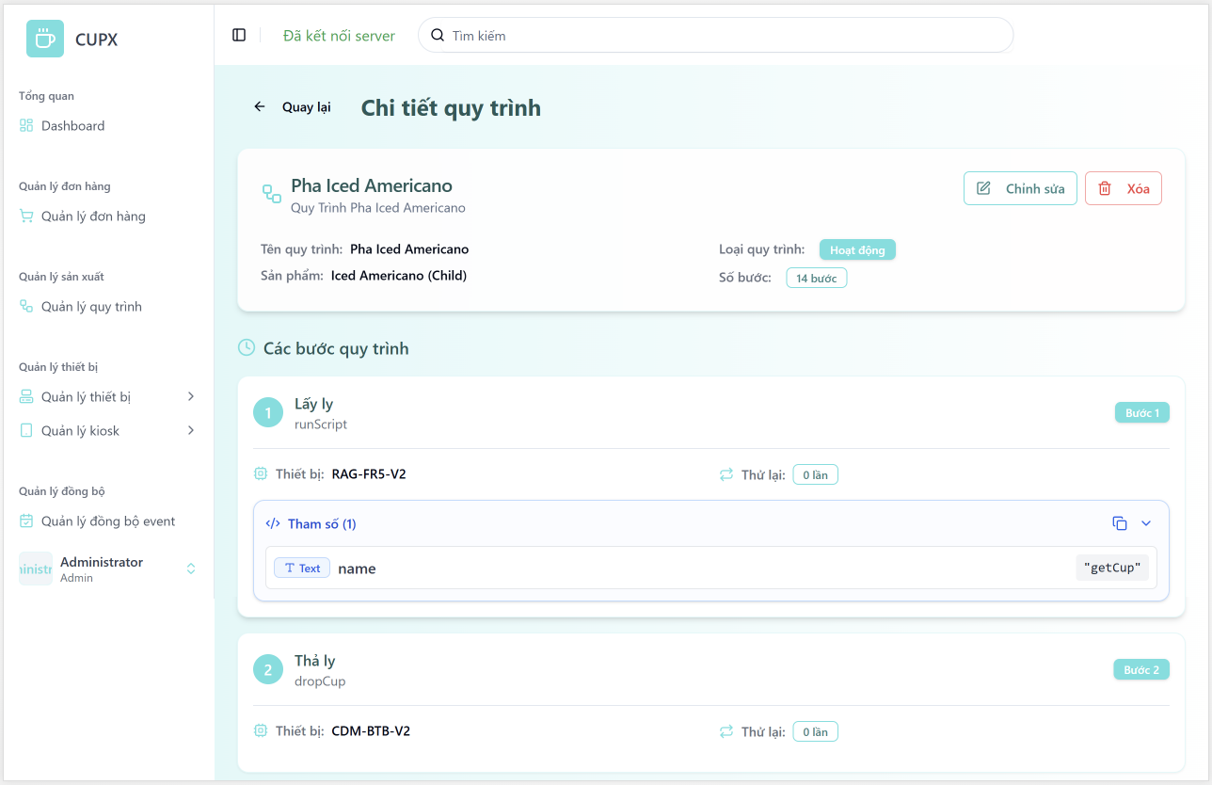
- Function details:
  - Data & Validation:
Data | Validation
WorkflowId | …
WorkflowName | …
ProductName | …
Status | …
StepName | …
StepType | …
DeviceModel | …
Parameters | …

  - Functionalities:
Function | Normal Cases | Abnormal Cases
Load workflow detail | All workflow info and steps display correctly | If workflow not found, show error toast “Không tìm thấy quy trình”
View header info | Workflow name, product, status badge, and step count displayed | If product link is broken, display “Không xác định sản phẩm”
View step detail | Each step shows name, device, retry count, parameters (with type + value) | If missing parameters, show “Không có tham số nào được cấu hình”
Click edit/delete | Buttons work as expected (redirect/edit confirmation) | If permissions restricted, disable or hide buttons
Back to list | Click “Quay lại” returns to list correctly | If navigation fails, fallback via browser back

  - Business Rules:

3.19.3 Create a workflow
- Function description:
  - Actors/Roles:
    - System Admin: Full access to create workflows.
    - Organization Admin: No access to this feature.
  - Purpose: This function allows administrators to create a new workflow for automatic drink-making, define detailed steps, and optionally assign it to a kiosk version for compatibility with physical devices.
  - Interface:
    - Screen Layout:
      - “Chọn phiên bản Kiosk” (optional dropdown).
      - Button “Xem thông tin quy trình”.
      - Canvas area for “Sơ đồ quy trình” with drag-and-drop support.
      - “Thêm bước” to add workflow steps.
      - Section “Các bước thực hiện” with list of all created steps.
      - “Thông tin quy trình” modal with inputs:
        - Workflow name
        - Workflow type
        - Product
        - Description
      - “Chỉnh sửa bước” modal per step with:
        - Step name,
        - Sequence
        - Retry limit
        - Step type
        - Device model
        - Device function
        - Optional callback
        - Parameters (JSON or visual input)
        - Conditions (expression builder: left-var/op/right-value)
    - Action Button
      - Modal close button “X”
      - “Tạo” (Create): Submits the form to the backend.
      - “Hủy” (Cancel): Closes modal without saving.
  - Data Processing:
    - When the admin submits the form, the frontend validates input data and sends it to the backend.
    - Backend persists the new device type and returns success/failure response.
    - Upon success, modal closes and the list is refreshed.
- Function trigger:
  - Navigation path: From the “Quản lý loại workflow” screen, admin clicks the "Thêm" (Add) button in the top-right corner.
  - Modal Display: A modal opens, showing a new page with multiple section input fields.
- Screen layout:
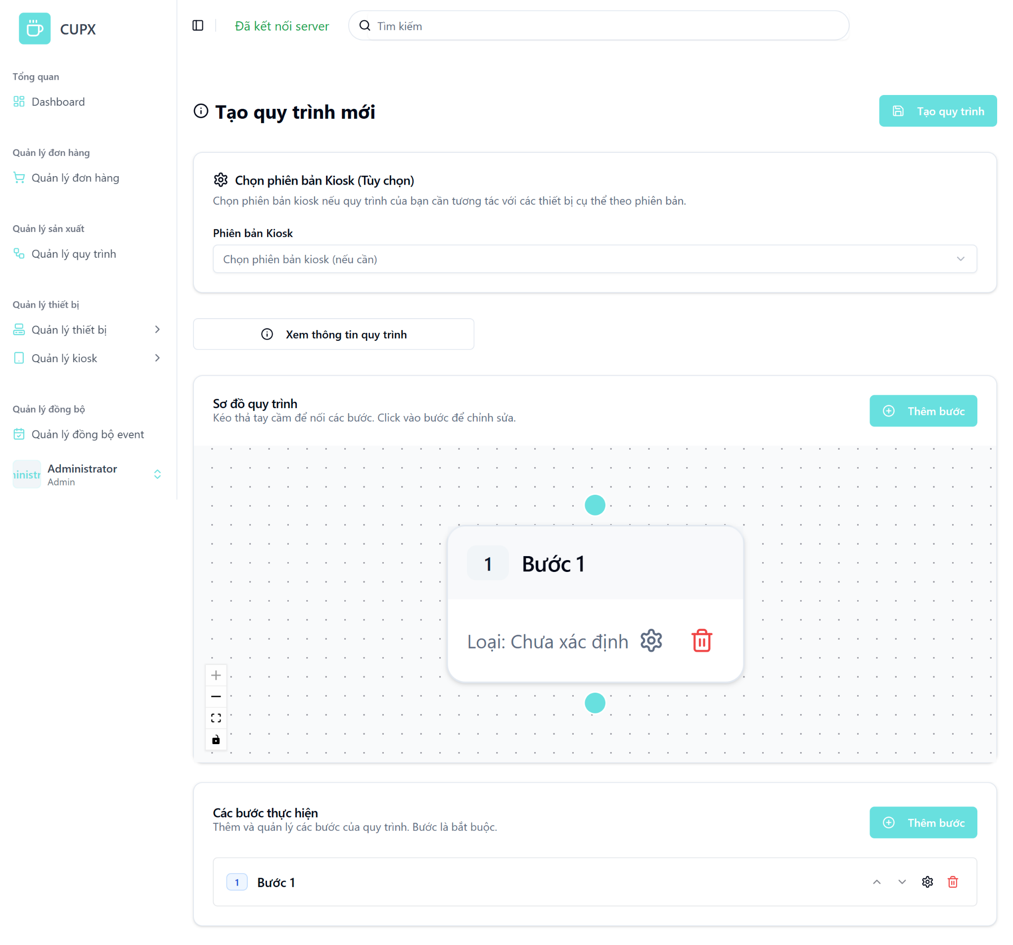
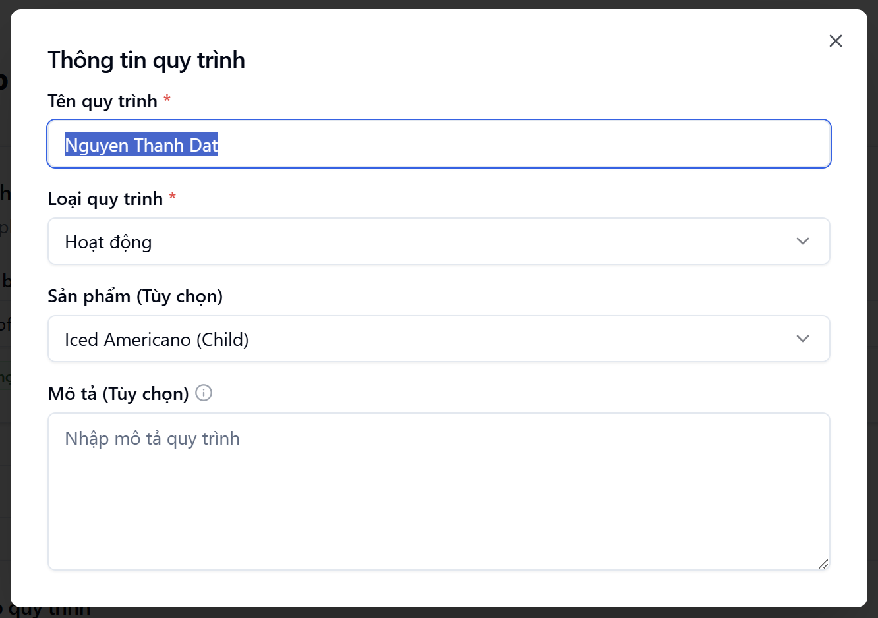

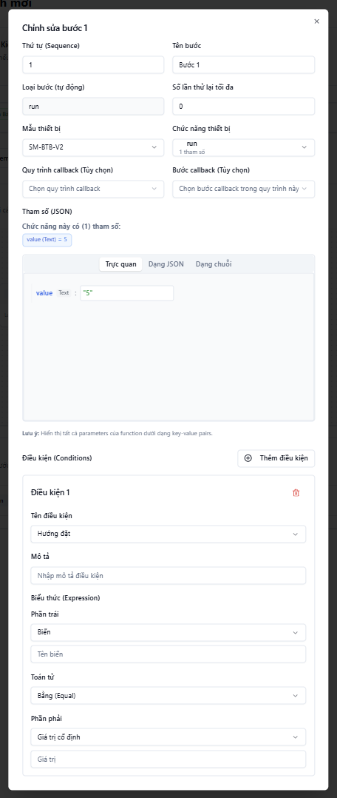
- Function details:
  - Data & Validation:
Field | Validation
ProductId | Optional, string, max length 50
Name | Optional, string, max length 100
Description | Optional, string, max length 300
KioskVersionId | Optional, string, max length 50
Type | Required, must match enum EWorkflowType
Steps | Optional, array of valid StepNestedDto
Steps[].Name | Required, string, max length 100
Steps[].Type | Required, string, max length 450
Steps[].DeviceModelId | Required, string
Steps[].MaxRetries | Optional, integer ≥ 0
Steps[].Sequence | Required, integer (step order in workflow)
Steps[].CallbackStepId | Optional, string, max length 50
Steps[].CallbackWorkflowId | Optional, string, max length 50
Steps[].Parameters | Optional, string, max length 500, must be valid JSON
Steps[].StepCode | Optional, string, max length 50
Steps[].CallbackStepCode | Optional, string, max length 50
Steps[].Conditions | Optional, array of valid StepConditionDto
Steps[].Conditions[].Name | Required, must match enum EConditionName, max length 50
Steps[].Conditions[].Description | Optional, string, max length 450
Steps[].Conditions[].Expression | Required, must contain valid left, operator, and right
Expression.Left.Type | Required, must match enum EExpressionType
Expression.Left.Value | Required, type depends on selected type (e.g., string, int)
Expression.Operator | Required, must match enum EOperation (Equal, NotEqual, >, <, etc.)
Expression.Right.Type | Required, must match enum EExpressionType
Expression.Right.Value | Required, type depends on selected type (e.g., string, int)

  - Functionalities:
Function | Normal Case | Abnormal Case
Open create workflow page | UI loads, default canvas shown | Server not connected → show offline error
Add new step | Step added to canvas and step list | If duplicate sequence, show error
Edit step | Data saved to local state | If missing required fields, show inline validation
Add condition | Expression builder opens, fields saved | Invalid expression (e.g. missing operand) → show error
Enter parameters | JSON/Visual input allowed | Invalid JSON format → validation failed
Submit workflow | Backend returns success, redirect | Backend failure → toast + retry option
Cancel | Return to list | N/A

  - Business Rules:

3.19.4 Update a workflow
- Function description:
  - Actors/Roles:
    - System Admin: Has full rights to update any device type in the system.
    - Organization Admin: No access to this feature.
  - Purpose: This function allows the admin to update an existing workflow’s information, such as its name, description, product mapping, kiosk version mapping, as well as edit, add, remove, or reorder steps in the workflow. Each step can also be updated with its function, parameters, device model, retry count, and conditions.
  - Interface:
    - Screen Layout:
      - “Chọn phiên bản Kiosk” (optional dropdown).
      - Button “Xem thông tin quy trình”.
      - Canvas area for “Sơ đồ quy trình” with drag-and-drop support.
      - “Thêm bước” to add workflow steps.
      - Section “Các bước thực hiện” with list of all created steps.
      - “Thông tin quy trình” modal with inputs:
        - Workflow name
        - Workflow type
        - Product
        - Description
      - “Chỉnh sửa bước” modal per step with:
        - Step name,
        - Sequence
        - Retry limit
        - Step type
        - Device model
        - Device function
        - Optional callback
        - Parameters (JSON or visual input)
        - Conditions (expression builder: left-var/op/right-value)
    - Action Button
      - Modal close button “X”
      - “Cập nhật” (Update): Submits the form to the backend.
      - “Hủy” (Cancel): Closes modal without saving.
  - Data Processing:
    - When the admin submits the form, the frontend validates input data and sends it to the backend.
    - Backend persists the new device type and returns success/failure response.
    - Upon success, modal closes and the list is refreshed.
- Function trigger:
  - Navigation path: From the sidebar, admin navigates to “Quản lý workflow” clicks “Hành động” on a row, selects “Chỉnh sửa”, and a pre-filled modal appears for editing.
  - Modal Display: A new page opens, showing a space form with input fields.
- Screen layout:
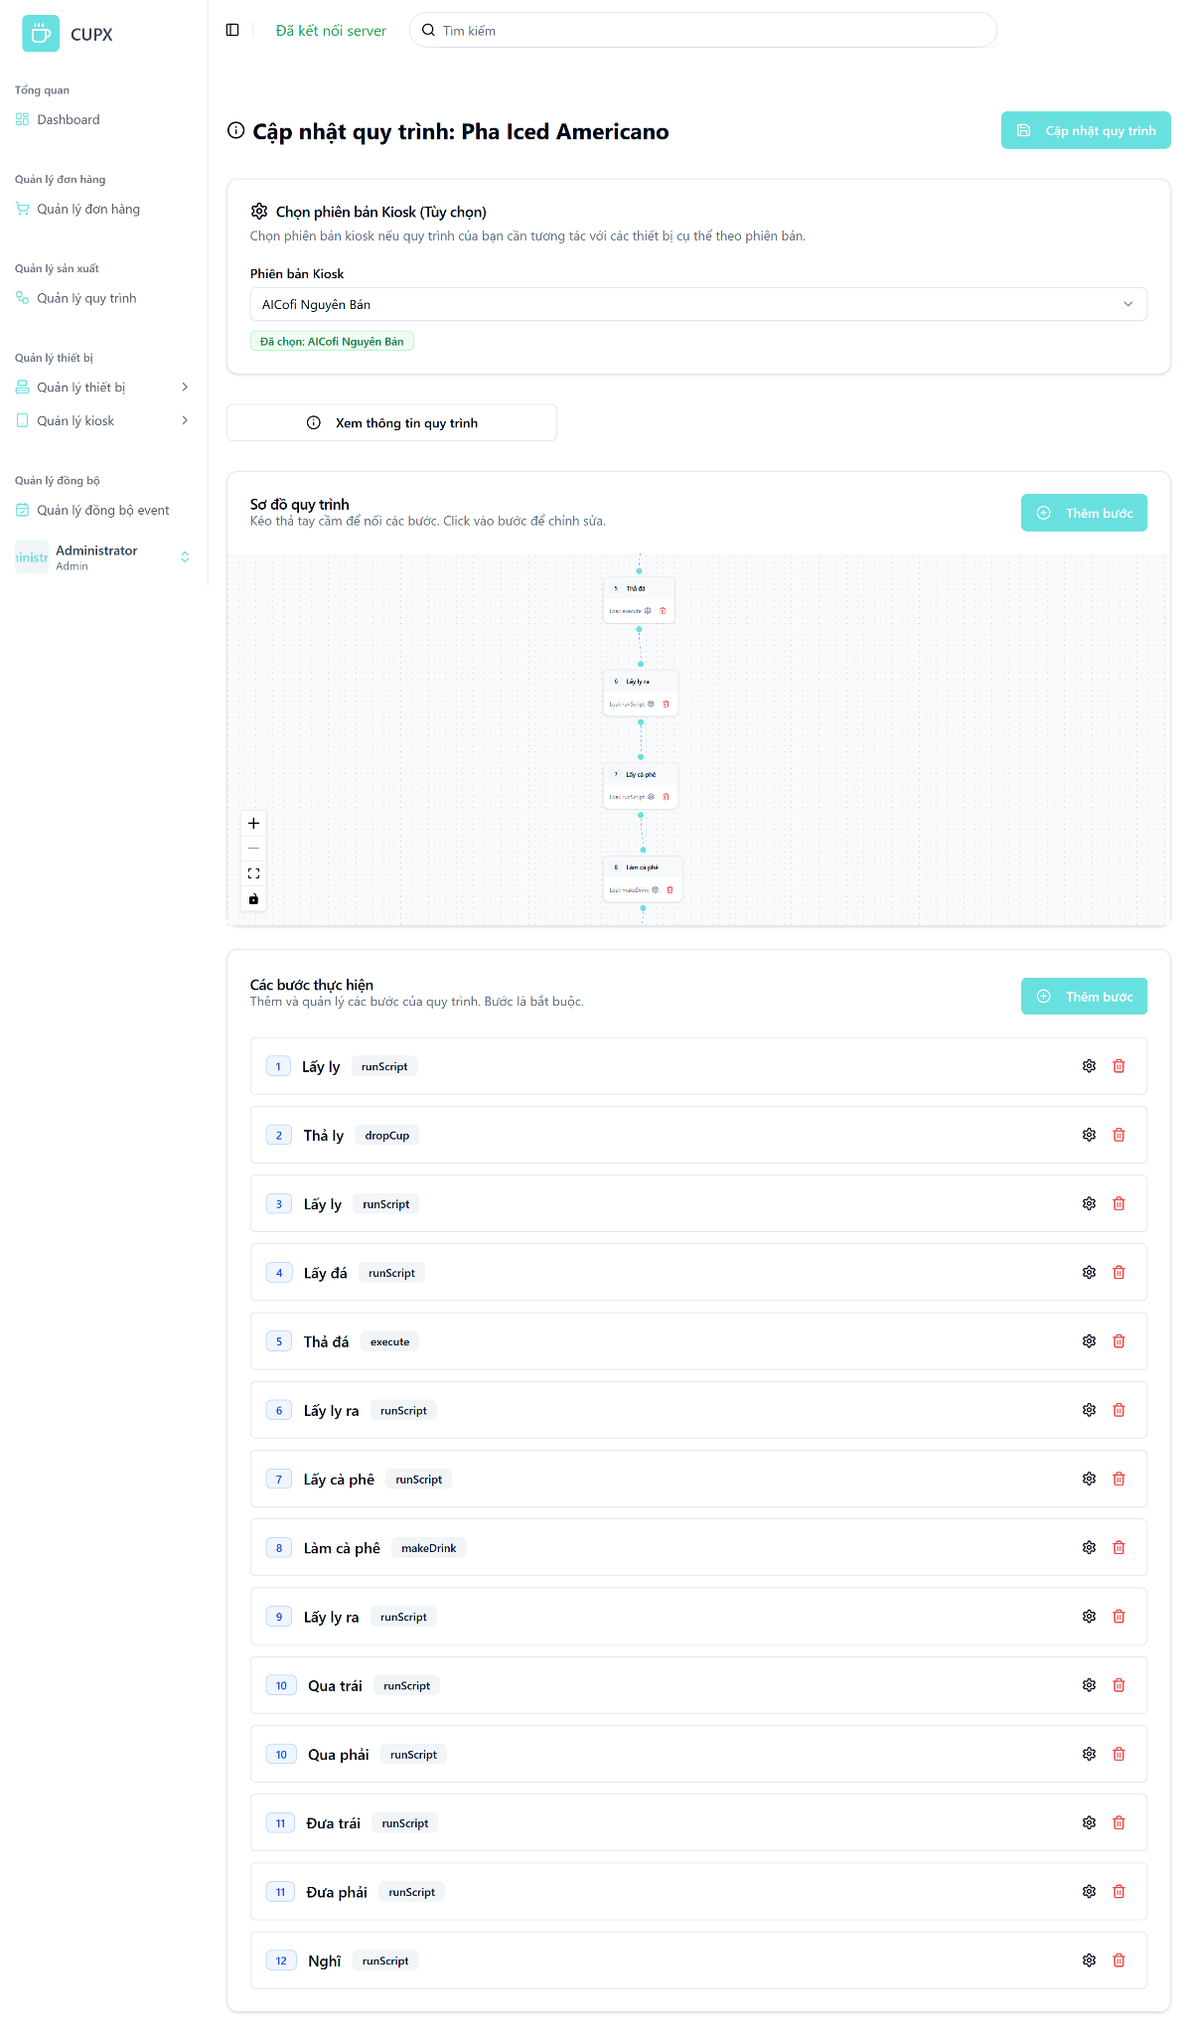
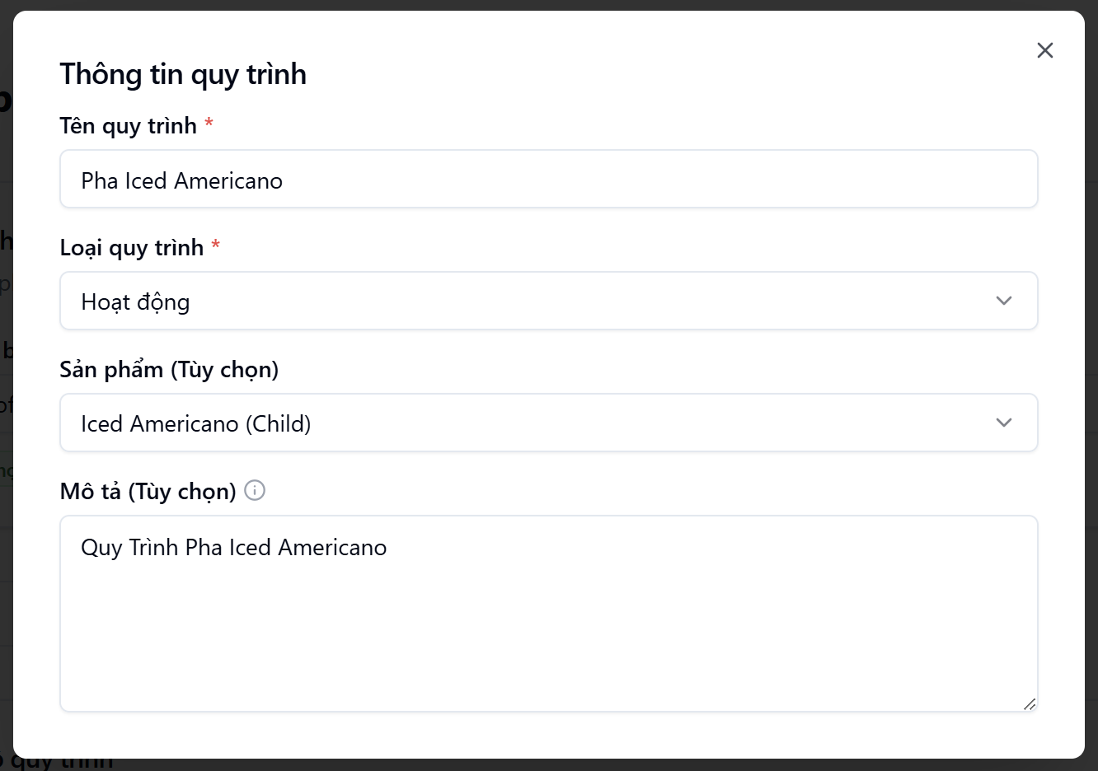
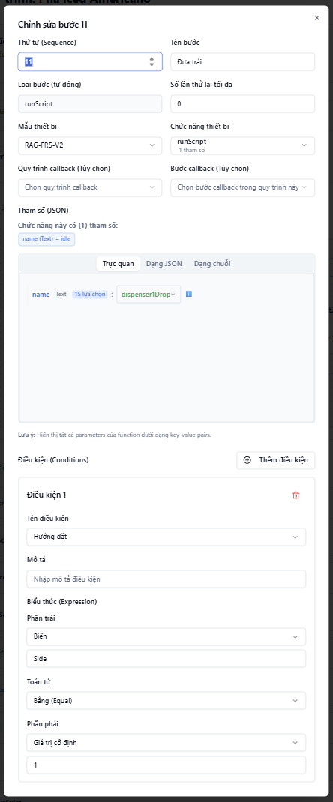
- Function details:
  - Data & Validation:
Field | Validation
ProductId | Optional, string, max length 50
Name | Optional, string, max length 100
Description | Optional, string, max length 300
KioskVersionId | Optional, string, max length 50
Type | Required, must match enum EWorkflowType
Steps | Optional, array of valid StepNestedDto
Steps[].Name | Required, string, max length 100
Steps[].Type | Required, string, max length 450
Steps[].DeviceModelId | Required, string
Steps[].MaxRetries | Optional, integer ≥ 0
Steps[].Sequence | Required, integer (step order in workflow)
Steps[].CallbackStepId | Optional, string, max length 50
Steps[].CallbackWorkflowId | Optional, string, max length 50
Steps[].Parameters | Optional, string, max length 500, must be valid JSON
Steps[].StepCode | Optional, string, max length 50
Steps[].CallbackStepCode | Optional, string, max length 50
Steps[].Conditions | Optional, array of valid StepConditionDto
Steps[].Conditions[].Name | Required, must match enum EConditionName, max length 50
Steps[].Conditions[].Description | Optional, string, max length 450
Steps[].Conditions[].Expression | Required, must contain valid left, operator, and right
Expression.Left.Type | Required, must match enum EExpressionType
Expression.Left.Value | Required, type depends on selected type (e.g., string, int)
Expression.Operator | Required, must match enum EOperation (Equal, NotEqual, >, <, etc.)
Expression.Right.Type | Required, must match enum EExpressionType
Expression.Right.Value | Required, type depends on selected type (e.g., string, int)

  - Functionalities:
Function | Normal Cases | Abnormal Cases
Open update modal | Admin clicks "Chỉnh sửa", modal opens with pre-filled workflow information | If workflow not found (404), show error toast
Modify fields | Admin updates workflow fields like name, description, steps, then submits | If required fields are empty or invalid, show inline validation errors
Submit update | Admin clicks “Cập nhật”, backend updates the workflow and closes the modal | If backend error (e.g. validation, server error), display retry option
Cancel/Close modal | Admin clicks “Hủy” or presses Esc to cancel update and close the modal | If modal fails to close, allow fallback via ESC key or reload the page

  - Business Rules:

3.19.5 Delete a workflow
- Function description:
  - Actors/Roles:
    - System Admin: Has full permission to delete any workflow.
    - Organization Admin: No access to this feature.
  - Purpose: This function allows a system admin to permanently remove a workflow from the system.
  - Interface:
    - The Delete option is located inside the "Hành động" (Action) dropdown on the workflow list screen.
    - A confirmation modal is shon — clicking "Xác nhận" will immediately trigger the deletion process and remove the workflow.
    - The deleted workflow will disappear from the table after the operation.
  - Data Processing:
    - Frontend sends a DELETE request to the backend API with the workflow ID.
    - Backend verifies permission, deletes workflow record, and returns success status.
    - On success, frontend refreshes the list to remove the deleted workflow.
    - Error toast is displayed in case of API failure (e.g., 403, 500).
- Function trigger:
  - Navigation path: From the sidebar, admin selects "Quản lý wokflow", clicks the "⋯" action button on a workflow row, and chooses "Xoá" to trigger the confirmation modal.
- Layout:
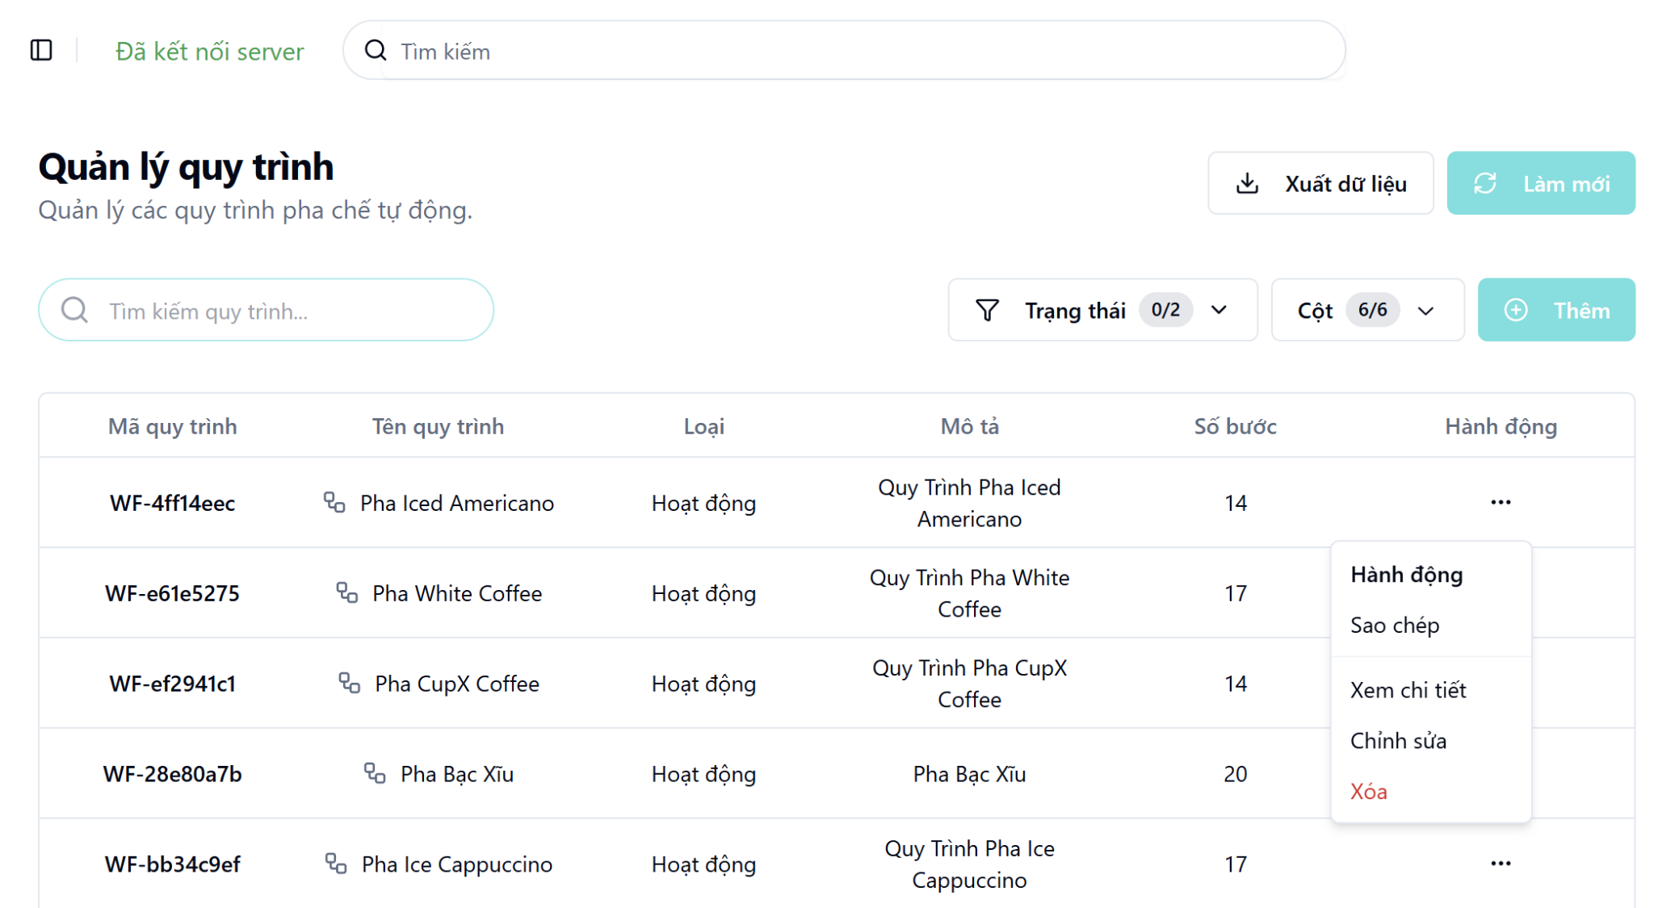
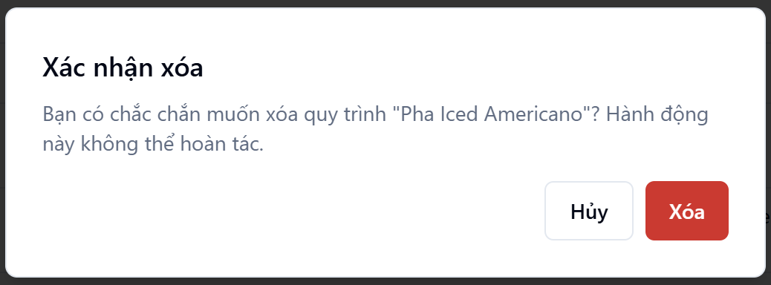

4. Non-Functional Requirements

4.1 External Interfaces
- The system provides RESTful APIs for integration with external services such as payment gateways and notification systems.
- Coffee kiosks connect to the central server via secure HTTPS protocols to ensure data integrity and confidentiality.
- Admin dashboards interact with backend services through authenticated API calls for real-time monitoring and control.

4.2 Quality Attributes

4.2.1 Usability
- Dashboard provides a clear overview of all kiosks and their current statuses.
- Filtering and sorting options allow quick access to specific kiosk/device information.
- Designed for ease of use by customers at kiosks.
- Minimal input required to place and complete an order.

4.2.2 Reliability
- The system performs consistently under expected conditions.
- Retry mechanisms for failed actions.
- Regular monitoring to detect and resolve issues proactively.

4.2.3 Performance
- Real-time communication between frontend and backend.
- Fast response time for admin operations.
- Low latency for user interactions on the kiosk.

4.2.4 Security

All data transmissions are encrypted using HTTPS.

Payment processing follows secure protocols.

Role-based access control for all admin and system actions.

4.2.5 Scalability

Easy to onboard new kiosks and organizations.

Modular architecture for expanding features.

Supports increasing user load without degrading performance.

5. Requirement Appendix

5.1 Business Rules
ID | Rule Definition
BR-01 | An order can only be processed if all required devices are in the “IDLE” state.
BR-02 | Each kiosk can only process one product at a time, following a First-In, First-Out (FIFO) queue.
BR-03 | Only the System Admin is allowed to manage workflows.
BR-04 | Each order can contain a maximum of two products.
BR-05 | Orders must be successfully paid before being added to the processing queue.
BR-06 | A QR code will automatically expire after 2 minutes if not scanned.
BR-07 | The kiosk system requires an active internet connection to function properly.
BR-08 | Each store must belong to exactly one organization.
BR-09 | A workflow cannot be deleted if it is currently active on any product.
BR-10 | A kiosk version cannot be deleted if any active kiosk instance is using it.
BR-11 | Each kiosk must have 2 ordering apps and 2 cup dispensers
BR-12 | Only the System Admin is allowed to synchronize workflows and devices to kiosks.
BR-13 | The order can not be canceled after payment.
BR-14 | The kiosk features two drink-serving stations: Position 1 on the left and Position 2 on the right.

5.2 Common Requirements
The system must update the device's status in real time, at a minimum frequency of 30 minutes.
The Android application only uses Vietnamese as the primary language.

5.3 Application Messages List
# | Message code | Message Type | Context | Content
1 | MSG01 | In line | When a search returns no results | No search results.
2 | MSG02 | In red, under the text box | When required input fields are left empty | The * field is required.
3 | MSG03 | Toast message | Updating asset(s) information successfully | Update asset(s) successfully.
4 | MSG04 | Toast message | Adding new asset successfully | Add asset successfully.
5 | MSG05 | Toast message | Deleting asset information successfully | Delete asset(s) successfully.
6 | MSG06 | In red, under the text box | Input value length > max length | Exceed max length of {max_length}.
7 | MSG07 | In line | The username or password is not correct when clicking sign-in button | Incorrect user name or password. Please check again.
8 | MSG08 | Toast message | When the workflow syncs to the kiosk is successful | Workflow synchronized to the kiosk successfully
9 | MSG09 | Toast message | When the workflow syncs to the kiosk fails | Failed to synchronize workflow to the kiosk. Please try again later.
10 | MSG10 | In red, under the text box | When inputs violate validations | Invalid input. Please check your entry.

